BOARD OF DIRECTORS MEETING MINUTES

4/18/2023 7:30 PM

EXECUTIVE BOARD COMMUNICATIONS DIVISION
State Chair: William Redpath Director: Amanda Parsons
Vice Chair: Matt Piron Deputy Director: Nathan Florey
Secretary: Ken Mattes Broadcasting Director: Stacy Apel
Treasurer: Russ Clark Social media Director: Alex O’Dell
Executive Director: Justin Tucker Deputy social media Director: Vacant

IT DIVISON FIELD OPERATIONS DIVISION
Director: Bob Blair Smith Director: Blake Hanson
Deputy Director: Carter Mitchell Deputy: Lorraine DeNardis-Albert
Website: Vacant Chapter Development: Paul DiMasi
Operations: Kelly Liebmann Activism: Vacant
CRM Training: Derek Evans Events: Vacant
Membership: Kevin Mahoney
POLITICAL DIVISION Campus Outreach: Vacant
Director: Jake Leonard 8:25- Volunteer: Vacant
1st Deputy Director: Jim Humay
Legislative: Vacant AD-HOC and NATIONAL
Campaigns: Jon King LP National Rep: Mark Tuniewicz
Candidate Recruitment: Vacant Convention Committee: Justin Tucker
Deputy Recruitment: Vacant
Ballot Access: William Redpath
Precincts: Vacant

STATE CENTRAL COMMITTEE
1st District: Jason Decker 10th District: Alexa Maffei
2nd District: vacant 11th District: Jon Harlson
3rd District: Danny Lewis -8:02 12th District: NOTA
4th District: vacant 13th District: vacant
5th District: Kevin Kauzlaric 14th District: vacant
6th District: Bob Blair-Smith 15th District: John Phillips Jr.
7th District: Jim Humay 16th District: Bennett Morris
8th District: Julie Fox 17th District: Donny Henry
9th District: Adam Balling

OTHER PARTICIPANTS:
Ronwell Nagales, Stuart Straub, Geri Mulso.

AGENDA
MEETING CALL TO ORDER 7:35 PM

PUBLIC COMMENT: Blake Hanson, Dan Lewis.

APPROVAL OF AGENDA passed w/o.

APPROVAL OF PREVIOUS MINUTES passed w/o.

OFFICER BRIEFS:

CHAIR:
Bill is retired from his professional career and is now a full-time Libertarian. Bill attended the LPWI Convention in Milwaukee and may be going to Arkansas soon to work on petitioning. Congratulations to our winning Libertarian candidates. Call for lobbying on behalf of RCV legislation HB2807 and SB1456. A new LPIL mailing address and phone number are pending.

VICE CHAIR:
Thanks to attendees and Field Ops for their help with the Take Human Action event. Matt is in touch with Theodore Gerken from the Libertarian Youth Caucus working on campus outreach.

TREASURER:
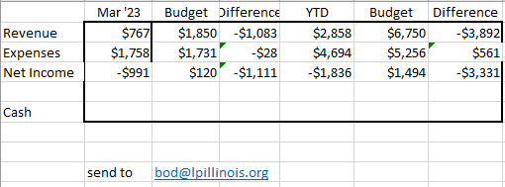

The candidate training in March had 10 attendees and was well received by attendees. I have also started an initiative to provide a new member orientation meeting once a month. This meeting is 30 minutes long and is focused on candidate responsibilities between state and county parties, ballot access needs and a call to action for new members to volunteer their time, talents, and money to our party. I have been extending an invitation to roughly 20 members in Sangamon County each month to find more volunteers in the county where I live. If you believe this orientation would be beneficial for your county party, I’m happy to share the presentation with you. Just email a request to treasurer@lpillinois.org.

Call to action from volunteers.
Cash on hand today $28,288.
Cash on hand at the end of March was $28,921.
Discussion on reported income versus net income after fees due to CRM misinterpretation.

SECRETARY:
Ken also attended the LPWI convention and met Chase Oliver, Michael Chianese, and Chris Nass, among others. Past delegates from 2018 on now have LPedia pages. Ken recommended potential 2024 delegates investigate using Amtrak with reward points from their credit card. National bylaws town hall and historical preservation committee opening. Thanks to Paul DiMasi for working on the survey.

EXECUTIVE DIRECTOR:
Fellow Libertarians - Congratulations to Bill Redpath on becoming Chair of the LPIL. I am very excited about working with Bill and I strongly feel we can continue to thrive under his leadership.

Another thanks to Chase Renwick for all his years of service to the LPIL. He will be missed as Chair. Chase was instrumental in getting out the Executive Director position established and without those efforts, we would not have more than $20,000 of additional resources in our coffers. His leadership will be greatly missed.

Please donate to the LP Illinois by visiting www.lpillinois.org and clicking DONATE. Also please consider Lifetime Memberships, which will get you into future conventions. Thanks to all our donors, both new and recurring. Established counties start petitioning around Novemberish and the statewide petition for the 2024 Presidential ticket starts next spring. Please reach into your couch cushions, put aside a few coffees, and give whatever you can spare, large or small, to help rebuild. Become a donor today!

If you are not a Precinct Committeeperson, please consider becoming one. If you are in an established county, start planning the next PC elections. Meanwhile, the information on https://lpillinois.org/precinct-committeemen/ should be updated.

My all-time haul as ED is $20,947.60.

On Friday, I will be meeting with State Rep. LaShawn Ford to discuss ballot access issues as well as Illinois decentralization issues. If anyone has the text of the 2018 resolution about dissolving the current Illinois structure into one or several states, please send it my way.

At the advice of the Executive Committee, I will begin the process of finding interested PCs in Chicago to appoint as Ward Committeepersons. I will soon call for a Cook County Libertarian Central Committee meeting as per the CCLCC bylaws and to announce appointments to Township Committeeperson.

Russ hosted a new member welcome meeting. This has the potential to be a great tool for helping onboard new members and gauging interest in running for office or volunteer activities.

I helped man the table at the Take Human Action event and facilitated a few new members to the LPIL.

I will continue to donate items to our archive at the UIC library. As some of you guys have just spent lots of money on Libertarian memorabilia, I encourage you to use the archive for safekeeping in case of a disaster like a fire. If you want to donate, let me know and I can help.

DIRECTOR BRIEFS:

Communications Division Report: Nothing new to report (Florey).

IT Division Report:
Last Month’s Activities

- Website updates for SCC member additions and interim Chair status
- Website updates for March Candidate training
- Voter database integration with new census boundaries/districts (possible way forward, depends on format of Illinois SOS voter database )
- Publicized upcoming CRM training and State Admin training opportunities

Open items:
- 2024 Convention dates / convention web page (no theme established yet)
- April / May events
- Unified conferencing expansion/awareness
- Document share / storage platform awareness

Budget:
- $1.19 from Amazon Web Services

Upcoming Plans / Priorities:
- Gather recommendations for Unified communications and document management platforms.
- inviting potential Conferencing / Doc management vendors to IT Division calls/ BoD calls
- Identify Website Director / volunteer(s)

Initial informal IT Division + volunteers calls:
- Continuing chapter visits and IT Division calls.

Field Ops Report:
Nothing to report besides the Take Human Action event (Hanson).
Outreach supply kits have been prepared for local chapters and echo the campus outreach initiative. (DeNardis-Albert).
Call for volunteers and use Discord (Hanson).

Political Division Report: Pending

AD-HOC and National Reports: N/A

OLD BUSINESS: N/A

NEW BUSINESS: MOTION #1 (DiMasi) to approve the attached survey to be sent out to membership via email (below). Seconded and PASSED w/o 8:24 PM.

MOTION #2 (Tucker) to adopt resolution (below). Seconded and PASSED by voice vote.

Next Meeting Date: MOTION to set next meeting date for 5/9 7:30 PM (Redpath) seconded and PASSED w/o.

Adjourn: MOTION TO ADJOURN (Liebmann) seconded and passed w/o. 8:41 PM.

Respectfully submitted by Secretary Ken Mattes.

MOTION #1 SURVEY:
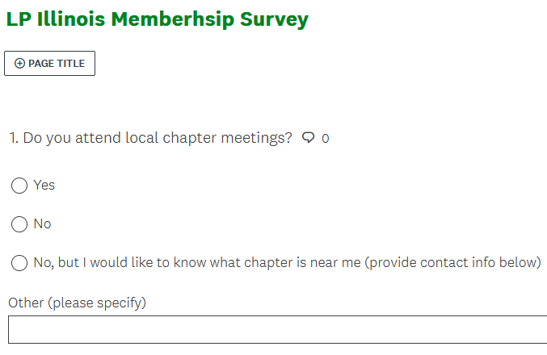
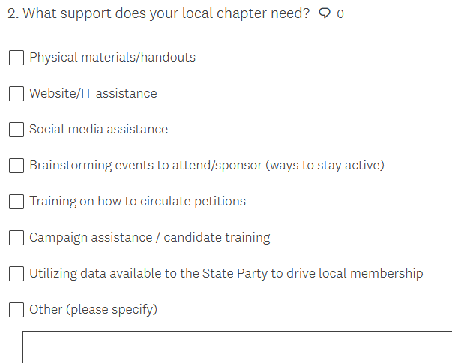
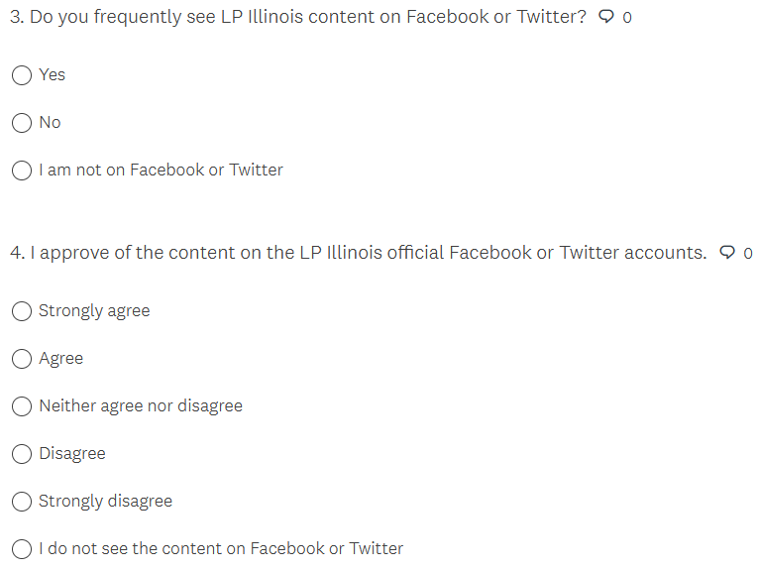
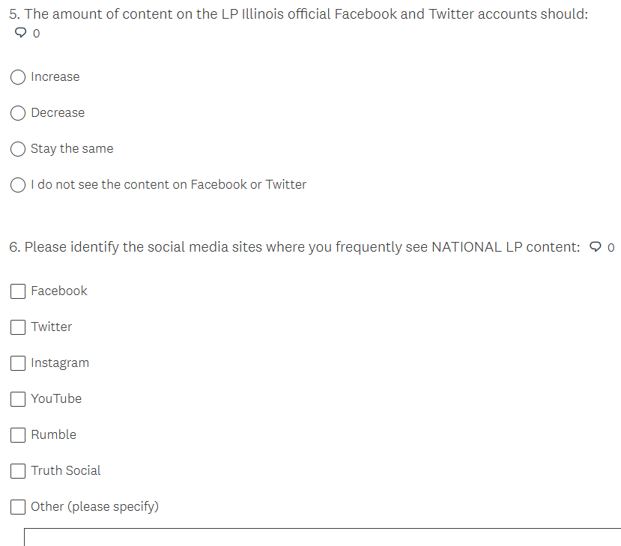
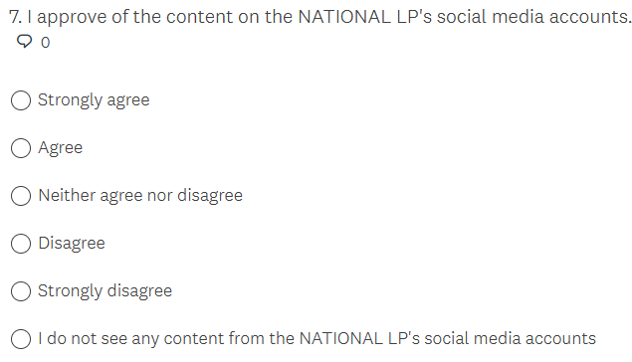
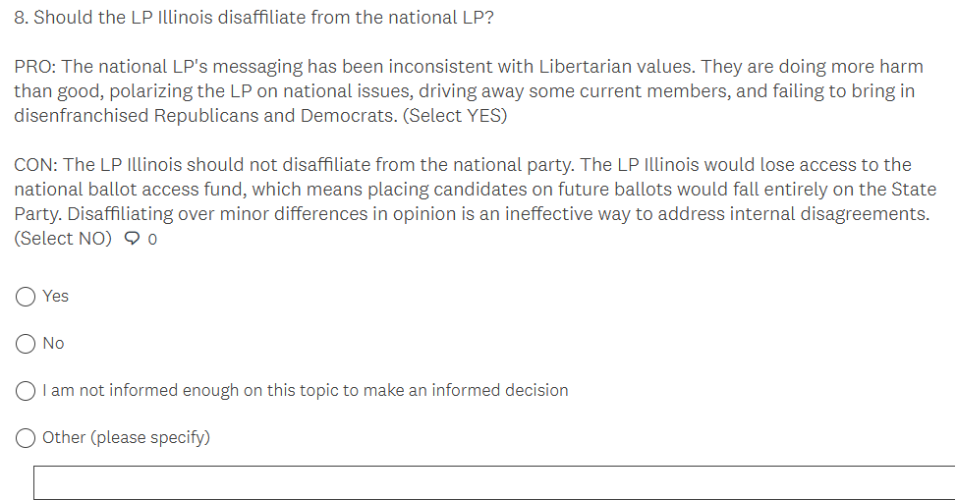
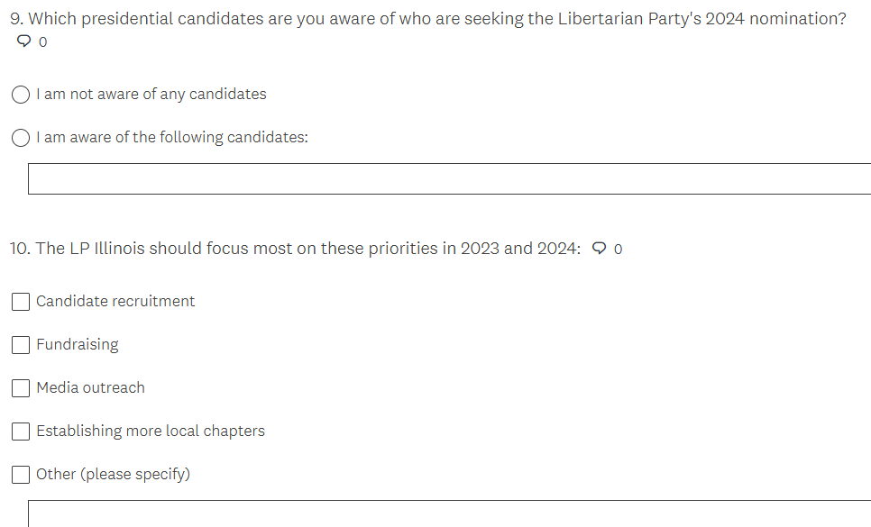

MOTION #2 RESOLUTION:

WHEREAS, Libertarians embrace the concept that all people are born with certain inherent rights
WHEREAS, Libertarians uphold and defend the rights of every person, regardless of their race, ethnicity, or any other aspect of their identity
WHEREAS, Libertarians hold governments, where they exist, should neither deny nor abridge any individual’s human right based upon sex, wealth, ethnicity, creed, age, national origin, personal habits, political preference, or sexual orientation
WHEREAS, Libertarians believe that the only legitimate use of force is in defense of individual rights — life, liberty, and justly acquired property — against aggression
WHEREAS, Libertarians affirm the individual right recognized by the Second Amendment to keep and bear arms
WHEREAS, Libertarians oppose the prosecution of individuals for exercising their rights of self-defense
WHEREAS, Libertarians oppose all laws at any level of government restricting, registering, or monitoring the ownership, manufacture, or transfer of firearms, ammunition, or firearm accessories
WHEREAS, Libertarians believe sexual orientation, preference, gender, or gender identity should have no impact on the government’s treatment of individuals
WHEREAS, Libertarians believe consenting adults should be free to choose their own sexual practices and personal relationships
WHEREAS, Libertarians believe parents, or other guardians, have the right to raise their children according to their own standards and beliefs, provided that the rights of children to be free from abuse and neglect are also protected
LET IT BE RESOLVED, the Libertarian Party of Illinois opposes any act of any legislative body to deny or abridge the right to self-defense of any individual.
LET IT BE RESOLVED, the Libertarian Party of Illinois opposes any act of any legislative body to deny or abridge the right of any individual to exercise sole dominion over their own lives.
LET IT BE RESOLVED, the Libertarian Party of Illinois opposes any act of any legislative body to deny or abridge on the right to live in whatever manner they choose, so long as they do not forcibly interfere with the equal right of others to live in whatever manner they choose.
LET IT BE FURTHER RESOLVED, the Libertarian Party of Illinois unites behind the inclusion of every individual who adheres to a lifestyle of non-aggression and stands in steadfast dedication to the defense of the rights of all.

LOBBYING TEMPLATE:
Senator or Representative XXXX:
I am writing to ask for changes to Illinois ballot access laws to make it easier for Third Party and Independent candidates for public office to appear on the ballot. I hope that at least some of these changes proposed below can be considered for the omnibus election legislation still being written this session.
Illinois has some of the most restrictive ballot access laws in this nation. This can easily be seen by looking at the 2022 General Election results. While it is true that the Libertarian Party was able to place a slate of statewide candidates on the ballot, there were 118 Illinois House and 59 Illinois Senate district elections, none of which had a Third Party or Independent candidate on the ballot. While there was one Third Party and one Independent candidate on the ballot among the 17 US House district elections, I do not know if they made the ballot because they gathered a sufficient number of signatures or because they were not challenged.
Illinois has the second most difficult petitioning requirement in the nation for US House elections. Except in years that end with the number “2,” the signature requirement for Independent and Third Party candidates for US House is 5% of the total votes for that office in the previous election. Only Georgia has a tougher requirement, which is 5% of the number of registered voters in that district. In years that end with the number “2,” the requirements are 5,000 valid signatures for US House, 3,000 valid signatures for Illinois Senate, and 1,500 valid signatures for Illinois House.
Illinois also has a 5% of the total last vote petition requirement for Third Party and Independent candidates for Illinois House and Illinois Senate. Attached please find an Excel spreadsheet that calculates how many signatures will be needed to get on the ballot for 2024 US House, Illinois House and Illinois Senate elections. On average, it will take about 12,000 valid signatures to be gathered within 90 days in highly gerrymandered congressional districts to place a non-R, non-D US House candidate on the 2024 ballot. To get that many valid signatures means that it will take 18,000+ total signatures to get just one US House candidate on the ballot. It will take an average of about 1,600 valid signatures to get on the ballot for Illinois House, and about 3,000 valid signatures to get on the ballot for Illinois Senate in highly gerrymandered districts.
If a non-R, non-D party wanted to run candidates for all US House, Illinois House and Illinois Senate districts in 2024, it would take at least 675,000 total signatures to get those candidates on the ballot. Include a statewide petition to put a presidential ticket on the ballot, and that number will increase to over 700,000 total signatures.
The petitioning requirement for 2026 will be even higher due to more people voting in the presidential election year of 2024.
Here are the changes that should be made to Illinois election law:
#1: Substantially reduce the number of required signatures for candidates to get on the ballot. I will address that with more specificity below.
#2: Allow a period for petitioning longer than the current 90 days, which generally runs from late March to late June, along with a later deadline for petitioning.
#3: Eliminate the law that states that voters can sign only one petition for a given office for the general election.
#4: Eliminate the law that bars petitioners from petitioning for the candidates of more than one political party. The fact of the matter is that most petitioning is done by professional petitioners. This law is in place simply to make it relatively difficult for non-R, non-D candidates to get on the general election ballot, because the best paid petitioners petition for R & D candidates in the primary, after which they are legally barred from petitioning for non-R, non-D candidates to get on the ballot for the General Election.
#5: End the petition challenge process and have petition signatures verified by State Board of Elections employees. This is what is done in the vast majority of states. The petition challenge process is a Kafkaesque process by which challengers attempt to terrorize, through large expenses and big hassles, potential candidates off the ballot. It is a political sport to try to kick candidates off the ballot (including Primary election ballots) in Illinois, and that should stop.
#6: Create a party petition process. Illinois only has candidate petitions. Illinois is one of eleven (11) states that does not have a party petition process, whereby signatures are gathered to allow a political party to place their candidates on the ballot before those candidates are selected. Neighboring states Missouri and Wisconsin have party petitions with only a 10,000 valid signature requirement that then allows a political party to place candidates on the ballot for any and all offices in that state.
#7: Reduce the ballot access retention requirement. Illinois law requires getting 5% of the vote for Governor for a political party to become a fully recognized political party. The median vote retention requirement among all the states is 2%, and that usually applies to any statewide office.
#8: Allow changed petition language that does not imply that signers are part of the political party formation process. It is my understanding that Illinois law requires such language. Petition language should be clear that the petition signer is just signing to allow a political party or a candidate to appear on the ballot.
#9: Allow multiple turn-ins of petitions to the State Board of Elections, with validity percentage feedback from the State Board of Elections. It is my understanding that current Illinois law allows only one petition turn-in, which often makes parties and candidates gather far more signatures than needed to get on the ballot and generally makes the petitioning process more difficult and uncertain.
Attached please find an article on model ballot access legislation from the Harvard Journal on Legislation from 1999. While the article is 24 years old, and some of the information in it is dated (e.g., paid petitioning is much more expensive than $2 per signature these days), the recommendations for ballot access legislation are still appropriate.
In summary, the model ballot access legislation calls for:
A: A party petition that qualifies a political party to place a candidate on the ballot for all offices in a state by gathering the signatures of 0.1% of the registered voters of that state between January 1 and August 15 of that election year; and
B: A candidate petition (for Third Party or Independent candidates) that qualifies them for the ballot by gathering the signatures of 0.1% of the registered voters in their district between January 1 and August 15 of that election year; and
C: A political party that qualifies for the ballot by having 0.05% of the registered voters in that state registered with that political party, as per the description in the Harvard model ballot access legislation (although this would not be applicable to Illinois unless party voter registration is enacted in Illinois); and
D: A political party qualifies for the ballot if any statewide candidate in either of the two previous statewide elections earns at least 1% of the vote, and, if that does not occur, a political party can place a district candidate on the ballot if its candidate earned at least 1% of the vote in that district’s election in either of the last two General Elections.
It is my understanding that there is an omnibus election bill being considered in the Illinois legislature this session. I respectfully request you to sponsor and vote for legislation incorporating A, B & D above, or to work to have it included in the omnibus election legislation.
Please let me know if you are willing to work for ballot access relief in Illinois.
Thank you very much.
Bill Redpath
1303 Westley Lane
West Dundee, IL. 60118-3545
MEETING DIALPAD CHAT:
Messages

Activity
Person AvatarRN
Ronwell Nagales7:14 PM
I was thinking of inviting Dave Smith, Spike Cohen and/or Justin Amash as Speakers.
Person AvatarRN
Ronwell Nagales7:24 PM
To those who wanted to see that I'm talking about. https://www.icollector.com/WandaVision-Mini-Moments-Set-Signed-by-Julian-Hilliard-Billy_i48187846
Alrighty. I'll just observe the BoD meeting then.
AM
Alexa Maffei7:34 PM
Y'all need VPNs
CM
Carter Mitchell7:34 PM
Having trouble getting mic working
Person AvatarBH
Blake Hanson7:37 PM
https://my.ilga.gov/WitnessSlip/Create?committeeHearingId=20165&legislationId=0&legislationdocumentid=0&fbclid=IwAR0aU6QHUp7uy87uyDE753fzh_OoB_X3TWW6nSSyD8NzTfExo_2Jezo0VjA
Person AvatarRN
Ronwell Nagales7:38 PM
I agree with Dan.
I would nominate Bill as well for State Chair.
Person AvatarBH
Blake Hanson7:39 PM
Fill out info; you can put "self" under organization, title, and represented in appearance. You'll want to fill out section 3 as "SB-1456" as a Proponent, and mark yourself as "Record of Appearance Only" on the last part
https://l.facebook.com/l.php?u=https%3A%2F%2Fwww.ilga.gov%2Flegislation%2Fwitnessslip.asp%3FDocNum%3D1456%26DocTypeID%3DSB%26LegID%3D146167%26GAID%3D17%26SessionID%3D112%26GA%3D103%26SpecSess%3D%26fbclid%3DIwAR3HWjOFogiQsVSX0J2JUqAhKJ2KlN8YLvwMM5O1KRyuB5dM4hY9bk5v0zo&h=AT0M25j-MzTXVhVmx-_sn5V79Q3DqumCYorOvh7-mcCmnUsenvenuzmdnPTG3II_FDDIp4vBUfdWy-9Yo_qiWzBaD4lCbEjg4O0LZWL3NDTLvTID1iazjvFWwi0KY-nD2GvVDURuTD9NAMC_VDqMiw
^ to see who has submitted a witness slip
https://www.ilga.gov/legislation/witnessslip.asp?DocNum=1456&DocTypeID=SB&LegID=146167&GAID=17&SessionID=112&GA=103

(shorter link)
https://www.ilga.gov/legislation/fulltext.asp?DocName=&SessionId=112&GA=103&DocTypeId=SB&DocNum=1456&GAID=17&LegID=146167&SpecSess=&Session=

(Full text of the Bill)
Person AvatarRN
Ronwell Nagales7:51 PM
I was actually considering enrolling in community college.
M
Matt (Vice Chair)7:52 PM
https://www.lycaucus.org/
chair@lycaucus.org
PD
Paul DiMasi7:53 PM
There is position description that can be provided.
RD
Radical Dan Lewis D3 LPWC IC Champ7:53 PM
"Representing: Yo Momma"
For the witness slip^
Person AvatarBH
Blake Hanson7:55 PM

We have the upper hand with proponents vs opponents for now. But make no mistake, the Duopoly -- especially the Democratic Party political machine -- has a lot invested in maintaining the status quo. They have poured quite a bit of money and personnel into being against this. So we need everyone we can to help us move the needle towards liberty.
Person AvatarLD
Lorraine DeNardis-Albert7:57 PM
Thanks for working on this!
RD
Radical Dan Lewis D3 LPWC IC Champ7:58 PM
How in the heck are there 542 opponents, there are literally orgs that are committed to opposing RCV. How do you start an org that hates freedom?
Person AvatarBH
Blake Hanson7:59 PM
Quite simply my dear Watson:

They are members of the Cult of the Omnipotent State.
A.k.a. Statists
RD
Radical Dan Lewis D3 LPWC IC Champ7:59 PM
Statist slaves
Mr. Secretary, I am due to attend a Presidential Campaign Meeting. Depending on the length of the meeting I can come back. However, would me jumping off put us below quorum?
AM
Alexa Maffei8:01 PM
They're from unions and other groups that like to buy elections so those public officials will feel obligated to support their groups through legislation, etc. Ranked choice voting makes that more challenging.
RD
Radical Dan Lewis D3 LPWC IC Champ8:02 PM
Makes sense
Person AvatarBH
Blake Hanson8:02 PM
I'm not sure who the people who have phone numbers calling in are; but we have 15 excluding them.
RD
Radical Dan Lewis D3 LPWC IC Champ8:02 PM
Q is 16
Person AvatarBH
Blake Hanson8:02 PM
I know, I'm not sure how many of the 5 other people are part of the BOD
AM
Alexa Maffei8:03 PM
For example, all the public sector unions who contributed 94% of the money of mayor-elect Brandon Johnson's campaign fund.
KM
Ken Mattes8:03 PM
https://www.amtrak.com/guestrewards/apply.html
Person AvatarBH
Blake Hanson8:14 PM
She did phenomenal work on them
Mr Chair, when Lorraine is done, I do have one more comment to make in closing for Field Ops.
JT
Justin Tucker8:17 PM
Future event: Bughouse Square Debates
Person AvatarBH
Blake Hanson8:17 PM
https://discord.gg/ahF8e8RtnT
Where is the text for the survey?
KM
Ken Mattes8:23 PM
The text is in the meeting minutes
*agenda
Person AvatarBH
Blake Hanson8:23 PM
Alrighty, that's what I am looking at right now
Let me copy the text here
KM
Ken Mattes8:23 PM
I tried, it won't work
Person AvatarBH
Blake Hanson8:25 PM

(Survey ^)
(Resolution from Executive Director v)
WHEREAS, Libertarians embrace the concept that all people are born with certain inherent rights

WHEREAS, Libertarians uphold and defend the rights of every person, regardless of their race, ethnicity, or any other aspect of their identity

WHEREAS, Libertarians hold governments, where they exist, should neither deny nor abridge any individual’s human right based upon sex, wealth, ethnicity, creed, age, national origin, personal habits, political preference, or sexual orientation

WHEREAS, Libertarians believe that the only legitimate use of force is in defense of individual rights — life, liberty, and justly acquired property — against aggression

WHEREAS, Libertarians affirm the individual right recognized by the Second Amendment to keep and bear arms

WHEREAS, Libertarians oppose the prosecution of individuals for exercising their rights of self-defense

WHEREAS, Libertarians oppose all laws at any level of government restricting, registering, or monitoring the ownership, manufacture, or transfer of firearms, ammunition, or firearm accessories

WHEREAS, Libertarians believe sexual orientation, preference, gender, or gender identity should have no impact on the government’s treatment of individuals

WHEREAS, Libertarians believe consenting adults should be free to choose their own sexual practices and personal relationships

WHEREAS, Libertarians believe parents, or other guardians, have the right to raise their children according to their own standards and beliefs, provided that the rights of children to be free from abuse and neglect are also protected

LET IT BE RESOLVED, the Libertarian Party of Illinois opposes any act of any legislative body to deny or abridge the right to self-defense of any individual.

LET IT BE RESOLVED, the Libertarian Party of Illinois opposes any act of any legislative body to deny or abridge the right of any individual to exercise sole dominion over their own lives.

LET IT BE RESOLVED, the Libertarian Party of Illinois opposes any act of any legislative body to deny or abridge on the right to live in whatever manner they choose, so long as they do not forcibly interfere with the equal right of others to live in whatever manner they choose.

LET IT BE FURTHER RESOLVED, the Libertarian Party of Illinois unites behind the inclusion of every individual who adheres to a lifestyle of non-aggression and stands in steadfast dedication to the defense of the rights of all.
JT
Justin Tucker8:28 PM
Paul - Tag me as well. I have experience with the email and also we need to ensure this goes to the membership of the state party.
Person AvatarLD
Lorraine DeNardis-Albert8:29 PM
Great job!
Person AvatarBH
Blake Hanson8:33 PM
The way I understand this is that this is a resolution stating "we support 'x'", whilst 'x' is being a hotly debated political topic in media and the Duopoly
Person AvatarRN
Ronwell Nagales8:33 PM
No, You're good, Donny.
Person AvatarBH
Blake Hanson8:35 PM
Agreed Ms Maffei
I'm going to go ahead and post it in the member's chat on FB for now
Just the text, no commentary
PD
Paul DiMasi8:37 PM
Get with me for my current IL media contact list if you want.
JT
Justin Tucker8:38 PM
Certainly. I have more contacts as well.
JF
Julie Fox8:40 PM
Can someone provide an update on the Chicago area picnic?
Person AvatarBH
Blake Hanson8:40 PM
I posted it in the Members group and tagged Amanda and Alex so they are at least aware for now of it

