Libertarian National Committee

Region 1 Report

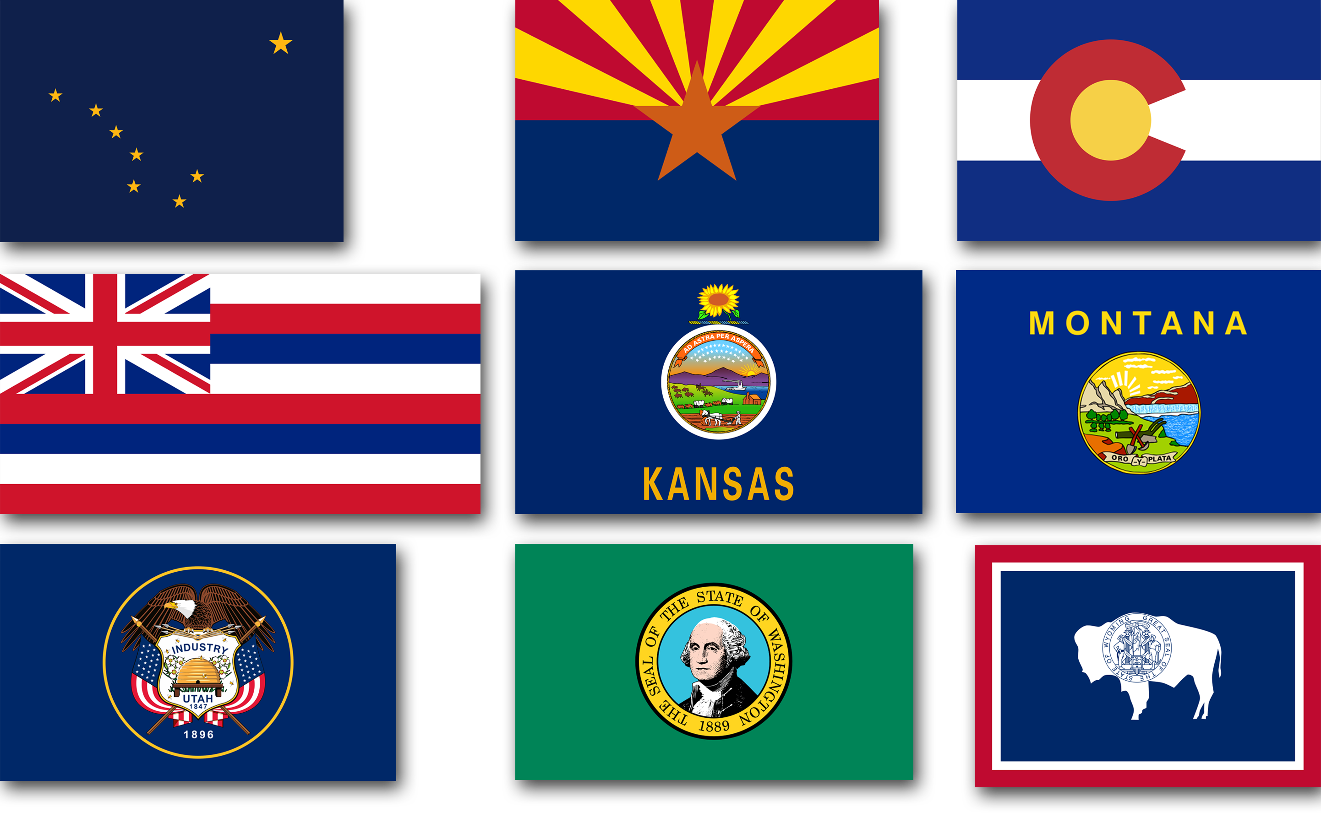
Regional Report for Region 1
Alaska, Arizona, Colorado, Hawaii, Kansas,
Montana, Utah, Washington, and Wyoming
Libertarian National Committee Meeting
April 21-22, 2018

Region 1 Representative
Ms. Caryn Ann Harlos, Colorado
Libertarian National Committee
T: 561.523.2250 E: Caryn.Ann.Harlos@LP.org

Region 1 Alternate
Mr. Craig Bowden, Utah
Libertarian National Committee T: 801.882.6472 E: Craig.Bowden@LP.org

Contents
Region 1 Overview 11
National Memberships 12
State Party Memberships 13
Ballot Access Requirements and Retention 14
State Conventions 16
Membership Growth 17
Region Re-Formation 17
Other 18
Alaska Libertarian Party 19
State Organization 19
At a Glance Statistics 20
Governing Documents 22
Board Meetings 22
State Convention 22
National Convention Preparation/Region Re-Formation 22
State Level Membership 23
Sub-Affiliates 23
Elections 23
Ballot Access and Party Status 25
Activities 25
Finances & Fundraising 25
Media Coverage 25
Other 26
What does affiliate think National should be doing? 26
Statement from the Chair 26
Arizona Libertarian Party 28
State Organization 28
At a Glance Statistics 29
Governing Documents 30
Board Meetings 31
State Convention 31
National Convention Preparation/Region Re-Formation 31
State Level Membership 31
Sub-Affiliates 31
Elections 32
Ballot Access and Party Status 34
Activities 36
Finances & Fundraising 36
Media Coverage 36
Other 36
What Does the Affiliate Think National Should be Doing? 36
Statement from the Chair 37
Libertarian Party of Colorado 39
State Organization 39
At a Glance Statistics 40
Governing Documents 41
Board Meetings 41
State Convention 42
National Convention Preparation/Region Re-Formation 42
State Level Membership 42
Sub-Affiliates 42
Elections 42
Ballot Access and Party Status 43
Activities 44
Finances & Fundraising 44
Media Coverage 44
Other 44
What Does the Affiliate Think National Should be Doing? 44
Statement from the Chair 44
Libertarian Party of Hawaii 46
State Organization 46
At a Glance Statistics 47
Governing Documents 48
Board Meetings 49
State Convention 49
National Convention Preparation/Region Re-Formation 49
State Level Membership 49
Sub-Affiliates 49
Elections 50
Ballot Access and Party Status 50
Activities 50
Finances & Fundraising 50
Media Coverage 51
Other 51
What does affiliate think National should be doing? 51
Statement from the Chair 51
Libertarian Party of Kansas 52
State Organization 52
At a Glance Statistics 53
Governing Documents 54
Board Meetings 55
State Convention 55
National Convention Preparation/Region Re-Formation 55
State Level Membership 55
Sub-Affiliates 55
Elections 56
Ballot Access and Party Status 56
Activities 57
Finances & Fundraising 57
Media Coverage 57
Other 57
What Does the Affiliate Think National Should be Doing? 57
Statement from the Chair 57
Montana Libertarian Party 58
State Organization 58
At a Glance Statistics 59
Governing Documents 60
Board Meetings 61
State Convention 61
National Convention Preparation/Region Re-Formation 61
State Level Membership 61
Sub-Affiliates 61
Elections 62
Ballot Access and Party Status 62
Activities 62
Finances & Fundraising 63
Media Coverage 63
Other 63
What does affiliate think National should be doing? 63
Statement from the Chair 63
Libertarian Party of Utah 65
State Organization 65
At a Glance Statistics 66
Governing Documents 67
Board Meetings 67
State Convention 67
National Convention Preparation/Region Re-Formation 68
State Level Membership 68
Sub-Affiliates 68
Elections 68
Ballot Access and Party Status 69
Activities 70
Finances & Fundraising 70
Media Coverage 70
Other 70
What does affiliate think National should be doing? 71
Statement from the Chair 71
Libertarian Party of Washington State 72
State Organization 72
At a Glance Statistics 73
Governing Documents 74
Board Meetings 74
State Convention 74
National Convention Preparation/Region Re-Formation 74
State Level Membership 75
Sub-Affiliates 75
Elections 75
Ballot Access and Party Status 76
Activities 77
Finances & Fundraising 77
Media Coverage 77
Other 78
What does affiliate think National should be doing? 78
Statement from the Chair 78
Wyoming Libertarian Party 79
State Organization 79
At a Glance Statistics 80
Board Meetings 82
State Convention 82
National Convention Preparation/Region 82
State Level Membership 82
Sub-Affiliates 82
Elections 82
Ballot Access and Party Status 83
Activities 83
Finances & Fundraising 84
Media Coverage 84
Other 84
What does affiliate think National should be doing? 84
Statement from the Chair 84

Region 1 Overview and Re-Formation

The nine affiliates that comprise Region 1 are: Alaska, Arizona, Colorado, Hawaii, Kansas, Montana, Utah, Washington, and Wyoming.
Due to the geographical nature of this region, spanning five time zones and extending from 19 to 71 degrees north latitude (some 3,000 x 3,000 miles), in-person contact between the Regional and Alternate Representatives and the individual affiliates will be infrequent. I attended the 2017/2018 affiliate conventions in Alaska, Arizona, Colorado, Montana, Utah, Washington, and Wyoming. Unfortunately Kansas had been scheduled on conflicting weekends for both years. The Hawaii convention was not realistic to attend due to its short length and distance/cost. Regular contact is maintained with the affiliates and members through email (including a newsletter), telephone, a dedicated Facebook discussion group, and informational website. Plans were considered for a regional teleconference to hear from members (this did not happen this term, and I would urge my successor to consider). Further, I remotely attend as many Regional Board meetings as I am able.
I am presently working with the Regional states to sign a re-formation agreement, and particularly to see if it should be modified to suit our needs more efficiently. New Mexico has approached me to join Region 1, and I will be speaking with South Dakota, Idaho, and Oregon.
Notice has been given to Region 1 members that I am not re-running for this position in favor of running for Party Secretary. Former Region 1 Alternate Steven Nielson resigned, and a majority of the Region 1 Chairs elected Craig Bowden as his replacement.

National Memberships  March 2017 National Membership Summary  March 2018 National Membership Summary
   | Total Sustaining Members | Sustaining Membership Rank
  alaska | 90 | 40
  arizona | 400 | 17
  colorado | 638 | 10
  hawaii | 76 | 43
  kansas | 167 | 33
  montana | 83 | 41
  utah | 146 | 35
  washington | 618 | 11
  wyoming | 37 | 51
   | Total Sustaining Members | Sustaining Membership Rank
  alaska | 92 | 39
  arizona | 325 | 16
  colorado | 469 | 11
  hawaii | 54 | 44
  kansas | 132 | 34
  montana | 78 | 41
  utah | 100 | 37
  washington | 507 | 10
  wyoming | 37 | 48
  YEAR OVER YEAR TRENDS TO NEAREST PERCENTAGE
  ALASKA membership UP 2%
  ARIZONA membership DOWN 23%
  COLORADO membership DOWN 36%
  HAWAII membership DOWN 40%
  KANSAS membership DOWN 26%
  montana membership DOWN .06%
  utah membership DOWN 46%
  washington membership DOWN 22%
  WYOMING MEMBERSHIP SAME

State Party Memberships

States with Partisan Libertarian Registration
 | Total Registrations | Registered Voters | Percentage  Libertarian | Change Since 12/18 Report
alaska | 7,350 | 531,810 | 1.4% | None
arizona | 5,258 | 485,424 | 1.08% | +.21%
colorado | 46,087 | 3,819,423 | 1.20% | +.01%
kansas | 15,463 | 1,776,703 | .87% | Same #s
utah | 14,080 | 1,557,550 | .90% | +.02%
wyoming | 2,411 | 262,406 | .91% | +.01%

States without Partisan Libertarian Registration
 | Total Members | How Determined | Growth Since 12/18 Report
HAWAII | 54 | Nat’l BSM | -.03%
montana | 78 | Nat’s BSM | +7.69%
washington | 507 | Nat’l BSM | -10%

Ballot Access Requirements and Retention

Alaska
In order to be a recognized political party, Alaska requires that the gubernatorial candidate receive at least 3% of the total votes cast or whose number of registered voters is equal to at least 3% of the total votes cast for governor. If the race for governor is not on the ballot, the race for US Senator is used to calculate the 3%, and if neither the governor nor the US Senate is on the ballot, the race for US Representative is used.
US Senate candidate Joe Miller achieved over 3% (he received 29.39%) thereby securing continued ballot access.
2018 will include ballot access races.

Arizona
There is no vote test needed. The AZLP needs to maintain .67% of registered voters (partisan) with the number currently at 1.08%.

Colorado
There is no vote test needed. The LPCO needs to maintain 1,000 registered Libertarians; the number is presently well over 40,000 of us.

Hawaii
The vote test requirement is 10% in a statewide race or US House, or alternatively, 4% of all votes cast for state Senate, 4% of all votes cast for State House, or 2% of all votes cast for state Senate and state House combined. Adopting a strategy of attempting the lowest threshold (4% of votes cast in a US Senate races), the total votes for the five candidates in qualifying races was 8,293 out of 135,298 votes across eight races for a percentage of 6.1, enough to retain ballot access for an additional five election cycles, i.e. the next ten years.

Kansas
The vote test requirement is 1% of a statewide race, including the presidential race. The LPKS has had access since 1992, and report that between the US Senate and presidential races. This threshold has been met across several races in 2016 and will need to be met in 2018.

Montana
The vote test requirement averages out to be 2.8% which can be met by any statewide candidate in about seven races. In this cycle, it turned out to be 12,542 votes needed. Three statewide candidates (Rick Breckenridge-US Representative, Roger Roots-Secretary of State, and Ted Dunlap-Governor) met this burden. This will also need to be met in 2018.

Utah
The vote test requirement is 2% of any statewide race. This was met by gubernatorial candidate Brian Kamerath (3.08%) and Attorney General candidate Andrew McCullough (6.73%). This will not need to be met again until 2020 (every four years).

Washington
1,000 signatures need. The LPWA will become ballot-qualified party if 5% in presidential vote is achieved (which they were robbed of in 2016).

Wyoming
The vote test requirement this race is 2% in a US House race which was met by US Representative candidate Lawrence Struempf (3.6%).
The vote test is limited in presidential years to just US House which must be achieved in order to remain on the ballot. If 10% is achieved, primary status would be retained, otherwise, nominations by convention would resume. In mid-term years, three offices count: US House, Governor, and Secretary of State.

Note on Major/Minor Party Designation
As per Richard Winger, there are 16 two-tier states and the other 34 states just have one category of qualified party. The two-tier states are Colorado, Connecticut, Delaware, Georgia, Indiana, Kansas, Kentucky, Maryland, Michigan, Nevada, New Mexico, Oregon, Texas, Vermont, West Virginia, and Wyoming.

State Conventions

Alaska
The 2017 Convention date took place May 6, 2017. I was in attendance. The 2018 Convention will be on May 12, 2018.

Arizona
The 2017 Convention took place on January 21, 2017. I was in attendance. The 2018 Convention took place on January 28, 2018, and I was in attendance but in the capacity of national membership recruiter.

Colorado
The 2017 Convention took place on March 24-26, 2017. I was in attendance. The 2018 Convention took place on March 23-25, 2018, and I was in attendance.

Hawaii
The 2017 Convention took place on December 3, 2017. I was not able to attend. They do not have conventions in even-numbered years.

Kansas
The 2017 Convention took place on April 21-23, 2017. I was not able to attend. The 2018 LPKS State Convention is slated to be held April 20-21 in Overland Park, Kansas and unfortunately conflicts with this LNC meeting.

Montana
The 2017 Convention took place on March 11, 2017. I was in attendance. An additional Convention took place on September 9, 2017. The 2018 Convention is scheduled for May 19, 2018.

Utah
The 2017 Convention took place April 22-23, 2017. I was not able to attend as I was in Washington. The next convention took place April 14, 2018, and I was in attendance.

Washington
The 2017 Convention was first set for April 21-23, 2017 but did not achieve quorum. I was in attendance. The Convention successfully re-convened on July 8, 2017. The 2018 Convention took place February 16-18, 2018, and I was in attendance in the capacity of national membership recruiter.

Wyoming
The Convention took place September 23, 2017. I was in attendance. Their 2018 nominating Convention took place March 31, 2018. I was not able to attend.

Membership Growth

I have been promoting National memberships at the state conventions with great success.

Region Re-Formation

Per LP Bylaws, Article 7, Section 2(c):

Any affiliate party with 10% or more of the total national party sustaining membership within affiliate parties (as determined for delegate allocation) shall be entitled to one National Committee representative and one alternate for each 10% of national sustaining
membership. Affiliate parties may, by mutual consent, band together to form "representative regions," and each such "region" with an aggregate national party sustaining membership of 10% or more shall be entitled to one National Committee representative and one alternate for each 10% of national party sustaining membership. "Representative regions" may be formed or dissolved once every two years during a period beginning 90 days before the beginning of and ending on the second day of the National Convention, and notice of new formations or dissolutions must be given in writing to the national Secretary prior to the close of the Convention at which they take place.

The present make-up of Region 1 has 1740 BSM members which is 12% of the national total.

If the Region stays the same, the entitlement to LNC representation will remain the same. I am working on a more specific regional agreement to present to the State Chairs. New Mexico has asked to join Region 1, with Oregon and South Dakota also showing potential interest.

Other

Google alerts have been set up in order to monitor the Web for news and information about each affiliate and key candidates (when appropriate) in Region 1 as well as a feed to monitor the regional Facebook content.

I confer regularly with the Chairs on Regional issues and send suggestions and interact regularly with the membership.

Alaska Libertarian Party
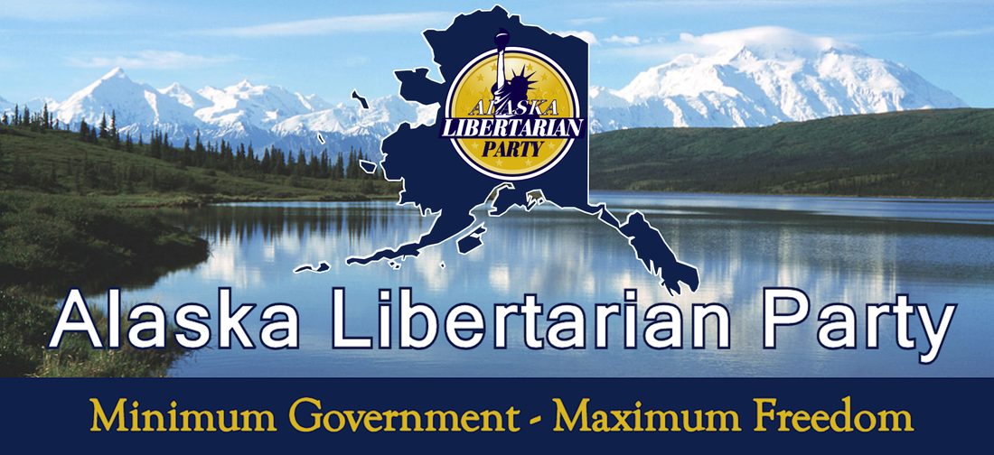
State Organization  Party Leadership Structure – Staggered Terms  Elected Positions  Chair: Jon Watts, jon.watts@alaskan.com  Vice Chair: Randy Stevens, randywild@gci.net  Treasurer: Vacant/Cean Stevens, mermaidcean@yahoo.com  Secretary: Cean Stevens, mermaidcean@yahoo.com  Membership: Stephanie Shaeffer, k9endeavors@gmail.com  Communications: Joel Hadley, joelhadley@hotmail.com  Website: http://ww.alaskalp.org | 

Office Space
None.

Paid Staff/Contractors
None at this time.

At a Glance Statistics
Number of Libertarians | 7,350. This represents 1.4% of the registered voters (531,810). This is numerically a 2.9% decrease since my last report.
Method of Membership Determination | The AKLP Constitution defines members as registered Libertarians voters who pay dues. That number is presently under 50. There is an ambiguity in the Constitution that was brought up to Chair Watts for possible correction as the way it currently reads, one interpretation could allow members of other parties could pay dues and be members and all registered Libertarians (whether they pay or dues or not) could be members.
Partisan Registration? | Yes.
Ballot Access Status/Requirement/Retention | The AKLP has ballot access.  Access is obtained through nomination from state-recognized political party.  2016 US Senate candidate Joe Miller received 29.39% of the vote.  2018 is a ballot access year so the affiliate will need to have a governor candidate to maintain.
Method of Determining Candidates | At convention or committee vote as per 2017 Bylaws. I spoke with Chair Watts about the importance of following these procedures so that no challenge can be made to their candidates.
Number of Candidates 2016/2018 | 3 / 5 (anticipated) for state offices.
Estimated Budget | $5K yearly. A Café Press account has also been opened for potential revenue but is still in development.
Website / Facebook Current? | The website is fresh and professional.  Facebook has 4,443 likes and is now ranked at 26 which remains unchanged since my last report. I suggested that the affiliate might want to look into Meet-up.
Newsletter? | The last newsletter was sent 2/16. This is a work in progress.
Database? | This is an area that they need to work on but they are relying on Excel spreadsheets and the National data dump. I alerted Chair Watts to the CRM program.
BSM Members | 92. This places Alaska at 39th in the affiliate rankings which is unchanged since my last report and is up 2% over a one-year period.

Governing Documents

PLATFORM:
On website (http://www.alaskalp.org/platform.html). Adopted May 7, 2016. The Platform has been updated but is not yet reflected on the website. Chair Watts is looking into this.

BYLAWS:
On website (http://www.alaskalp.org/bylaws.html). Adopted 2017.

CONSTITUTION:
On website (http://www.alaskalp.org/constitution.html). Adopted 2017.

Board Meetings
The current Board is scattered over a large geographic area so that meetings are attended in person in Anchorage by those who can and by teleconferencing for those who live further away using Zoom software. Meetings have been quarterly.

State Convention
The 2018 Convention will take place on May 12, 2018 with officer positions up for election.

National Convention Preparation/Region Re-Formation

leadership:
Party leadership may change at the May Convention but negotiations for regional re-formation will be started with Chair Watts this month.

delegates:
Alaska has seven delegate spots and expects to fill them all at their May Convention.

State Level Membership
The AKLP Constitution defines members as registered Libertarians voters who pay dues. That number is presently under 50. However see above “at a glance” portion for potential ambiguity.

Sub-Affiliates
The state is broken down into burrows, and the location of new affiliates, gatherings, and candidates are a featured part of the new website. The Facebook page shows the following groups: ALP Local Affiliate Support Group, ALP Matanuska-Suisitna, ALP Sitka, ALP Interior Alaska, ALP Kenai, ALP Eagle River, ALP Ketchikan. | 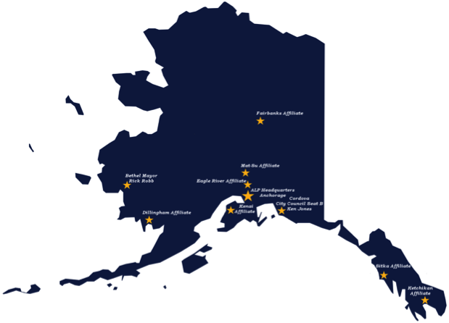

Elections

Current Election Cycle (2018)
Mark Fish has announced for State House and has a Facebook page (https://www.facebook.com/fishforhouse2018/). He is listed on the National site.

ELECTED LIBERTARIANS:
- Rick Robb (Bethel Mayor)
- Ken Jones (Cordova City Council)

PRIMARIES:
Alaska is a blanket primary state. The date of the mid-term congressional primary is August 21, 2018.

Ballot Access and Party Status
In order to be a recognized political party, Alaska requires that the gubernatorial candidate receive at least 3% of the total votes cast or whose number of registered voters is equal to at least 3% of the total votes cast for governor. If the race for governor is not on the ballot, the race for US Senator is used to calculate the 3%, and if neither the governor nor the US Senate is on the ballot, the race for US Representative is used.
US Senate candidate Joe Miller achieved over 3% (he received 29.39%) thereby securing continued ballot access. 2018 will be a ballot access race year and thus there will need to be a gubernatorial candidate with several qualified persons being interested.

MAJOR/MINOR PARTY:
Alaska does not have this distinction but has recognized political parties and registered political groups.

OTHER:
N/A

Activities
Focus is presently on local affiliate building and candidate recruiting and a new event series of “Fireside Chats with the Chair” is being planned.

Finances & Fundraising
This has been progressing and the affiliate is in healthy shape.

Media Coverage
None came across my newsfeed.

Other
As noted in my past reports, tension and rivalries between social conservatives and social liberals has been a source of dissension within the affiliate. They are presently focusing on candidate recruitment.
Also from Ballot Access News:
On September 19, 2017, professional petitioner Darryl Bonner and Alaska Libertarian activist Scott Kohlhaas filed a federal lawsuit against the Alaska law that bans out-of-state circulators for initiative petitions. Bonner v Bahnke, 3:17cv-202. On October 20, the state said it would not attempt to defend the ban, and so a stipulated judgment and order was issued. Out-of-state circulators can now circulate initiative petitions in Alaska, and they are permitted to cross out language on the petition saying they are Alaska residents.
Alaska never had a ban on out-of-state circulators for candidate petitions.

What does the affiliate think National should be doing?
The National Party needs to focus on credibility and decorum issues that end up harming the Party. The level of intelligence within the Libertarian Party is very high, but conversely the wisdom is low. Alaska has been quite resolute in its opposition to the actions of Vice-Chair Arvin Vohra.

Statement from the Chair
The Libertarian Party may very well have the highest IQ per member of all time. What we need right now however is a great influx of wisdom – Not factional partisanship, not ego-centered power-grabs, but the judgment to choose practical, unifying, and yes, sometimes corrective action to negate influences that impede the combined forward movement of libertarian principles AND political success. With all the knowledge and reason at our disposal, we continue to have unwise decisions that enable and sustain harm to the LP. This must change at the national convention. We will see you there.
~Jon Watts, Chair

Arizona Libertarian Party

State Organization  Party Leadership Structure  Elected Positions  Chair: Howard Blitz, chairman@azlp.org  1st Vice Chair: Jonathan Winder  2nd Vice Chair: Kevin McCormick  Treasurer: Robert Allen Pepiton  Assistant Treasurer: Laila Aussie  Secretary: Jeff Daniels  Assistant Secretary: Emily Goldberg  Website: www.azlp.org | 
The AZLP has three statutory officers and four non-statutory officers. There are restrictions on which members may vote for the statutory officers at Party elections. The affiliate is active, healthy, and acts as a leader and facilitator with county parties on various initiatives, ballot access issues, and the like.

Office Space
No.

Paid Staff/Contractors
No.

At a Glance Statistics
Number of Libertarians | 5,258. This represents 1.08% of the registered voters (485,424). The numbers represent a .21% increase since my last report.
Method of Membership Determination | Registered voters.
Partisan Registration? | Yes.
Ballot Access Status/Requirement | The AZLP has ballot access. However, there is also a requirement on a per-county level for ballot access.  .67% of active registered voters (2/3 of 1%).  Currently has 1.08% of the registered voters.
Number of Candidates 2016/2018 | 26 / Chair Blitz did not yet have an estimated total for me for the 2018 races. 6 candidates are listed on the website, and 9 are listed on the national party website.
Estimated Budget | Last year went very well with over 20K raised and set to do likewise this year.
Website / Facebook Current? | Website is modern and current. Facebook page likes are at 5,912. This would place Arizona about 17th in the affiliate rankings which is up two ranks since my last report. I suggested linking their community group with their Facebook page.
Newsletter? | No.
Database? | Yes, NationBuilder.
BSM Members | 325. This places Arizona at 16th in the affiliate rankings which is the same as my last report and down 23% over a one-year period.

Governing Documents

PLATFORM:
On website (http://www.azlp.org/arizonaplatform). Adopted January 21, 2017.

BYLAWS:
On website (http://www.azlp.org/bylaws). Amended January 2005.

CONSTITUTION:
On website (http://www.azlp.org/constitution). Adopted August 31, 1999.

Board Meetings
The Board now meets once per month and with some attending in person and others attending electronically.

State Convention
The 2017 Convention took place on January 21, 2017. I was in attendance. The 2018 Convention took place on January 28, 2018, and I was in attendance but in the capacity of national membership recruiter.

National Convention Preparation/Region Re-Formation

leadership:
I have discussed with Chair Blitz the region re-formation agreement.

delegates:
The affiliate has 23 delegate spots and has filled them all. They have not yet been submitted to the Credentials Committee.

State Level Membership
The AZLP Constitution defines 3 classes of membership: registered Libertarians, County Precinct Committeemen, and State Committeemen that are all defined statutorily. Only the Committeemen have voting rights at the State Convention.

Sub-Affiliates
Arizona comprises 15 counties, and there are eight county level affiliates. They are working to add affiliates and recognized county parties for Apache, Coconino, Graham, Greenlee, La Paz, Navajo, Santa Cruz, and Yavapai Counties. Ballot access is not granted on a statewide basis across the board; individual counties also have to make the threshold of .67% of active registered voters within that county in addition to having an active county party.
The most active sub-affiliate is the Maricopa County Libertarian Party which meets monthly (https://www.lpmaricopa.org). 60-65% of the population of Arizona resides in this county.
In addition to Maricopa County, the AZLP website lists affiliates in the following counties: Cochise, Gila, Mohave, Navajo, Pima, Pinal, and Yuma.

Elections

Current Election Cycle (2018)
6 candidates are listed on the website, and 9 are listed on the national party website. The only candidates listed on the AZLP website as there are minimum requirements for listing including a multi-page website. All of the candidates meeting the requirements are listed.
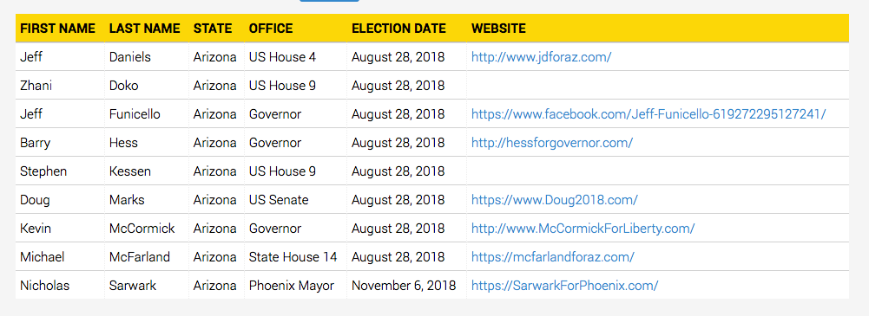

ELECTED LIBERTARIANS:
- Jeff Daniels (re-elected to Christopher Kohl’s Fire District Board)
- Ruth E. Bennett (re-elected to Continental Elementary School District Board)
- Levi Tappan (elected to Page City Council) PRIMARIES:
The AZLP has the choice of a closed or semi-closed primary and has chosen a closed primary. This primary will take place August 30, 2018.

Ballot Access and Party Status
The first hurdle in Arizona ballot access is having registered Libertarians comprise .67% of active registered voters. Right now, they have 1.08% of the active registered voters. In addition, in order to be on the Primary ballot (either printed or added as a write-in), candidates have to obtain a certain number of signed Nominating Petitions. This is particularly critical as the County Precinct Committeemen are included that are the pool from which the Party officers will be chosen. An open Primary would effectively be allowing non-Libertarians to chose the eventual Party officers. If the State Party ever fall off, they must petition and obtain about 21,000 valid signatures as any Party that loses qualification cannot get back on via registrations. Petitions are now allowed to be collected online.
The issue of the Nominating Petitions is currently the subject of a lawsuit as Arizona has changed the requirements in a way that is calculated to deny access to minor parties. Previously, the Nominating Petition requirement was .5 % of the registered Libertarians in the candidate’s district (or statewide). However, the new requirements cut the percentage in half to .25% but expanded the total pool from which the calculation is determined to include both Libertarians and independents/undeclared which are the most numerous voting bloc in the state. For example, using 2016 statewide figures (rounded for simplicity) of 25,000 Libertarians and 1,180,000 “others,” the former rule would have required 125 signatures, while this new requirement totals 3,012 signatures. As a counter-example, using the statewide figures for Republicans of 1,125,000, and the same number of independents/undeclared, the former rule would have required 5,625 signatures, and the new one would require 5,762 signatures, a negligible difference. With this in mind, if a candidate does not obtain the required nominating signatures, they can be put in as a write-in candidate but still have to meet the same burden in write-in votes which puts the AZLP in a conundrum since their Primary is closed, yet the figures that the write-ins have to meet include independents/undeclared. In some areas, it would be mathematically impossible for the write-in to obtain the required number of votes from the pool of registered Libertarians.
The AZLP has lost this case in the US District Court and an appellate brief has been filed with the 9th Circuit. Former Chair Buttrick did not believe that any decision will come down in time to possible help the 2018 candidates in their petitioning requirements.
Ballot Access News reported thusly: On July 10, U.S. District Court Judge David G. Campbell, a Bush Jr. appointee, upheld the 2015 Arizona law that sharply increased the number of signatures a member of an established small qualified party needs to get on his or her own party’s primary ballot. Arizona Libertarian Party v Reagan, cv-16-1019. The decision is 30 pages. The new law also sharply increased the number of write-in votes needed for a member of a minor party to be considered nominated (assuming he or she gets the most votes of anyone seeking that nomination).
The 2015 law, passed by the majority Republicans in the legislature, seemed aimed at stopping Libertarians, and only Libertarians, from running for partisan office. It did not injure the ballot-qualified Green Party, and made only slight changes for Democrats and Republicans. Whereas the old law set the number of signatures to get on a party primary ballot as a percentage of the party’s number of registered voters, the new law says the number of signatures is a percentage of all the registered voters. However, not all registered voters can sign. A Libertarian primary petition can be signed by registered voters who are not Democrats or Republicans.
The Green Party was not injured by the 2015 law because it is considered a “new” party, even though it last petitioned for party status in 2014 (for the 2016 and 2018 elections), and members of new parties only need a tiny number of signatures to get on their party’s primary ballot, and only need one write-in to get a nomination by write-in. The decision says the law is not discriminatory, relative to Libertarians and Greens, because it wasn’t passed with discriminatory intent, and also because the Greens (due to their failure to ever have registration of at least two-thirds of 1%) are forced to do a party petition every four years.
The decision is based on Munro v Socialist Workers Party, a 1986 U.S. District Court decision that upheld Washington state’s old ballot access law. That old law said a minor party or independent candidate could not appear on the November ballot unless he or she got 1% in the September blanket primary (all voters got the same ballot, and it listed all candidates from all parties). The Arizona decision says that law was also hard on minor party and independent voters, because under the Washington state law, only one of twelve minor party candidates got the 1%, and yet it was constitutional. But the Arizona decision doesn’t mention footnote eleven of the Munro decision, which said that 40 minor party and independent candidates (out of 45 who tried) successfully got on the Washington state general election ballot for non-statewide office. The reference to one of twelve only referred to statewide offices. The impact of the Arizona law on the 2016 Libertarian campaign was so severe that only one Libertarian for any partisan office managed to appear on the November ballot (excluding president, which has nothing to do with primaries).
The decision excludes some of the evidence submitted by the Libertarian Party, for various procedural reasons. It is very likely that the party will appeal to the Ninth Circuit. The major flaw with the decision is that it requires Libertarian candidates, seeking their party’s nomination, to ask for signatures for independent voters, which violates the party’s associational rights. In response to that point, the Arizona decision says the party should just go out and increase its registration (see pages 21 and 27).
UPDATE: under the logic of the decision, there is no rational reason why all voters shouldn’t be allowed to sign Libertarian primary petitions. Yet the law doesn’t allow Democrats or Republicans to sign.

MAJOR/MINOR PARTY:
Arizona does not have that distinction, but only has “recognized political party.”

OTHER:
N/A

Activities
The Facebook page lists an active schedule with a mix of education, activism, and social activities. The AZLP participates in regular outreach. The AZLP has also created an attractive specialized Facebook profile picture graphic. During my term, I have seen the AZLP rise exponentially in polished presentation. There will be a presence at the state fair.

Finances & Fundraising
The AZLP gets an average of $1,000 year from a truly voluntary state income-tax return check off in which taxpayers can voluntarily fund a political party that then increases or reduces the amount of taxes owed and also conducts regular fund-raising drives.

Media Coverage
Significant press mentions include:
http://www.yumasun.com/news/longtime-yuman-blitz-chosen-to-head-ariz-libertarian-party/article_7df29cf4-1a8b-11e8-bc61-cf5f5f7a8876.html

Other
The affiliate continues to grow and strengthen at the local levels.

What does the affiliate think National should be doing?
Chair Blitz believes national should continue to improve on its support of and communications with the state parties.

Statement from the Chair
Our new board was elected January 28, 2018 to finish out the remaining 1 year left on the term of office of many of the board members. Since then our 7-person board meets monthly by phone conferencing as the seven of us live in a variety of different places throughout the state of Arizona. One board member is from Gila County, one from Mohave County, one from Yuma County, three from Maricopa County, and one from Pima County.
Our first challenge has been to select 23 delegates to represent AZLP at the LNC convention in June in New Orleans. The body at the January 28 convention decided to use the first come first serve method as a basis for deciding those delegates, which has proven to be a very ineffective method since we now have more people wanting to be delegates than slots available unlike in the past when we did not have enough people wanting to fill all of the slots. One of the first priorities this year is to put a Bylaws change in place in making delegate selection smoother and more efficient.
Another item on our agenda this year is to have all of our committees operational and functional submitting suggestions on not only the delegate selection process but also setting up procedures on how a county can become organized and distributing them to the counties throughout Arizona. We are also looking into how to make the AZLP website more available to everyone including candidates and candidate listing so that the public will be aware of who is running for which offices. This includes making our bylaws available to the public. Another item we are investigating is appointing someone to be our website master to keep the AZLP website updated at all times.
In summary the following are the goals for 2018 of the AZLP:
- AZ delegate selection process established
- Committees operational and functional
- County Organization protocol established
- Make website user friendly and information available to the public
- Identify a website master

Big goals, but doable, especially with the type of individuals on the board. They are all awesome!!!
~Howard Blitz, Chair

Libertarian Party of Colorado
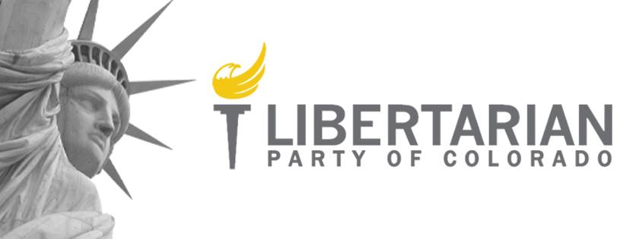
State Organization  Party Leadership Structure – Staggered Terms  Elected Positions  Chair: Wayne Harlos (chair@lpcolorado.org)  Vice Chair: Marc Montoni (vicechair@lpcolorado.org)  Treasurer: John Hjersman (treasurer@lpcolorado.org)  Records: Mike Spalding (recordsdirector@lpcolorado.org)  Membership: Matt DiGiallonardo (membershipdirector@lpcolorado.org)  Communications: Lance Cayko (communicationsdirector@lpcolorado.org)  Outreach: Kevin Gulbranson (outreachdirector@lpcolorado.org)  Regions: Steve Gallant (regionsdirector@lpcolorado.org)  Campaigns: Bruce Griffith (campaignsdirector@lpcolorado.org)  Legislative: Michael Stapleton (legistlativedirector@lpcolorado.org)  Fundraising: Roger Barris (fundraisingdirector@lpcolorado.org)  APPOINTED Positions  Database Manager: David Aitken (databasemanager@lpcolorado.org)  Technology Chair: Clayton Casciato (technologychair@lpcolorado.org)  Website: http://www.lpcolorado.org/ | 

Office Space
No. Meeting space is provided monthly by The Independence Institute.

Paid Staff/Contractors
No.

At a Glance Statistics
Number of Libertarians | 46,087. This represents 1.20% of the registered voters (3,819,423) and is up .01% percentage-wise from the last Region 1 report.
Method of Membership Determination | Registered voters.
Partisan Registration? | Yes.
Ballot Access Status/Requirement | The LPCO has ballot access.  The access requirement is 1,000 registered Libertarian voters.
Number of Candidates 2016/2018 | 26 / 36- they are not all listed on the national site.
Estimated Budget | $12K yearly
Website / Facebook Current? | Page likes are at 25,005. This would place Colorado about 4th in the affiliate rankings which remains unchanged but closing in on number 3. The affiliate has a dedicated social media volunteer team. Website is current and managed by an IT professional.
Newsletter? | No. Mail blasts are sent regularly. A regular newsletter is being planned with the election of a Membership Director and change to the affiliate Bylaws.
Database? | Yes through NationBuilder and managed by an IT professional.
BSM Members | 469. This places the affiliate at 11th in rankings which is down one rank since my last report and down 36% over a one-year period.

Governing Documents

PLATFORM:
On website (http:// http://www.lpcolorado.org/platform). Adopted March 2017. The 2018 changes are not yet reflected.

BYLAWS:
On website (http:// http://www.lpcolorado.org/bylaws). Adopted March 2017. The 2018 changes are not yet reflected.

CONSTITUTION:
On website (http:// http://www.lpcolorado.org/constitution). Adopted March 2017. The 2018 changes are not yet reflected.

Board Meetings
The Board meets monthly at space offered by The Independence Institute. The meetings are open and streamed live for public viewing. Board reports, emails, and documents are available online in an effort to move towards greater transparency and interface with the membership.

State Convention
The 2018 Convention took place March 23-25, 2018 with elections of nearly every Board member due to multiple resignations.

National Convention Preparation/Region Re-Formation

leadership:
The Board has staggered terms, and the Chair will not change in 2018. I will be discussing re-formation of Region 1 with Chair Harlos.

delegates:
The affiliate has filled all of its 34 delegate slots. These have not yet been uploaded to the Credentials Committee.

State Level Membership
State party members are the registered Libertarians. There is no separate membership structure. However the Libertarian registrations have grown at a pace outpacing both old parties.

Sub-Affiliates
There are 64 counties in Colorado, and a structure of county affiliates and a “pre-affiliate” phase of development group. The LPCO is attempting to have development groups in every county that does not have an affiliate. Affiliates are currently established in Arapahoe, Boulder, Delta, Douglas, and El Paso counties. There are approximately nine Development Groups. Regular data dumps are provided to the affiliates and development groups to spur growth.

Elections

Current Election Cycle (2018)
A healthy slate of candidates are being ran in 2018 with a mixture of serious candidates and line-holders. Chair Harlos is running for a non-partisan Town Council position.

ELECTED LIBERTARIANS:
- Mike Spalding (Ken-Caryl Water and Sanitation Board)
- Beau Woodcock (Miliken Mayor)
- Dylan Lewis-Silt Town Trustee
- Mike Spalding (Ken-Caryl Water and Sanitation Board)

PRIMARIES:
With the passage of Propositions 107 and 108 creating semi-closed primaries, the LPCO, as a minor party, can easily opt out though a primary is required when multiple candidates for a single office have significant support at convention—and in that eventuality, the primary is June 8, 2018.

Ballot Access and Party Status
Ballot access is secured with Colorado having the easiest ballot access laws in the country.

MAJOR/MINOR PARTY:
The LPCO is a recognized minor political party. Major party recognition requires 10% of the vote in the gubernatorial race.

OTHER:
From Ballot Access News: On February 14, a U.S. District Court issued a ruling in Semple v Williams, 1:17cv-1007, a case over the 2016 law change that made it more difficult to get constitutional amendments on the Colorado ballot. The ruling makes it almost certain that the restriction will be invalidated. It requires signatures of 2% of the registered voters in each of Colorado’s 35 State Senate districts.
The flaw in the restriction is that it requires 2% of the registered voters, instead of some percentage of the population of each district, or instead of a flat number in each district. The ruling says that because some districts contain approximately 50% more registered voters than other districts, the law violates “one person, one vote.”
Additionally, the LPCO lost a Colorado Supreme Court case seeking fees in an election access claim joined with a civil rights claim. This case is being appealed to the United States Supreme Court with the national party filing a supporting brief.

Activities
Regular Op-Eds are being submitted by the Media Action Committee led by Jay Stooksberry. There is regular well-staffed and attended Outreach events. A tax day protest was led by the Douglas County affiliate.

Finances & Fundraising
The LPCO was without an active Fundraising Director for a lengthy period of time (years) and is attempting to fire back up an active donor solicitation program.

Media Coverage
Significant media coverage included:
http://www.westword.com/news/awaii-ban-in-denver-ripped-by-libertarian-party-of-colorado-9908252

Other
The LPCO is supporting a major tax reform initiative.

What Does the Affiliate Think National Should be Doing?
Leaders in the LNC need to stop sabotaging affiliate parties with reckless “shock and awe” statements.

Statement from the Chair
Colorado has had a bit of a slowdown in activity since we are into the Fall and holiday season, but we have built good momentum for the upcoming year.
We had a great year that closed with a great Convention. We have many new board members including the election of Marc Montoni, formally of Virginia, Roger Barris, who just returned from England, Bruce Griffith, Lance Cayko, and Matt Digi.
This is a powerhouse group and I expect a fantastic year.
Cheers to all.
~Wayne Harlos, Chair

Libertarian Party of Hawaii
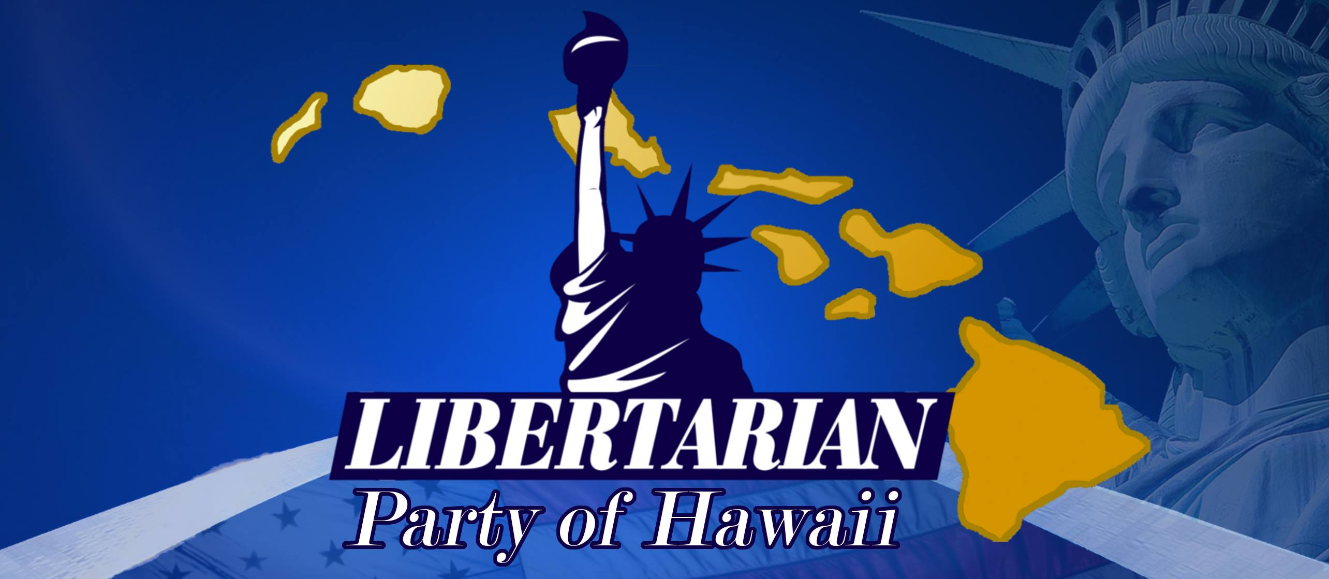
State Organization  Party Leadership Structure  Elected Positions  Chair: Tracy Ryan, tracyar@hawaiiantel.net  Vice Chair and Big Island Chair: Gregory Arianoff, info@arianoff.us  Treasurer: Pat Brock, TBD  Secretary: Joe Kent, joe_kent@hotmail.com  At Large: Feena Bonoan (Maui Chair, TBD), Eric Weinert (ericdraheweinert@gmail.com), Anthony Higa (Oahu Chair, hawaii.higa.hawaii@gmail.com)  International Ambassador of Liberty & Goodwill: Ken Schoolland, ken.schoolland@gmail.com  Website: http://www.libertarianpartyofhawaii.org | 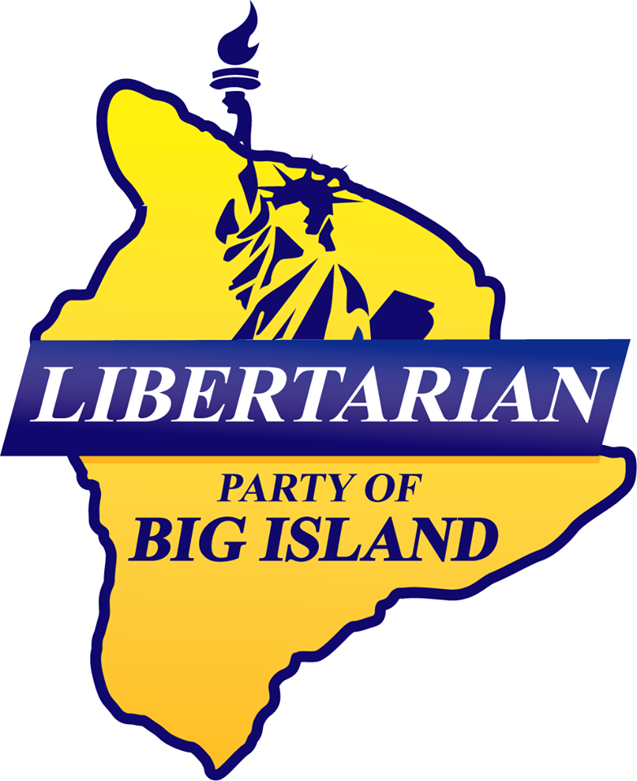

Office Space
No.

Paid Staff/Contractors
No.

At a Glance Statistics
Number of Libertarians | 54 (BSM members).
Method of Membership Determination | National Membership BSM.
Partisan Registration? | No.
Ballot Access Status/Requirement | The LPHI has ballot access.  Hawaii has a unique system. It requires 10% in a statewide race or US House or ~ 750 signatures ( 1/10th of 1% of the number of registered voters), or alternatively, if the Libertarian candidates bring in at least 4% of all the votes cast for state Senate, 4% for state House, or 2% of the votes for state Senate and state House combined. After a party has either met the vote test or petitioned for three elections in a row, then they are automatically on for the next five elections.
Number of Candidates 2016/2018 | 12 / the number for 2018 cannot yet be estimated.
Estimated Budget | $2-3K in odd years, and $8-10K (or more depending upon campaign assistance) in even years.
Website / Facebook Current? | The website is current and professionally done. Facebook page likes are at 5,837. This would place Hawaii about 19th in the affiliate rankings which is down one place since my last report. I alerted Chair Ryan that the frequency of postings seems to have dropped down over many months. The page dropped in the amount of likes.
Newsletter? | No.
Database? | Yes, but scattered over several locations and formats.
BSM Members | 54. This places Hawaii at 44th in the affiliate rankings which is a decrease in one ranking since my last report and down 40% over a one-year period.

Governing Documents

PLATFORM:
On website (http://www.libertarianpartyofhawaii.org/platform). Adopted 2015.

BYLAWS:
On website (http://www.libertarianpartyofhawaii.org/by-laws). Adopted 2015.

CONSTITUTION:
None.

Board Meetings
The geography of an island state makes travel for in-person attendance difficult. The Executive Committee meets about 6 times a year with some members meeting in person at Chair Ryan’s home in Honolulu and the rest appearing by Skype.

State Convention
The LPHI 2017 Convention took place December 3, 2017 in several locations; it was not possible for me to attend remotely. The affiliate does not have conventions in even-numbered years.

National Convention Preparation/Region Re-Formation

leadership:
I have been in touch with Chair to begin the re-formation of the Region 1 with Hawaii.

delegates:
The delegate allocation of 5 has been filled and reported to the Credentials Committee.

State Level Membership
The LPHI has state level membership for dues-payers and life members ($20/year for renewals;
$25/year for new members, and $1,000 for life members). There are under 100 members combined in those categories, but they have several hundred lapsed that get back involved periodically. In addition there are 54 BSM members.

Sub-Affiliates
The Libertarian Party of Big Island (Hawaii County) is an active sub-affiliate that has tapered off somewhat but they are working to keep it going. Maui County had an active affiliate, but it fell apart, and they are working on getting that going again; they really need representatives for the Maui area. They are striving to be competitive in Hilo (settlement in Hawaii County) and Kona (district in Hawaii County).

Elections

Current Election Cycle (2018)
The affiliate is recruiting for 2018 candidates with a focus on the state legislature.

PRIMARIES:
Hawaii has a mandatory open primary that the LPHI must participate in which will be held on August 11, 2018.

Ballot Access and Party Status
The vote test requirement is 10% in a statewide race or US House, or alternatively , 4% of all votes cast for state Senate, 4% of all votes cast for State House, or 2% of all votes cast for state Senate and state House combined. Adopting a strategy of attempting the lowest threshold (4% of votes cast in a US Senate races), the total votes for the five candidates in qualifying races was 8,293 out of 135,298 votes across eight races for a percentage of 6.1, enough to retain ballot access for an additional five election cycles, i.e. the next ten years. The affiliate, however, wishes to qualify each time as it grants even greater credibility to the Party and although ballot access is secured they do have to run candidates in state elections.

MAJOR/MINOR PARTY:
Hawaii does not have this distinction but rather simply has recognized political parties.

OTHER:

The Hawaii state elections office has determined that the Constitution Party petition for party status has enough valid signatures.

Activities
They do hold two general meetings per year in different locations to facilitate attendance.

Finances & Fundraising
The affiliate will be working on fundraising for its 2018 candidates.

Media Coverage
None at this time.

Other
H.B. No. 2739 is presently in committee which would provide a right-to-die in limited circumstances.

What does the affiliate think National should be doing?
The LNC needs to continue on its program of candidate and affiliate support, and continue to secure and maintain our ballot access, but should be concentrating on changing the ballot access laws rather than pouring petition money in year after year. Chair Ryan was very disappointed in the unprofessional actions of the Vice-Chair.

Statement from the Chair
Our focus is on running candidates and legislative actions.
~Tracy Ryan, Chair

Libertarian Party of Kansas
PLEASE NOTE THAT CHAIR LOGAN HAD A FAMILY EMERGENCY AND WAS NOT AVAILABLE TO GIVE AN UPDATE OR CONFERENCE WITH THE REGIONAL REPRESENTATIVE SO THIS IS INFORMATION IS NOT COMPLETE
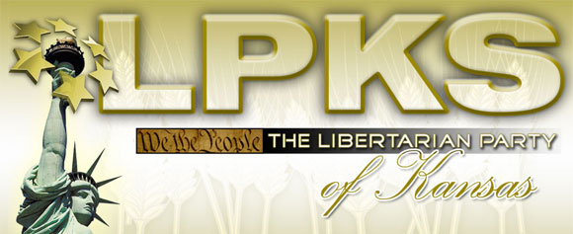
State Organization – Staggered Terms  Party Leadership Structure  Elected Positions  Chair: Kris Logan, chair@lpks.org  Vice Chair: Sharon DuBois, vice-chair@lpks.org  Treasurer: Ric Koehn, treasurer@lpks.org  Secretary: Mike Kerner, secretary@lpks.org  1st District Coordinator: Vacant  1st District Deputy Coordinator: Mike Wilson, dist1@lpks.org  2nd District Coordinator: Rachéll (Shelly) Rowand, dist2@lpks.org  2nd District Deputy Coordinator: Vacant, dist2@lpks.org  3rd District Coordinator: Jeff Caldwell, dist3@lpks.org  3rd District Deputy Coordinator: Brandon Caldwell, dist3@lpks.org  4th District Coordinator: Steven Rosile, dist4@lpks.org  4th District Deputy Coordinators: Maria Church, dist4@lpks.org  Website: http://www.lpks.org | 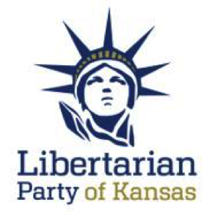

Office Space
No.

Paid Staff/Contractors
No.

At a Glance Statistics
Number of Libertarians | Approximately 15,463. This represents .87% of the registered voters (1,776,703). There has not been new numbers released by the Secretary of State since the last few reports.
Method of Membership Determination | Registered voters.
Partisan Registration? | Yes.
Ballot Access Status/Requirement | The LPKS has ballot access.  The access requirement is 1% of statewide race including president (the Secretary of State has ignored precedent and intent in this interpretation). This threshold was met 2016 this year over several races and will come up again in 2018.
Number of Candidates 2016/2018 | 14 / Chair Logan was not available for an update. 6 are listed on the affiliate website but only 1 is listed on the national website.
Estimated Budget | $6K yearly
Website / Facebook Current? | Website is current and attractive. Facebook pages likes are at 3,412. This would place it about 34th in the affiliate rankings which is up two since my last report.
Newsletter? | No.
Database? | Yes, NationBuilder.
BSM Members | 132. This places Kansas at 34th in the affiliate rankings which ranking remains unchanged since my last report and down 26% over a one-year period.

Governing Documents

PLATFORM:
On website (http://www.lpks.org/platform). Adopted April 26, 2014.

BYLAWS:
On website (http://www.lpks.org/party_bylaws). Adopted April 30, 2016.

CONSTITUTION:
On website (http://www.lpks.org/party_constitution). Adopted April 30, 2016.

Board Meetings
The Board has quarterly in-person meetings and monthly teleconferences.

State Convention
The 2017 Convention took place on April 21-23, 2017. I was not able to attend. The 2018 LPKS State Convention is slated to be held April 20-21 in Overland Park, Kansas which is the same time as the LNC meeting.

National Convention Preparation/Region Re-Formation

leadership:
I will be in touch with Chair Logan regarding the re-formation of Region 1 with Kansas.

delegates:
I will find out from Chair Logan if the 11 delegate slots were filled at their 2018 convention.

State Level Membership
There is no dues-paying structure. The interest level has stabilized and remains high with new prospects. A lot of new persons are attending the Ex-Comm meetings.

Sub-Affiliates
There are four congressional districts , each of which has executive committees. There are 105 counties in Kansas, which are unevenly divided between the districts. The 3rd District is very active , and there are about eight active county groups. They are working on developing the Libertarians of Northern Kansas (LNK pronounced L-Neck) which is the area that contains the capital city so it is important they are active there.

Elections

Current Election Cycle (2018)
Jeff Caldwell is seeking the nomination for Governor and former Chair Rob Hodgkinson for Secretary of State. Four other candidates are listed on the affiliate website but Chair Ryan was not available to discuss.

ELECTED LIBERTARIANS:
- Nick Schlossmacher (Mission City Council Ward 2)

PRIMARIES:
There is no Libertarian primary unless they obtain major party status, and at that point, it would be the Party’s choice to have an open or closed primary.

Ballot Access and Party Status
The LPKS has had access since 1992. The access requirement is 1% of statewide race including president (the Secretary of State has ignored precedent and intent in this interpretation). This threshold was met in 2016 over several races and will come up again in 2018.
In order to obtain major party status, the LPKS needs to obtain 5% in the gubernatorial election.

MAJOR/MINOR PARTY:
Major party status is achieved by obtaining 5% vote in gubernatorial race.

OTHER:
Nothing else found of note.

Activities
Chair Logan was not available for an update.

Finances & Fundraising
A fundraising campaign of “You Might be a Libertarian if…” is being started. Chair Logan was not available for an update.

Media Coverage
None at this time.

Other
Chair Logan was not available for an update.

What does the affiliate think National should be doing?
Chair Logan was not available due to family emergency.

Statement from the Chair
Chair Logan was not available due to family emergency.

Montana Libertarian Party
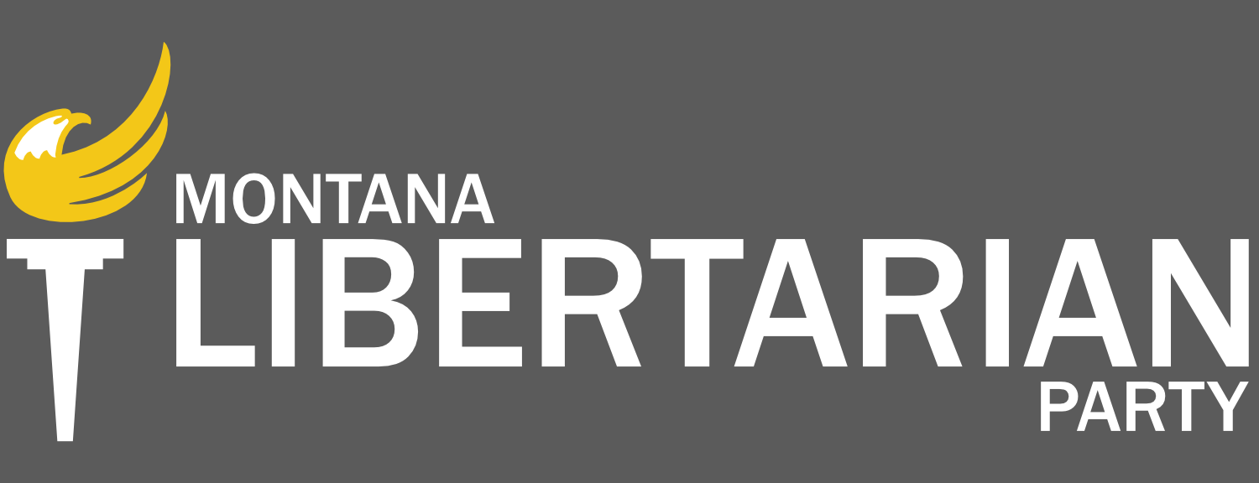
State Organization  Party Leadership Structure  Elected Positions  Chair: Francis Wendt, francis.wendt@mtlp.org  First Vice-Chair: Elinor Swanson, elinor.swanson@mtlp.org  Second Vice-Chair: Sid Daoud, sid.daoud@mtlp.org  Treasurer: Joe Leavengood, joe.leavengood@mtlp.org  Assistant Treasurer: Rick Breckenridge, joe.leavengood@mtlp.org  Secretary: Cindy Dyson, cindy.dyson@mtlp.org  Assistant Secretary: Conor Burns, conor.burns@mtlp.org  Website: http://www.mtlp.org (new website in development)  NOTE THAT THE REGIONAL CONFERENCE WAS HAD WITH FORMER CHAIR FUCCI JUST PRIOR TO HIS RESIGNATION. | 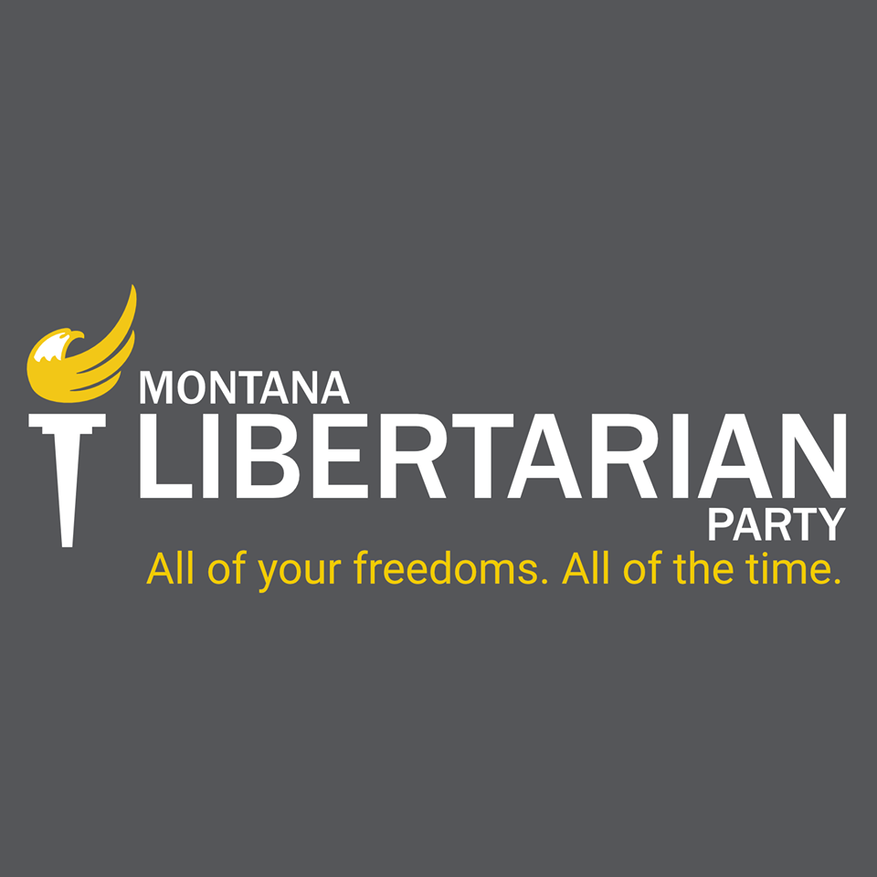

Office Space
No.

Paid Staff/Contractors
No.

At a Glance Statistics
Number of Libertarians | About 252.
Method of Membership Determination | National Membership BSM and sign-up. Dues have been functionally eliminated.
Partisan Registration? | No.
Ballot Access Status/Requirement | The vote test requirement averages out to be 2.8% which can be met by any statewide candidate in about seven races. In this cycle, it turned out to be 12,542 votes needed. Three statewide candidates (Rick Breckenridge-US House Representative, Roger Roots-Secretary of State, and Ted Dunlap-Governor) met this burden. They are sufficient candidates to meet this requirement in 2018.  Montana has mandatory open primaries.
Number of Candidates 2016/2018 | 10 / 21 which are all listed on the national website. The affiliate website needs to be updated from the 2017 candidates.
Estimated Budget | $900 with the rest being covered by in-kind contributions.
Website / Facebook Current? | Website is modern and current due to recent efforts. Facebook is presently at 2,381 likes and ranks 40th which is up one rank since my prior report.
Newsletter? | The affiliate is working on instituting an email or other regular electronic updates and is exploring MailChimp.
Database? | Yes through manual Excel Sheets. The affiliate is also one of the test cases for the CRM project.
BSM Members | 78. This places Montana at 41st in the affiliate rankings. This is down one rank since my last report and .06% down over a one-year period. Montana earned a per-capita Platform Committee seat.

Governing Documents

PLATFORM:
On website (https://www.mtlp.org/platform/). Same as National Party.

BYLAWS:
On website (https://www.mtlp.org/s/MTLP-Bylaws-as-Adopted-9-9-17.pdf). Amended March 6, 2018.

CONSTITUTION:
Not applicable.

Board Meetings
They are setting up regular meetings and have added me to the attendance notice list. They can modify Bylaws at meeting, and that is a current project.

State Convention
The 2017 Convention was on March 11, 2017, and I was in attendance. This was their first convention in about twenty years and by any metric was a success. About 50 enthusiastic members attended (including seasoned and new members). An additional convention was had on September 9, 2017 and new officers were elected. The 2018 convention is scheduled for May 19, 2018.

National Convention Preparation/Region Re-Formation

leadership:
I am speaking with new Chair Wendt about the re-formation of Region 1.

delegates:
Delegate selection will take place at their May convention. The affiliate has 7 slots and is expected to fill them all.

State Level Membership
The MTLP Bylaws provide for free memberships to those who certify in writing that they oppose the initiation of force to achieve social or political goals, dues are optional. There are about 250 state members.

Sub-Affiliates
Chapters are established/starting in multiple counties as the affiliate is in re-building mode, including Gallatin County (Libertarian Party of Gallatin Valley), Lake County (Lake County Libertarian Party), Missoula County (Missoula County Libertarian Party - organizing), and Ravalli County (Libertarian Party of Ravalli County – becoming inactive ). Yellowstone, Lincoln (organizing), and Cascade counties are currently organizing. Flathead Libertarians has an active monthly meeting with guest speakers

Elections

Current Election Cycle (2018)
Elinor Swanson has declared for the sole US House seat, and Rick Breckenridge has declared for the US Senate race.

ELECTED LIBERTARIANS:
- None.

PRIMARIES:
Montana has a mandatory open primary on June 5, 2018 but the affiliate does not need to participate as there are no contested nominations.

Ballot Access and Party Status
The vote test requirement averages out to be 2.8% which can be met by any statewide candidate in about seven races. In 2016 it was met by three statewide candidates (Rick Breckenridge-US House Representative, Roger Roots-Secretary of State, and Ted Dunlap-Governor).

MAJOR/MINOR PARTY:
Montana does not have that distinction but only qualified political parties.

OTHER:
The Montana Green Party has regained its ballot access.

Activities
Nothing specifically scheduled, and the affiliate just went through a leadership change. The Flathead affiliate is active with events such as a presentation on jury nullification: https://www.lp.org/montana-libertarians-promote-sweet-justice-event-jury-nullification/

Finances & Fundraising
The affiliate is still in re-organization mode and is working on a fundraising base.

Media Coverage
Significant media coverage includes:
http://www.krtv.com/story/37551545/sen-tester-files-as-candidate-field-may-be-complete-for-mts-top-2018-race
http://www.ktvh.com/2018/02/billings-lawyer-enters-montana-u-s-house-race-as-libertarian-candidate
https://www.greatfallstribune.com/story/news/2018/03/05/libertarian-says-hell-enter-montana-u-s-senate-race/396186002/

Other
Nothing at this time.

What does the affiliate think National should be doing?
The LNC needs to be able to guide affiliates through financial reporting requirements with the FEC.

Statement from the Chair

The candidate filing period in Montana ended on March 12th, and I am happy to report that the Montana Libertarian Party will be fielding more candidates than it has in 35 years! Twenty-One Libertarians are running for office this year in Montana, including for all three statewide and federal races. Eighteen Libertarians are running for state legislature with ten in two-way races (four vs. Democrats, six vs. Republicans).
On March 6th, the Montana Libertarian Party Executive Board completed its work on the state party bylaws. This project was undertaken at the request of State Central Committee during the Officers Convention in September 2017. The Board is pleased with the results and believe the document is a significant improvement over the prior version.
The MTLP’s State Delegate convention will take place on May 19th in Butte, MT. Business will include: Electing delegates and alternates to the national convention, amending or adopting the MTLP platform, and electing a representative to the 2020 National Platform Committee. Additional details, including speakers and ticket prices are still to be announced.
~Michael Fucci, Former Chair

Libertarian Party of Utah
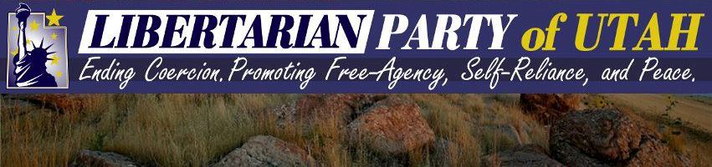
State Organization  Party Leadership Structure (2-year terms odd-numbered years)  Elected Positions  Chair: Joseph Buchman, chair@libertarianutah.org  Vice Chair: Barry Short  Treasurer: Shawn Curtis  Secretary: Justin Bake  Website: http://www.libertarianutah.org | 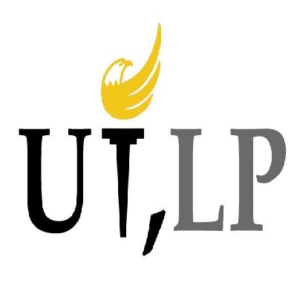

Office Space
They do not have physical office space.

Paid Staff/Contractors
Scott Linsley is a volunteer who has been acting as Executive/Communications Director but is not paid.

At a Glance Statistics
Number of Libertarians | 14,080. This represents .9% of the registered voters (1,557,550). This is up .02% since my last report.
Method of Membership Determination | The LPUT Constitution defines membership as including dues-payers and pledgers to its Statement of Principles, but does not require partisan registration.
Partisan Registration? | Yes.
Ballot Access Status/Requirement | The vote test requirement is 2% of any statewide race. This was met in 2016 by gubernatorial candidate Brian Kamerath (3.08%) and Attorney General candidate Andrew McCullough (6.73%). This must be met every four years. This will not need to be met again until 2020.
Number of Candidates 2016/2018 | 11 / 17 (8 are listed on national site)
Estimated Budget | $10-12K per year
Website / Facebook Current? | Website is modern. Facebook page likes are at 2,814. This would place Utah 40th in the affiliate rankings, unchanged since my last report.
Newsletter? | They are experimenting with sending out postcards.
Database? | They purchased the state database and have that archived into a database.
BSM Members | 100. This places Utah at 37th in the affiliate rankings which is down two rankings since my last report and is down 46% over a one-year period.

Governing Documents

PLATFORM:
On website (http://www.libertarianutah.org/our-party/platform/). No date listed. Changes were made at 2018 convention.

BYLAWS:
On website (http://www.libertarianutah.org/utlp-bylaws/). No date listed. Changes were made at 2018 convention.

CONSTITUTION:
On website (http://www.libertarianutah.org/constitution/). Adopted March 31, 2012.

Board Meetings
There are monthly open meetings. Chair Buchman is working on organizing a Central Committee to meet quarterly.

State Convention
The 2018 convention took place April 14, 2018. I was in attendance.

National Convention Preparation/Region Re-Formation

leadership:
I am speaking with Chair Buchman about regional re-formation.

delegates:
The affiliate’s 8 delegate slots were filled at the 2018 convention.

State Level Membership
Yes. They have two operational classes of membership: pledged (to their Statement of Principles) dues-payers; and pledgers only. Only pledged dues-payers are eligible to vote in internal Party business at their convention but pledged members can vote on candidate selection. Chair Buchman will let me know membership numbers.

Sub-Affiliates
There are a few active groups and several County Chairs (Davis, Utah, and Weber). Chair Buchman also has plans for a Southern Utah multi-county group., and central coalition of four counties (Libertarians of Castle Country) has been formed and is being spearheaded by Barry Hess.

Elections

Current Election Cycle (2018)
These candidates were nominated at convention:
US Senate: Craig R. Bowden
US House of Representatives: Jeffrey Whipple (District 2)
Utah State Senate: Kevin L. Bryan (District 18)
Utah House of Representatives:
- District 16: Brent Zimmerman
- District 19: Joe Speciale
- District 22: Amber Christiansen Beltran
- District 26: Jonathan Greene
- District 27: Joseph Geddes Buchman
- District 35: Chelsea Travis
- District 43: Shawn Curtis
- District 46: Lee Anne Walker
- District 68: Denyse Housley Cox
- District 72: Barry Evan Short
- District 74: Daniel Holloway
- District 75: Michael A. Gardner
Tooele County Commissioner A: Justin Bake
Utah County Attorney: Andrew McCullough

ELECTED LIBERTARIANS:
- Apollo Pazell (Copperton Metro Township – won seat November 2017)

PRIMARIES:
The LPUT does not participate in the primary system although they could opt in, but rather they nominate through convention, and primaries only become relevant when two candidates get 35% of the vote in a party endorsements meeting.

Ballot Access and Party Status
The vote test requirement is 2% of any statewide race. This was met by gubernatorial candidate Brian Kamerath (3.08%) and Attorney General candidate Andrew McCullough (6.73%). This will not need to be met again until 2020.

MAJOR/MINOR PARTY:
Utah does not have these distinctions but rather has registered political parties and qualified political parties.

OTHER:
This year will see the LPUT facing not only candidates from United Utah and the Independent American Party, but also the Greens (who obtained ballot access as a party last year from signature gathering), the Constitution Party, and some unaffiliated candidates like Sean Whalen.

Activities
There was a 2A rally on the morning of the convention also attended by Chair Sarwark.

Finances & Fundraising
In the Utah state tax laws, taxpayers are offered the opportunity to have a part of their taxes “refunded” in the form of a $2 donation to a political party of their choice. The LPUT receives up to $10K a year through this benefit, but the old parties receive a huge windfall. This public funding works very much like the Federal system in that selecting this option does not increase or decrease the amount of taxes owed. Chair Buchman mentioned that in the past they advertised that they would refund this money to anyone who came by their office and asked and that this earned some media attention. For 2017 the affiliate received $5,416.00. The 2018 numbers are not yet known.
The affiliate is always trying out new and innovative fundraising events that at least garner attention if not successful at the original goal.

Media Coverage
Media coverage includes:
https://stgeorgeutah.com/news/archive/2018/04/14/jmr-libertarians-lead-rally-in-cedar-city-in-support-of-second-amendment-gun-rights/#.WtfgwtPwbBJ

Other
Utah still has straight ticket voting which failed in a repeal effort in 2016. A special session will likely be called in 2018 to consider repeal of the .05 BAC for DUI. The LPUT will be cooperating and assisting in the efforts by the Utah Patients Coalition to put medical cannabis legislation on the ballot via initiative. Watch for an announcement of dates for signature gathering.

What does the affiliate think National should be doing?
A standard procedure for rating and vetting candidates along with an updated best practices candidate handbook would be very useful.

Statement from the Chair
Requested.

Libertarian Party of Washington State
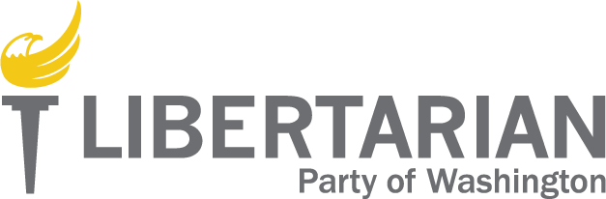

State Organization

Party Leadership Structure – Staggered Terms

Elected Positions
Chair: Randy McGlenn, chair@lpwa.org.
Vice Chair: Tiffany Diaz De Leon, ladyliberty@lpwa.org
Treasurer: Charles Schaefer, charlesschaefer@lpwa.org
Secretary: Daniel Hodun, danielhodun@lpwa.org

The LPWA also has eight Regional Directors (Jacob Lamont, Bryan Simonson, Bill Johnson, Chris Rholoff, Josh Smith, Sonny Patterson, Rory Leckland, and Mike Leimon.

Website: www.lpwa.org - which is undergoing re-structuring due to security and speed issues and so is not up-to-date.

Office Space
No.

Paid Staff/Contractors
No.

At a Glance Statistics
Number of Libertarians | 507 BSM members, and approximately 300 state Party dues-paying members.
Method of Membership Determination | National Membership BSM and Party Bylaws.
Partisan Registration? | No.
Ballot Access Status/Requirement | 1,000 signatures. Will become ballot-qualified party if 5% in presidential vote is achieved.
Number of Candidates 2016/2018 | 13 /16 . 5 listed on national site.
Estimated Budget | $13K yearly
Website / Facebook Current? | The website is undergoing re-structuring due to security and speed issues and so is not up-to-date.. Page likes are at 9,730. This would place Washington about 12th in the affiliate rankings which is an increase of one rank since my last report.
Newsletter? | Yes this has been started successfully.
Database? | Yes, CiviCRM but they are exploring other issues.
BSM Members | 507. This places Washington at 10th in the affiliate rankings which is up one rank since my last report and down 10% over a one-year period. The affiliate is organizing a Retention Committee.

Governing Documents

PLATFORM:
None. Has an “Issues” section on website.”

CONSTITUTION & BYLAWS:
On website (https://lpwa.org/activist-resources/constitution-and-bylaws/). Adopted July 8, 2017.

Board Meetings
The LPWA meets quarterly in person and monthly via teleconference. I have asked to be on this distribution list.

State Convention
The 2018 Convention took place on February 16-18,2018, and I was in attendance functioning as national membership recruiter.

National Convention Preparation/Region Re-Formation

leadership:
Party leadership is now on two-year terms and will not change at the 2018 Convention. I am speaking with Chair McGlenn about Region 1 re-formation.

delegates:
LPWA has 35 delegate slots and has filled 22 of them with the remainder expected to be filled. They do not seat out-of-state delegates.

State Level Membership
Yes, as defined by the LPWA Bylaws. They have about 300 dues-paying members.

Sub-Affiliates

The LPWA has eight regions (with regional directors mentioned on site) and about 12-15 county groups, but none of them are recognized and there was a dispute with the county parties over a provision that was added to the governing documents that county affiliates or officers could not endorse non-Libertarian candidates. Only King County is officially recognized. | 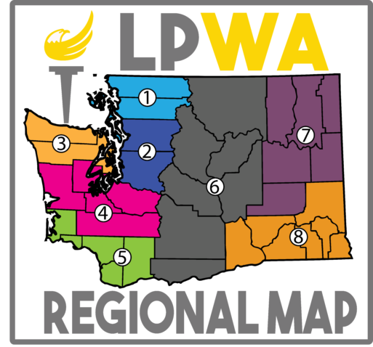

Elections

Current Election Cycle (2018)
From the national party site:
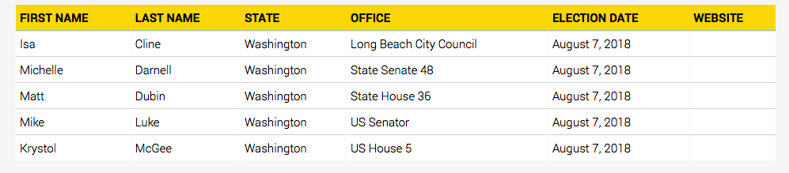
For 2018 they have likely candidates for all of the Federal races and are working on the State races though some important races may be missed. Anthony Welti’s race for Insurance Commissioner will be high profile. Matt Dubin’s State House race has already raised over $20,000.

ELECTED LIBERTARIANS:
- Barbara Brenner (Whatcom County Council District 3 Position B)
- Robb Gibbs (Kelso School Director Position 3)
- Don Myers (Moses Lake City Council Member #3)
- Joshua Penner (Orting City Council Position 5 and Pierce County Charter Review Committee, District 1, Position 3)
- Joseph Cimaomo (Covington City Council Position 4 ELECTED 2017)
- Kevin “Isa” Cline (Long Beach City Council Position 4 ELECTED 2017)

PRIMARIES:
Washington is a “top-two” state in which only two candidates make it out of the primaries onto the general ballot.

Ballot Access and Party Status
Unless LPWA becomes a major party, they are required to obtain 1,000 signatures in order to petition onto the ballot.
As Richard Winger noted, Washington should consider lobbying for a lower threshold to become ballot qualified which is presently 5% in the presidential race. The median vote test of the 50 states is only 2%.

MAJOR/MINOR PARTY:
In order to obtain qualified party status and have automatic ballot access (as well as other benefits including higher placement on ballots), the LPWA must obtain 5% in the Presidential race. The Washington Secretary of State does not appear to use the distinction of major and minor party status though that is the common parlance. Ballot status was denied in 2016 by the Secretary of State in a shocking break with precedent by including write-in votes in the total which lowered Johnson’s vote result to under 5%; however, the write-ins were invalid votes.

Activities

King County is the most active group and has regular events. I recommended that the affiliate may wish to try Meet-Up in order to attract more attendance.  Thurston County is also becoming very active but focusing on activism events instead of meetings. | 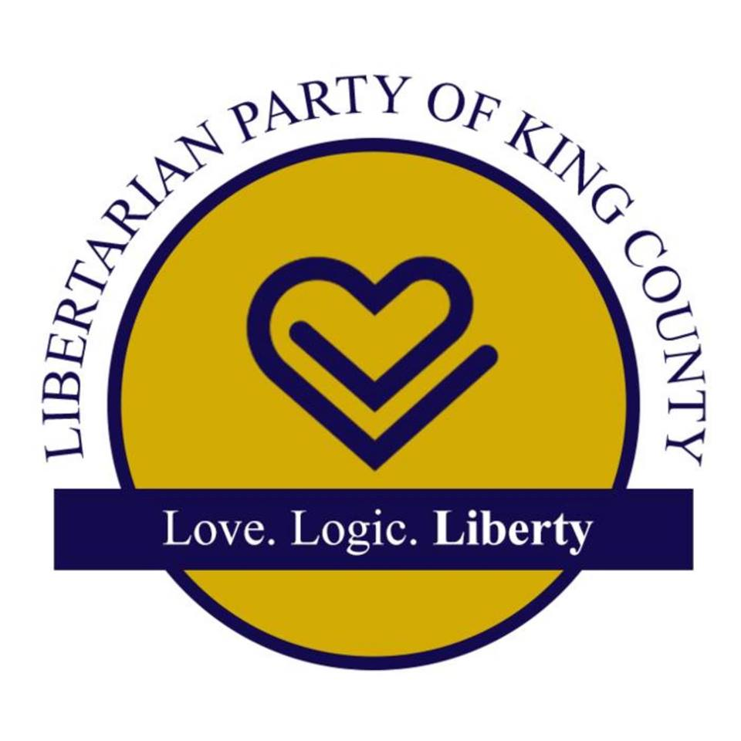
The Madison Jamboree is planned for possibly August 2018.
Jacob Lamont has also been working on opposing post-Parkland gun controls measures.

Finances & Fundraising
The LPWA’s primary source of funding is membership dues and voluntary donations. Chair McGlenn has a capital growth plan of 10%.

Media Coverage
Significant media coverage included:
http://www.tri-cityherald.com/news/local/article206330769.html

Other
The LPWA does not have any specific issues they are focusing on as a party, but housing has become a critical issue for Kitsap County with a lot of moving pieces and a growing homelessness problem. Post-Parkland gun control issues are now also an issue. The pay-per-mile gas tax (fee) appears to have been defeated.

What does the affiliate think National should be doing?
Continue with our program of candidate support and development.

Statement from the Chair
Requested.

Wyoming Libertarian Party
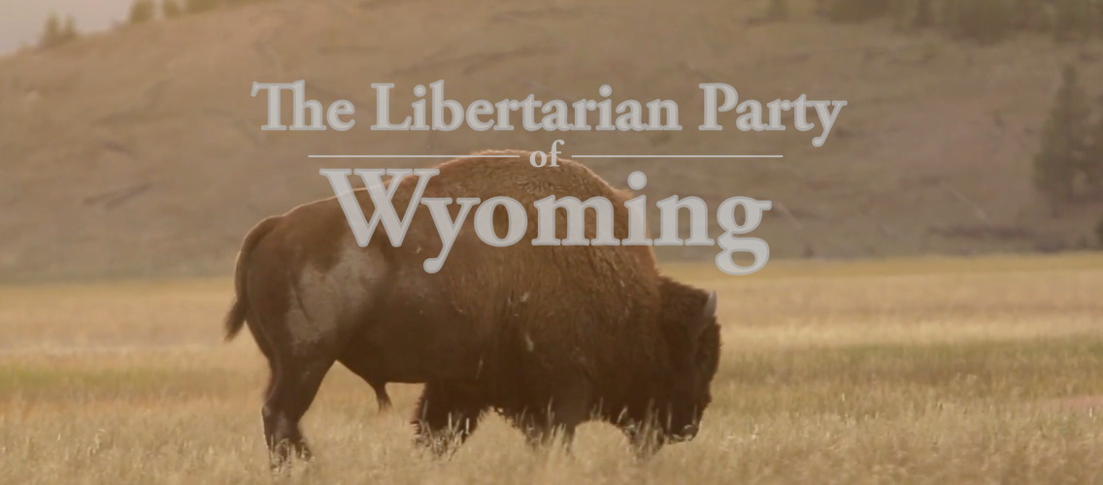
State Organization  Party Leadership Structure  Elected Positions  Chair: Dee Cozzens, RCozzens@aol.com  Vice Chair/Treasurer: Kit Carson, cspoa@aol.com  Secretary: Tammy Porambo, touchdowndavis@yahoo.com  Executive Director: Joe Porambo, papajoe192@yahoo.com  Website: http://wyolibertarianparty.com/ (see below) | 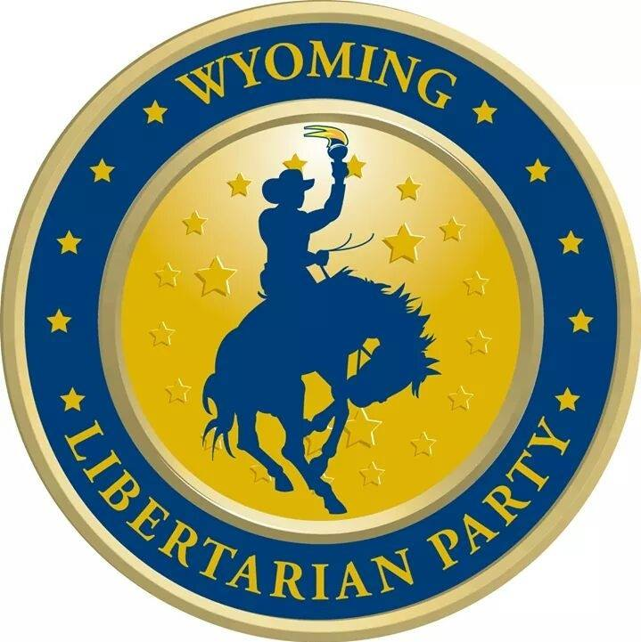

Office Space
No.

Paid Staff/Contractors
No.

At a Glance Statistics
Number of Libertarians | 2,411 registered voters representing .91% of the voters (262,406) and is up .01% since my last report.
Method of Membership Determination | Dues-paying registered voters. These number about 20.
Partisan Registration? | Yes.
Ballot Access Status/Requirement | The WYLP has ballot access and earned major party status in 2014 when Kit Carson won over 10% in the secretary of state race.  The access requirement is 2% of statewide race. In presidential years this test is limited to just US House. In mid-term years, three offices count towards this test: US House, governor, and secretary of state. This was met by US House Representative candidate Lawrence Struempf (3.6%).  The affiliate expects to easily meet the threshold this year as well.
Number of Candidates 2016/2018 | 4 / 5 (anticipated) 2 are listed on national site.
Estimated Budget | None at this time. There were already some funds in the account that they are using to rebuild.
Website / Facebook Current? | Andy Burns has created a new website for the affiliate at wy.lp.org but they have some concerns about privacy and security and are exploring some other options. After that exploration they will make a decision—this has been pending for several years. Facebook has been a rocky experience with trying to get control of two prior pages for the affiliate, and a third one just started. I advised them to make every attempt to have these pages merged as it is difficult to get traction. It does not appear that they have settled upon which page they will be using, and this is an issue that needs to be addressed.
Newsletter? | No.
Database? | No.
BSM Members | 37. This places Wyoming at 48th in the affiliate rankings which is up two rankings since my last report and flat over a one-year period.

Board Meetings
The Board meets regularly via conference call.

State Convention
I attend the 2017 Convention and Board elections. Their 2018 nominating convention was March 31, 2018.

National Convention Preparation/Region

leadership:
I am speaking with Chair Cozzens about Region 1 re-formation.

delegates:
The affiliate expects to fill its 3 delegate slots.

State Level Membership
The WYLP Bylaws do provide for dues-paying state level membership. They presently only have about 20 dues-paying members. The Bylaws are in a period of review and revision.

Sub-Affiliates
There are 23 counties in Wyoming but the affiliate is having difficulty starting active county groups. One group has successfully started in Natrona County.

Elections

Current Election Cycle (2018)
From the national site:
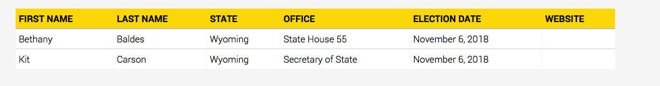
Larry Streumpf is likely to run for Governor with Richard Brubaker to run for US House.

ELECTED LIBERTARIANS:
- None.

PRIMARIES:
In Wyoming, parties that receive 10% in a qualifying race receive their own primary while other qualified parties nominate by convention. This threshold was met in 2014 for Secretary of State, but was not met in 2016 so the WYLP will be nominating by convention, which is more economical to the taxpayers and didn’t really give the Party any advantage at all.

Ballot Access and Party Status
The vote test requirement this race is 2% in a US House race which was met in 2016 by US House of Representatives candidate Lawrence Struempf (3.6%). The affiliate expects to easily hit that threshold in 2018 with Kit Carson’s Secretary of State race.
The vote test is limited in presidential years to just US House which must be achieved in order to remain on the ballot. If 10% is achieved, primary status would be retained, otherwise, nominations by convention would resume. In mid-term years, three offices count: US House, Governor, and Secretary of State.

MAJOR/MINOR PARTY:
The Wyoming Secretary of State lists the WYLP as a major political party but this will change as the Party did not obtain 10% for US House, Secretary of State, or Governor, which is the required threshold.

Activities
There is nothing currently planned.

Finances & Fundraising
Finances are virtually non-existent, and the WYLP is planning on ways to attract dues-paying members. The affiliate is struggling to come back from near-extinction but has a dedicated core and motivated Executive Director.

Media Coverage
None.

Other
The issues that are of unique concern to the WYLP are common core and public lands with the catch-phrase “public lands in public hands” being popular.

What does the affiliate think National should be doing?
The LNC needs to continue on its program of candidate and affiliate support and be willing to help rebuild struggling affiliates. Apollo Pazell has been a big help to them.

Statement from the Chair

Requested.

The AKLP Bylaws states that a personal shall become a member of the ALP when the person has become a registered Libertarian voter in the State of Alaska or submits a membership application to the secretary, and pays an annual fee as enumerated in the bylaws.
Percentage of active registered voters. The AZLP Constitution defines 3 classes of membership: registered Libertarians, county precinct committeemen, and state committeemen that are all defined statutorily. Only the committeemen have voting rights at the state convention.
The LPUT Constitution defines membership differently as including dues-payers and pledgers but not requiring partisan Libertarian registration.
The WYLP Bylaws provides for three classes of voting membership: statutory committeemen, partisan Libertarian candidate in the past two years, or dues-paying registered voters. This membership was only a handful at the time of this report.
The LPWA has about 385 dues-paying state party members.
A recognized political party in Alaska is an organized group of voters whose candidate for governor received at least 3% of the total votes cast in the preceding general election or whose number of registered voters is equal to at least 3% of the total votes cast for governor. In non-gubernatorial years, the US Senate (and then the US House of Representatives) race is used.
From Richard Winger: A blanket primary puts all candidates on the same primary ballot. Then the top vote-getter from each party goes to the November ballot. Washington state invented the blanket primary in 1934, and used it until it was declared unconstitutional in 2002. Washington state voters liked the blanket primary. After it was taken away from them by the courts, that set up a bad situation in which the top-two got a foothold. Washington voters passed the top-two initiative in 2004, because they resented that they had lost their blanket primary. California had a blanket primary in 1998 and 2000. California voters had passed Prop. 198 for a blanket primary in 1996. It passed easily. Unlike Washington State's blanket primary, the California blanket primary did not include independent candidates. They did not participate in the blanket primary and petitioned for a place on the November ballot. The California Dem, Rep, Libt and Peace & Freedom Parties filed a lawsuit in early 1997 to fight the blanket primary. We lost in US District Court and in the 9th circuit. But we won in the US Supreme Court. The decision, Calif. Dem Party v Jones, was 7-2. Scalia wrote it. He said the freedom of association part of the First Amendment protects political parties from having to let members of other parties help determine their nominees. His decision came out in June 2000. So California switched starting in 2002 to a semi-closed primary. Although we were very happy with this decision at the time, in retrospect it has done more harm than good. Because of that decision, the top-two movement began. After Washington state passed the initiative for top-two in 2004, the US District Court struck it down, and the 9th circuit agreed. But then in March 2008, in a decision by Clarence Thomas, the US Supreme Court said that the top-two primary was not unconstitutional on its face, at least as to freedom of association. So then California top-two people saw their chance and got the California legislature to put it on the ballot in June 2010. That US Supreme Court decision of 2008 was called Washington State Grange v Washington State Republican Party. Meanwhile, Alaska had a blanket primary, which survived, because the parties in Alaska liked it. The law permits a blanket primary if the parties agree to it. In Alaska, the Libertarian, Green, Alaskan Independence, and Democratic Parties all liked it. But the Republican Party doesn't like it. So Alaska has two primary ballots. One has the candidates of the Democratic Party and all the qualified minor parties. The other ballot just has Republican candidates. The Green Party is no longer qualified in Alaska, so currently the blanket primary ballot just has Libertarians, Democrats, and Alaskan Independence Party members. The Alaska LP likes the blanket primary because (a) there are virtually never two Libertarians running against each other for a single nomination so it really doesn't change anything for us; (b) it is easier to get people to register Libertarian because they are still free to vote for Democrats in the blanket primary. We need lots of registrations in Alaska to remain on the ballot, because we can't count on meeting the alternate vote test. Although we did pass the vote test in both 2014 and 2016.
Per Ballot Access News, the last time a minor party or independent candidate won a Constitutional ballot access lawsuit in Alaska was in 2016 (Hall v. Bennett: 3% petition in special elections for U.S. House is too difficult).
The AZLP board is elected every 2 years and was elected in 2017. Due to resignations during 2017 the board filled positions according to its Bylaws. The members that were placed by the board were only temporary and the bylaws required that they hold an election to fill those positions at the 2018 convention during which elections were held for every position expect for Treasurer and assistant Treasurer. The current board’s term will expire at the 2019 convention at which time a board will be elected again to two-year terms. our next convention to be help Jan 2019.
The AZLP Constitution defines 3 classes of membership: registered Libertarians, county precinct committeemen, and state committeemen that are all defined statutorily. Only the committeemen have voting rights at the state convention.
A semi-closed primary is one in which registered Democrats must choose a Democratic primary ballot, ditto for Republican, but independents can choose whichever primary ballot they want. In an open primary, each party has its own primary and its own nominees, but on primary day any voter can choose any party's primary ballot. Generally open primary states' voter registration forms don't ask about political party choice. The question is missing. There are 19 open primary states. Most southern states are open primary states.
The WYLP Bylaws provide for three classes of voting membership: statutory committeemen, partisan Libertarian candidate in the past two years, or dues-paying registered voters. This number is just a handful.

