BOARD OF DIRECTORS MEETING MINUTES

3/19/2025 7:30 PM

EXECUTIVE BOARD COMMUNICATIONS DIVISION
State Chair: Jim Humay Director: Vacant
Vice Chair: Matt Piron Deputy Director: Vacant
Secretary: Ken Mattes Social Media: Ray Walden IV
Treasurer: Russ Clark ABSENT Newsletter: Vacant
Executive Director: Justin Tucker Public Relations: Vacant
Broadcasting: Vacant
POLITICAL DIVISION
Director: Jake Leonard ABSENT FIELD OPERATIONS DIVISION
Deputy Director Cook/DuPage: Jim Humay Director: Blake Hanson ABSENT
Candidate Recruitment: Vacant Deputy Director: Lorraine DeNardis-Albert A
Campaigns: Jon King ABSENT Campus Outreach: Vacant
Legislative: Cody Graves ABSENT Volunteer: Lorraine DeNardis-Albert ABSEN
Ballot Access: Vacant Membership: Vacant
Precincts: Vacant Activism: Vacant
Chapter Development: Paul DiMasi
IT DIVISON Deputy Chapter Development: Vacant
Director: Bob Blair-Smith
Deputy Director: Vacant Convention Committee: Ken Mattes Operations: Kelly Liebmann ABSENT
CRM Training: Gabe Carrier ABSENT
Website: Jarrod Weishaar

STATE CENTRAL COMMITTEE
1st District: Matt Cunningham ABSENT 10th District: Vacant
2nd District: Vacant 11th District: Vacant
3rd District: Danny Lewis 12th District: Vacant
4th District: Ray Walden IV 13th District: Vacant
5th District: Vacant 14th District: Vacant
6th District: Bob Blair-Smith 15th District: Jake Leonard ABSENT
7th District: Jim Humay 16th District: Vacant
8th District: Julie Fox 17th District: Dan Groeling ABSENT
9th District: Adam Balling

OTHER PARTICIPANTS: Andrew Kopinski
AGENDA
MEETING CALL TO ORDER 7:40 PM

PUBLIC COMMENT Balling, Lewis.

APPROVAL OF AGENDA
MOTION (Mattes) to amend proposed agenda to add two items SECONDED and PASSED W/O.

APPROVAL OF PREVIOUS MINUTES N/A

OFFICER BRIEFS

Chair:
Conversation with Brad Fritts re. HB2587 which is still in Rules Committee, Homeschooling act HB 2827 passed Education Committee with amendments despite 40,000 witness slips against it, interview with Jim Talamonti re. Real ID, conversation with LNC Vice Chair Paul Darr, attended McHenry County meeting and Chicago North Side Irish parade.

Vice Chair:
Call for activism against homeschooling act and for more boots on the ground, five year anniversary of COVID lockdowns with resolution to be discussed.

Secretary:
McHenry County meeting and parade, traveled to LA and Texas and met Louis Rossman and Eron Wolf from FUTO Foundation (futo.org), produced a small batch of business cards, Convention Committee meetings 30 minutes before each Board meeting.

Treasurer: N/A

Executive Director:
Fellow Libertarians - Thank you to all our donors, both new and recurring. If you are not a recurring monthly LP Illinois donor, please visit www.lpillinois.org and click DONATE. 2026 elections are just under 2 years away, and the statewide petition drive must be considered. I did not get as many $25 donations as I hoped, so please dig into your couch cushions or your tax return and contribute. A small recurring donation goes a long way.

If you are not a Precinct Committeeperson, please consider becoming one. Visit https://lpillinois.org/precinct-committeemen/ to learn more. We have several openings on the SCC that can only be filled if you are a PC. If you live in Cook County, please consider running as a Township Committeeperson. Petitioning starts in the fall.

The envelopes have arrived however, they were another customer's order. Awaiting the new order to arrive. I submitted a couple templates to the EC for approval to mail to Illinois Libertarians. Thanks to Jarrod for making http://www.lpillinois.org/donate a functional URL again, which now will redirect to the current URL.

The LPC marched in the NW Side Irish Parade. Thanks to those who marched with us!

I hope to send an e-mail appeal tomorrow to capitalize on the first day of spring. I sent a draft to the EC for approval.

I was invited to join Tom Palmer from the Atlas Network and others for dinner on a Sunday evening and look forward to representing the LP Illinois at that dinner.

The LPC will be hosting Jen Guzman from Rise Chicago at the April 1st meeting. Rise Chicago works to improve education and the economy in Chicago. Please try to make it if you can.

The LPC also plans to host a social event in early April in Berwyn on a Saturday. Keep out for details and also please consider joining us.

To train petitioners ahead of the fall petition drive, the LPC will be out at farmers markets starting in the spring with the Chicago mayoral recall petition calling for a referendum. If you want to learn how to petition or hone your petitioning skills, please join us in the spring.

My all-time haul is $33,108 give or take.

I got an A or A- (depending on how my last quiz went) in my DePaul University Paralegal Studies course. I should have the certificate in a matter of weeks. Know any lawyers? Thanks to the BOD for the accommodation and would not be opposed to returning to the third Tuesday schedule if others are also not opposed.

DIRECTOR BRIEFS

Communications Division Report:
Ray Walden IV summarized social media posts, still having difficulty with Facebook and YouTube account consolidation. Discussion (Humay) on upgrading to a verified X page and (Tucker) brainstorming the Facebook access issue as a group including Vice Chair Piron.

Field Operations Division Report: N/A

IT Division Report:
Previous projects / activities-

- Website Revisions to lpillinois.org
- National IT training calls on web form for Political demographics
- Phone Service (217) 864-8337 greeting re-provisioning

February Activities:

- Enhanced Donation page access / navigation (Web Director)
- Reviewed cloud Document management options for Winter 2025 (March) migration
- Requested recommendations from users for next doc platform

Training / Train the Trainer
- No new training requests or events since previous Report

Expenses:
Amazon Web Services
February $74.81

Grasshopper Virtual Phone. (paid Annually each May)
1 new phone call for Chair

IT Requests
Request/request by | Platform | Owner | Status | Date of resolution
- Various, ExCOM | lpillinois.org | Web | Updated /donate page links and re-direction on | 3/7
- SCC | Lpmail, Civi | IT Ops | Re-set, onboarding, & communications on CRM NDA | 2/5
- Field Ops | lpmail | IT Ops | Re-sets & communication | 2/17

New and ongoing Projects:
- Document Management Platform selection and migration:
Vet and compare next Document Management System platform options for LP of IL as AWS WorkDocs is going away in March
- Box
- DropBox
- OneHub
- Sync
- Hetzner IaaS

Next steps:
- Box recommendation motion:
Submitted to Secretary March 16th
- Migration / admin structure for 5-7 users to be built soon after

- IL Voter Database on hold

Political Division Report: N/A

SCC/CHAPTER REPORTS: Please submit any chapter reports to Secretary@LPIllinois.org

LNC REGIONAL/NATIONAL REPORTS:
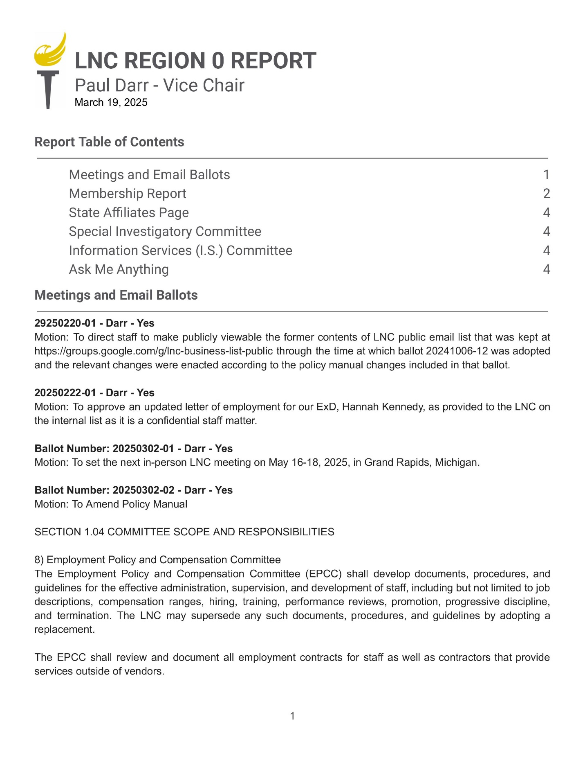
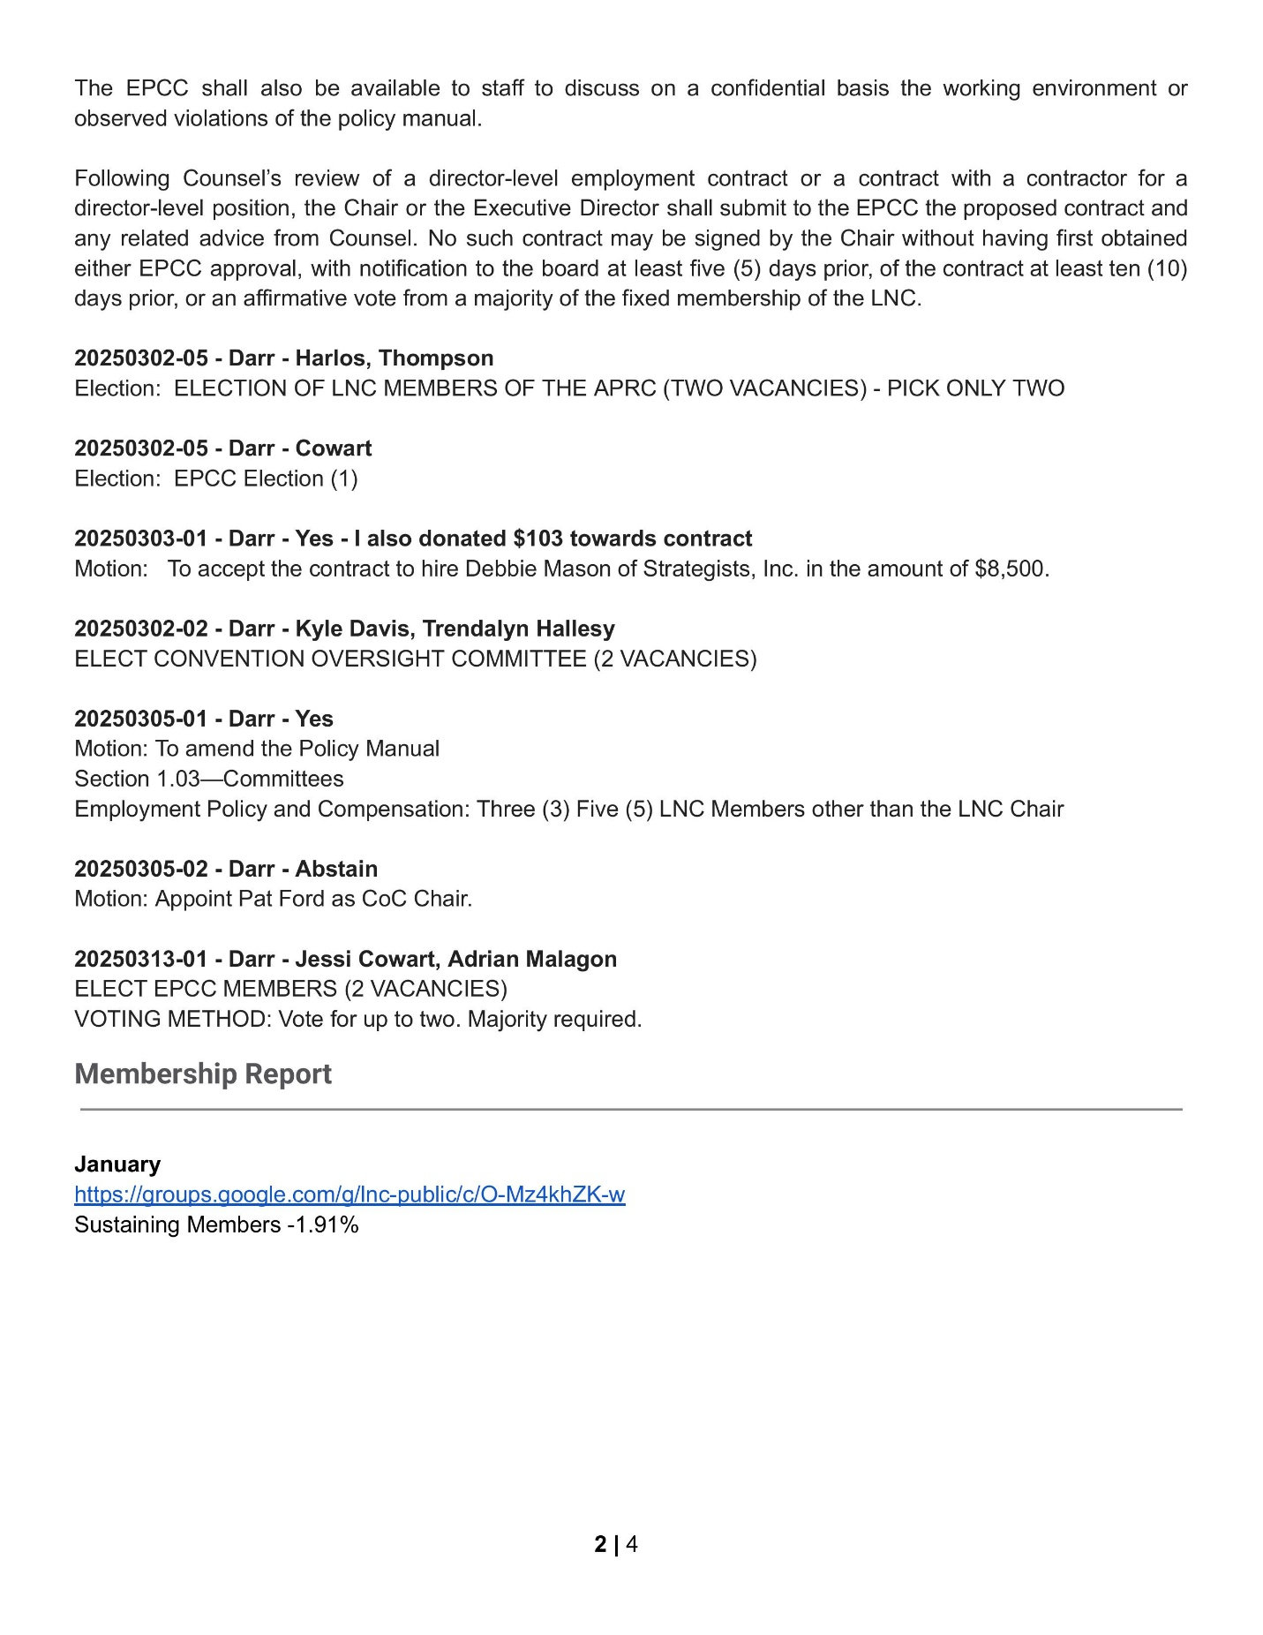
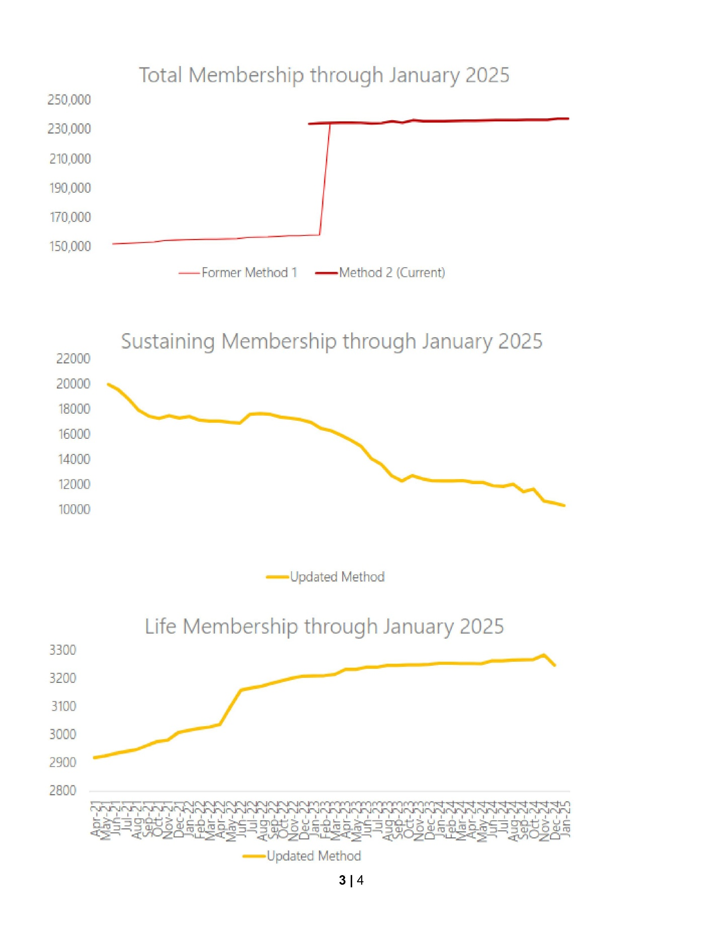
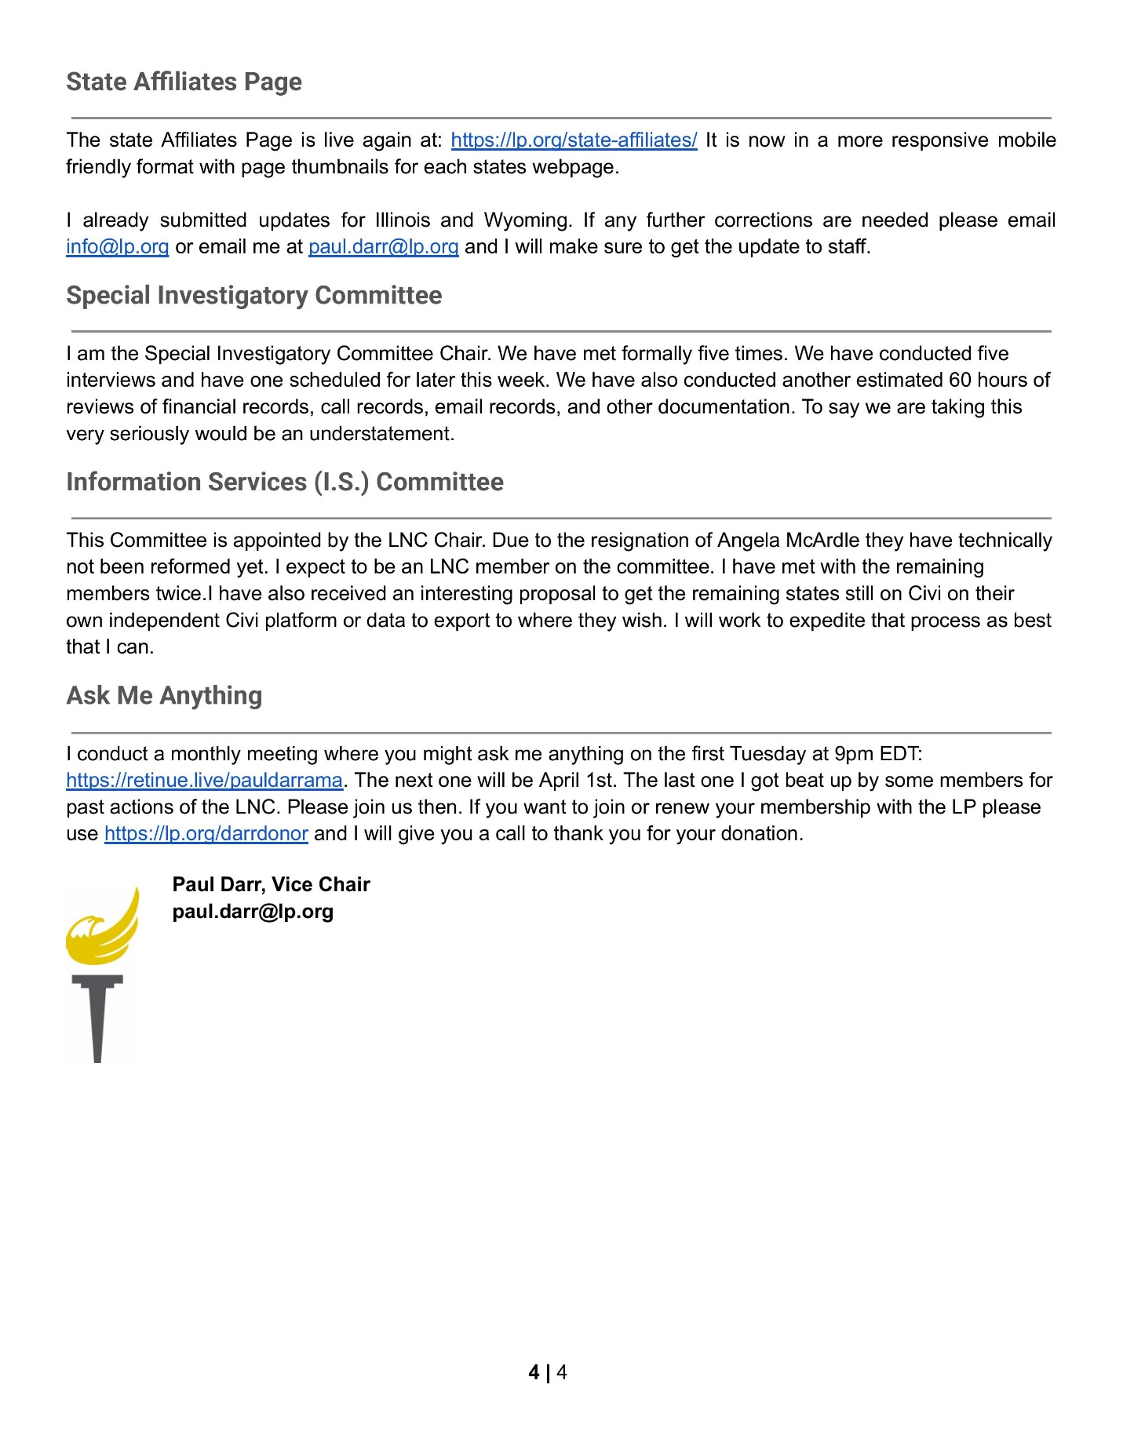

OLD BUSINESS: N/A

NEW BUSINESS: MOTION 1 (DiMasi) to return $600 to the Lake County chapter if we can re-establish that chapter by April 2027. MOTION 1 SECONDED. DiMasi spoke to his motion. MOTION 1 PASSED W/O.

MOTION 2 (Blair-Smith II) to adopt Box.com as the LP of Illinois' secure document management / sharing collaboration platform. MOTION 2 SECONDED. Blair-Smith II spoke to his motion. MOTION 2 PASSED W/O.

Chair Humay brought forward a statement for media release to be approved by the Executive Committee pending any edits or suggestions:

The Libertarian Party of Illinois strongly condemns the recent passage of the continuing resolution by the US Congress, yet another example of reckless fiscal policy that burdens Illinois taxpayers and future generations with unsustainable debt. This stopgap measure, pushed through by the entrenched two-party system, fails to address the root causes of government overspending and instead kicks the can down the road, perpetuating a cycle of inefficiency and waste.
As advocates for individual liberty and limited government, we believe that elected officials have a responsibility to prioritize fiscal discipline over political expediency. The continuing resolution does nothing to curb the bloated bureaucracy or reduce the scope of government intervention in our lives. Instead, it maintains the status quo, funding programs and policies that infringe upon personal freedoms and stifle economic opportunity—all while adding to the staggering national debt, which now exceeds $35 trillion.
Illinoisans deserve better than this. Our state already suffers under some of the highest tax rates and most oppressive regulations in the nation, and this resolution only compounds the problem by ensuring that federal spending continues unchecked. The Libertarian Party of Illinois calls for an immediate shift toward fiscal sanity—eliminating unnecessary programs, reducing the size and scope of government, and prioritizing a free-market economy that empowers individuals, not bureaucrats. The time for half-measures and political posturing is over.
We urge voters to reject the failed leadership of the Republican and Democratic parties, who have once again proven their allegiance lies with special interests rather than the principles of liberty and accountability, and support Libertarian candidates who will fight for real solutions, not just temporary patches. The time for real change is now—join us in building a future where government respects the rights of individuals and lives within its means.

MOTION 3 (Piron) to adopt resolution:
RESOLUTION CONDEMNING THE COVID-19 RESPONSE IN ILLINOIS AND DEMANDING ACCOUNTABILITY
WHEREAS, on March 21, 2020, Governor J.B. Pritzker issued a stay-at-home order that significantly restricted personal freedoms and economic activity in Illinois under the guise of public health emergency measures; and
WHEREAS, government officials and mainstream media actively suppressed alternative theories regarding COVID-19's origins, particularly the Wuhan lab leak theory, limiting public discourse and scientific inquiry; and
WHEREAS, mask mandates and social distancing requirements were implemented without sufficient scientific evidence, as later acknowledged by public health officials, including Dr. Anthony Fauci's admission that the six-foot social distancing rule lacked scientific basis; and
WHEREAS, government-mandated lockdowns caused severe economic damage, particularly to small businesses, while arbitrarily designating workers as "essential" or "non-essential" without clear metrics or reasoning, and the closure of schools severely disrupted children's education, resulting in significant learning losses—especially among disadvantaged students lacking access to online resources—while also contributing to widespread youth mental health issues including anxiety and depression, creating profound and long-lasting educational, social, and economic consequences; and
WHEREAS, experimental mRNA vaccines were deployed under emergency use authorization, bypassing standard testing protocols, and were mandated for many workers without full informed consent or recognition of natural immunity; and
WHEREAS, no government officials have been held accountable for policies that violated individual liberties, caused economic devastation, and exceeded constitutional authority; and
WHEREAS, these actions have resulted in a significant loss of public trust in government institutions and public health authorities; now, therefore, be it
RESOLVED, that the Libertarian Party of Illinois formally condemns the overreaching COVID-19 response measures implemented in Illinois since March 2020; and be it further
RESOLVED, that we demand a thorough, independent investigation into the scientific basis and decision-making process behind all COVID-19 mandates and restrictions implemented in Illinois; and be it further
RESOLVED, that we call for the creation of new legislation preventing future executive overreach during declared emergencies and establishing clear limitations on emergency powers; and be it further
RESOLVED, that we advocate for legal accountability for any public officials found to have knowingly implemented policies without scientific basis or in violation of constitutional rights; and be it finally
RESOLVED, that this resolution be distributed to the Governor of Illinois, the Illinois General Assembly, and all Illinois county health departments as an expression of our firm commitment to preventing such governmental overreach in the future.
Adopted this 19th day of March, 2025
Libertarian Party of Illinois

MOTION 3 SECONDED.

MOTION TO AMEND (Tucker) paragraph two to replace ‘mainstream’ with ‘many in the’:

WHEREAS, government officials and mainstream many in the media actively suppressed alternative theories regarding COVID-19's origins, particularly the Wuhan lab leak theory, limiting public discourse and scientific inquiry; and

SECONDED and PASSED W/O.

Dan Lewis abstains with comment. MOTION 3 PASSED W/O.

Resolution as passed reads:

RESOLUTION CONDEMNING THE COVID-19 RESPONSE IN ILLINOIS AND DEMANDING ACCOUNTABILITY
WHEREAS, on March 21, 2020, Governor J.B. Pritzker issued a stay-at-home order that significantly restricted personal freedoms and economic activity in Illinois under the guise of public health emergency measures; and
WHEREAS, government officials and many in the media actively suppressed alternative theories regarding COVID-19's origins, particularly the Wuhan lab leak theory, limiting public discourse and scientific inquiry; and
WHEREAS, mask mandates and social distancing requirements were implemented without sufficient scientific evidence, as later acknowledged by public health officials, including Dr. Anthony Fauci's admission that the six-foot social distancing rule lacked scientific basis; and
WHEREAS, government-mandated lockdowns caused severe economic damage, particularly to small businesses, while arbitrarily designating workers as "essential" or "non-essential" without clear metrics or reasoning, and the closure of schools severely disrupted children's education, resulting in significant learning losses—especially among disadvantaged students lacking access to online resources—while also contributing to widespread youth mental health issues including anxiety and depression, creating profound and long-lasting educational, social, and economic consequences; and
WHEREAS, experimental mRNA vaccines were deployed under emergency use authorization, bypassing standard testing protocols, and were mandated for many workers without full informed consent or recognition of natural immunity; and
WHEREAS, no government officials have been held accountable for policies that violated individual liberties, caused economic devastation, and exceeded constitutional authority; and
WHEREAS, these actions have resulted in a significant loss of public trust in government institutions and public health authorities; now, therefore, be it
RESOLVED, that the Libertarian Party of Illinois formally condemns the overreaching COVID-19 response measures implemented in Illinois since March 2020; and be it further
RESOLVED, that we demand a thorough, independent investigation into the scientific basis and decision-making process behind all COVID-19 mandates and restrictions implemented in Illinois; and be it further
RESOLVED, that we call for the creation of new legislation preventing future executive overreach during declared emergencies and establishing clear limitations on emergency powers; and be it further
RESOLVED, that we advocate for legal accountability for any public officials found to have knowingly implemented policies without scientific basis or in violation of constitutional rights; and be it finally
RESOLVED, that this resolution be distributed to the Governor of Illinois, the Illinois General Assembly, and all Illinois county health departments as an expression of our firm commitment to preventing such governmental overreach in the future.
Adopted this 19th day of March, 2025
Libertarian Party of Illinois

NEXT MEETING DATE:
MOTION (Lewis) to set the next meeting date for 4/16 SECONDED and PASSED W/O.

Adjourn: 8:28 pm
Respectfully submitted by Secretary Ken Mattes

