IT Division Report
Nov-Dec 2024

Previous projects / activities-

- Website updates to note results for local Illinois candidates/ Elected officials
- 2024 Election-related Pages removed from lpillinois.org
- Field Operations / chapter and member requests

December Activities:
VOTER OUTREACH MAILING TEMPLATE:
- National has built a New Voter Info request email template launched in December:
- Can be sent to all members active or not by Political or Field Ops through the CRM
- May help correct incorrect US Congress and Illinois Legislative district #s (but template would need to point recipients to Il State district lookup websites

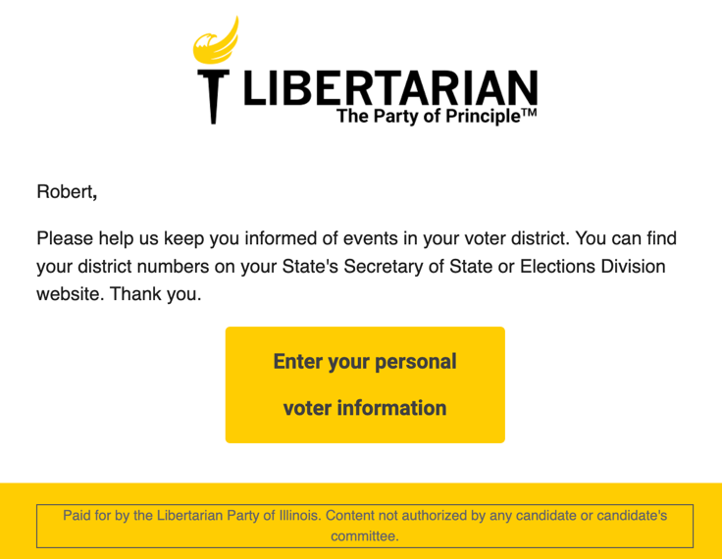

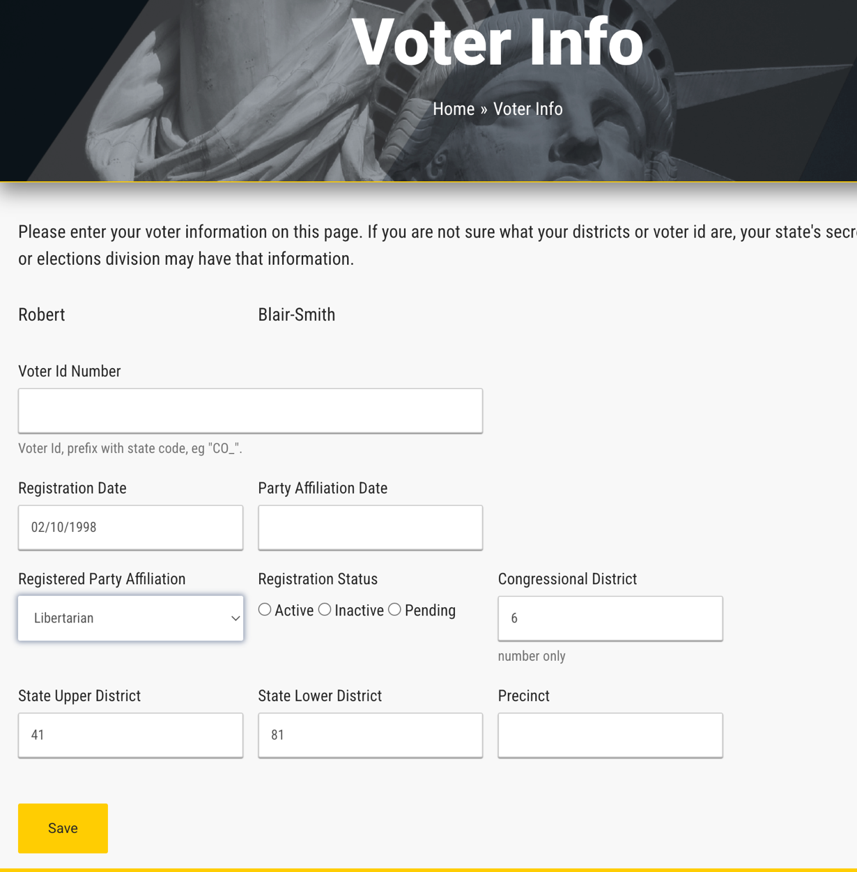

Training / Train the Trainer
- No new training requests or events since previous Report

Expenses:
Amazon Web Services
October $81.50
November $80.92
December $80.34

Grasshopper Virtual Phone. (paid Annually each May)
No new phone calls in or out with this platform in Nov-December.

IT Requests
Request/request by | Platform | Owner | Status | Date of resolution
- ExCom | lpillinois.org | Web | Remove 2024 campaign related pages | 11/27
BoD/ F. Ops | lpillinois.org | IT /CRM | Delivered Champaign County list (revised) to Field Ops/ Chapter Development | Jan 6/15

New and ongoing Projects:
- Web Director – seeking assistance with previous elected candidates currently in office to ensure Elected Officials page is current and up to date

- Document Management Platform selection and migration:
Vet and compare next Document Management System platform options for LP of IL as AWS WorkDocs is going away in March
- Box
- DropBox
- OneHub
- Sync
- Hetzner IaaS
Next steps:
- Open IT Division call held to review JAN 9, 2025
- IT Division will make recommendations before the Feb 2025 BoD call
- Users should plan to DOWNLOAD all content they saved in Amazon Workdocs starting now and store in a place to be uploaded later onto new platform

- IL Voter Database [See voter info request template above]

- CRM Evolution call with Andy Burns (AB Consulting) March 25th . This project is on hold

