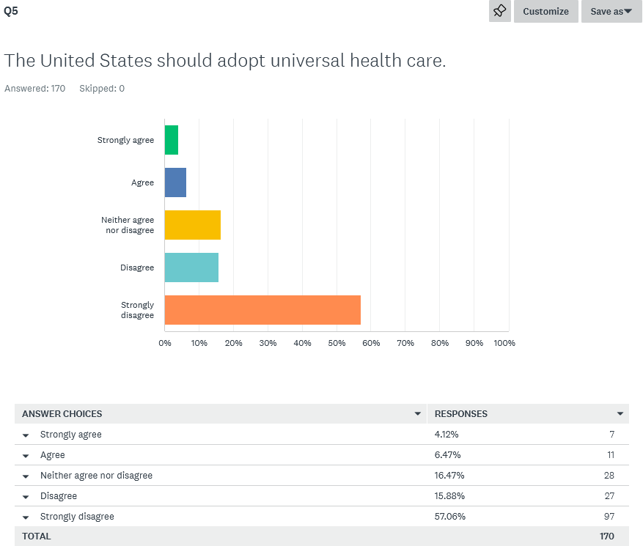

* I have been a libertarian all my life except when I registered democrat so I could vote against Joe Biden an extra time in a primary.
* It's about the issues that matter most
* Constitution Party
* None
* I was more of a left-leaning moderate
* Republican, but that was when I was 12
* Tea Party
* Ron Paul only Republican
* 45 yrs ago, democrat; 25 yrs ago, republican; 15 yrs ago, independent; 5 yrs ago, libertarian
* I've been voting Libertarian since my first election
* After leaving the GOP I became a politically homeless Anarchist
* Socialist
* Anarchist
* "Raised" as a Democrat, probably independent for years, leaned towards the populist ideas of the first couple of years of Trump era, then full libertarian the last 5 years
* I have been registered as both major parties.
* I started our as a Libertarian in 1976

|  |
| --- |
| * Government spending and debt. |
| * Excessive spending. |
| * Division between groups of people. Rich and poor, ethnicity, political standing, religious affiliations. |
| * We the People being too compliant and not knowing our own laws and history. |
| * Social Security and Health Care |
| * Socialism, Liberalism |
| * The federal government's lack thereof of fiscal responsibility |
| * Corruption |
| * Starting World War III |
| * National debt, gun control |
| * Youth of America incorrectly seem convinced that a strong central government can fix all problems. |
| * Debt, and two party control |
| * Cultural regression and destabilization. Also inflation and overreach of government powers and inconsistent (nonexistant) application of law and policy. |
| * Christian Nationalism |
| * Spending/social program obligations |
| * Ignorance and Disinformation driving people bonkers |
| * Government overreach |
| * Overspending without accountability |
| * leftist control of institutions and culture |
| * Fiscal irresponsibility |
| * Inflation, erosion of civil liberties |
| * Greed!!! |
| * Excess deaths |
| * Warmongering in the Ukraine could lead to nuclear war |
| * Our government treating immigrants like property at the border. The right for humans to relocate themselves is a natural right. Our government has absolutely no business regulating immigration. |
| * Lack of moral frameorks |
| * Tyrannical, unelected government |
| * Poverty, homelessness, and censorship |
| * Leftistm. All of it. |
| * National Debt |
| * Disinformation and how it is being used to attack Americans. Example, is the FBI going after citizens based on misleading or incorrect information. |
| * The slow infringement of the 2nd amendment by both state and federal entities |
| * To many to list, but most issues are because of ignoring the primary tenets of the original Constitution. |
| * deficit spending |
| * Lack of concern for economic over social issues |
| * The fact that everyone thinks they are a victim that wants to exact revenge on everyone that's different. |
| * Divisiveness. Healthcare. |
| * The continuing takeover of our social and political institutions by the ideological Left. Of course, no less threatening is the probability of an ultimate backlash and swing to the authoritarian Right. |
| * Imperialism and militarism, dis-functional congress that rubber-stamps deep state's and military-industrial complex's corruption schemes, criminal intervention in other countries' affairs. |
| * Legislatures are in charge of the asylum. In Illinois the Democratic Party is allowed and does pass any law no matter the constitutionality of that law |
| * economy, taxes, corruption |
| * Political polarization |
| * Itself |
| * Economy and getting into wars |
| * money printing / debt collapse |
| * News coverage has scewed my ability to rank issues by imortance, but I would guess it might be the corruption in Federal agencies. i.e. CIA FBI |
| * Cultural decay |
| * National security. Without a secure environment, everything can be taken from us. |
| * All roads lead to Rome: big gubment needs to be steadily shriveled up and do less |
| * The duopoly |
| * National Debt, unsound money/federal reserve system |
| * The two primary political parties. |
| * Censorship |
| * Progressives |
| * Economic freedom and policy failure (too much printing, heavy-handed interference, occupational licensing, etc) |
| * Debt |
| * The aisle between Rs and Ds grows wider on a daily basis. |
| * Polarization in general, in particular with opposing movements and major parties becoming more authoritarian, plus the rise of armed militant groups at the fringes. |
| * Trying to start a war with Russia. |
| * Corruption, lack of accountability & term limits are needed. |
| * The two party systems entrenched Democrats and Rinos. |
| * Economy, preserving natural rights |
| * Corruption at the federal level |
| * Inflation |
| * The education system. It's forming future generations. |
| * Debt |
| * Debt. |
| * The United States risking war with Russia over Ukraine. |
| * War and foreign policy |
| * Government over-reach into every aspect of our lives |
| * Inflation |
| * Erosion of freedoms, increasing taxation, and threats to body autonomy |
| * overall crime due to many cirumcstances |
| * Political dogma, mainstream media promoting an agenda and not being honest in their reporting, the fact that while the government has forgotten they work for We the People, the people have forgotten the government works for us |
| * Controlled implosion of Constitutional values by multinational corporations and globalists |
| * Joe Biden |
| * Inflation |
| * The corruption at the highest levels and the criminal behavior of the Biden family. |
| * Size of the Federal Govt. Some departments should be eliminated ( Education), others minimized. |
| * Our government, in general... |
| * Erosion of freedon |
| * Out of control spending |
| * The federal reserve existing. They've destroyed our currency and are a cornerstone of the military industrial complex. It has to be totally abolished. |
| * Government spending, national debt, income tax. |
| * National debt |
| * The lack of education concerning civics and history. |
| * inflation |
| * CBDC |
| * The threat of Marxism, politically and culturally. |
| * The unseriousness of our politicians. |
| * Excessive government at every level but especially the federal level |
| * Proxy war against Russia |
| * The state of our economy. The Fed is destroying wealth and consolidating control |
| * personal freedom |
| * Debt/deficit |
| * The Federal Reserve funding the military-industrial complex. |
| * Spending/size of government |
| * The risk of default on the national debt, leading to the collapse of the Dollar and the economy. |
|  |
|  |
| * Wasteful, excessive spending. Use of Social Security funds by government. This whole Trump witch hunt that has been wasting tax money for 6 years. The left's incessant push towards Socialism. The fear mongering that instills paranoia and a false sense of safety in the population. |
| * broken legal system - should be centered on restoration and accessible by poor and rich evenly should return to concept of federalism - country too large to be ruled by central government weaken the power of the central government - the more powerful it is, the more likely powerful and monied interests hold sway |
| * Promoting the LP as a the best alternative to disillusioned Republicans and Democrats |
| * Too many laws, you can't go through life without breaking some. This gives authorities the ability to selectively prosecute individuals. All laws should have sunset dates where if law is not renewed, it goes away. |
| * A two way tie between the National Debt and restrictions on personal liberties |
| * Gun control |
| * The evil money hungry/power hungry government! |
| * Debt/inflation |
| * The starving govt behemoth. |
| * Jobs. |
| * Civil Rights issues especially concerning women (Bodily Autonomy) and the GSM Community |
| * Our government causing overall moral decay. Everyone who isn’t in favor of liberty wants to push their morals on everyone else causing nothing but infighting and authoritarianism. Everyone who is in favor of liberty wants it without acknowledging the consequences and the responsibility that comes with it. The whole system is decaying because our government has pitted us against one another. |
| * Ignorance of history, ignorance of science, christian nationalism, corporate greed....take ur pick. Remember Dickens, though..."beware this boy" |
| * Avoiding further escalation with Russia. We need to withdraw all military aid to Ukraine immediately, and help facilitate peace in the region. |
| * Ignorance |
| * Centralization of state power and infringement of constitutional law |
| * National Debt |
| * Lack of fundamental education (reading, math problem solving) and development social intelligence skills like resilience and critical thinking |
| * The Assault on our gun rights. |
| * Too much legislation around moral issues. |
| * To many to list. |
| * War escalation in eastern Europe and the collapse of the U.S. dollar. |
| * Inflation. |
| * Pending implementation of CBDC |
| * Economy |
| * Sluggish economy |
| * Growing government power, shrinking personal and economic power of individuals. |
| * Government spending and government debt |
| * Unregulated spending |
| * The Marxist intrusion into all facets of life, causing strife and distracting from the actions of our government that is implementing catastrophic policies and abolishing freedom. |
| * Inflation and NATO caused wars |
| * Political extremism on both sides leading to inability to consider the constituents you represent |
| * Actual acceptance of socialist and communist ideas and tendencies, emanating from public schools and higher education. Also legitimate efforts to censor and stifle speech. |
| * Inflation and growing threat of nuclear conflict. |
| * Liberal politicians |
| * National debt, inflation, and increased tensions over social issues on both sides of the political spectrum. |
| * Leftist ideology / Corruption |
| * War on the middle class |
| * There are almost too many to list. (1) Inflation probably first for me personally (since I'm a retiree and my savings are being eroded). (2) Whittling away of natural rights on several fronts, with insidious federal interference in media (govt propaganda getting worse), gun control legislation both federally and in certain states, and the massive rise of both the administrative state and the police state on the federal and state level. |
| * Inflation and Government spending |
| * Two Party System |
| * Overspending and lack of accountability in Goverment at all levels. |
| * The gradual decline of our military |
| * National debt |
| * Border crisis, national debt, inflation. |
| * The current administration |
| * Growing national debt exacerbated by reckless spending programs |
| * Economy, wokeism. |
| * National debt |
| * Extreme polarization. |
| * Marxist indoctrination of society using CRT, Queer Theory, Climate Change and Centralized Digital Currencies. |
| * out of control spending and the existence of the Fed |
| * Rapidly increasing government overreach in social, cultural, and economic spheres |
| * Everything |
| * The military industrial complex bankrupting the country in a potential nuclear standoff with Russia. |
| * Size of government/National debt |
| * two-party system & foreign powers influencing political hatred |
| * Misinformation. |
| * Financial instability. |
| * National debt and deficit spending - failure to balance the budget |

|  |
| --- |
| * Corruption, debt, and civil rights trampling gun laws |
| * Excessive spending. |
| * Government wasteful spending. |
| * It’s all systemic |
| * Taxes, Health Care |
| * Loss of American values |
| * The state government's lack thereof of fiscal responsibility |
| * Corruption |
| * A total Blue state cluster fuck |
| * Property taxes |
| * Illinois continues to raise taxes and restrictions, successfully driving those able to pay taxes and easily move to leave the state. |
| * Debt and 40 years of one party control (94 in Chicago) |
| * Government waste and corruption, and overtaxation to compensate. |
| * Christian Nationalism |
| * Pension crisis |
| * taxation increases |
| * Corruption |
| * Corruption |
| * government schools |
| * Fiscal irresponsibility |
| * Corruption, pensions |
| * Corruption!!! |
| * Murder |
| * Out of control spending |
| * Restrictive laws. Stealing from residents |
| * Insane democratic party that only wants more power and control |
| * poverty and taxes are outrageous. |
| * Bad policy. Crime. Bad politicians. |
| * Socialist Government |
| * Education. Politicians have been using tax payer dollars and teachers union for political gain and not education of the young. |
| * No accountability for where tax money goes and no repercussions for those who abuse and mis-manage the funds. |
| * It is essentially a one political party state. |
|  |
| * pensions via government |
| * Gun control and decriminalization of crimes |
| * MY PROPERTY TAXES ARE KILLING ME AND THE SCHOOLS ARE STILL AWFUL |
| * Cost of living |
| * The anti-business climate that is pushing residents to more economically-free states. |
| * Government debt. |
| * Getting common sense back. Require reading the constitution for every citizen! Lol. Mostly the fact that cook county controls this state |
| * economy, taxes, corruption |
| * Chicago |
| * Politicians aren't doing anything and everything is too centralized on Chicago than the rest of the state |
| * Economy |
| * pension crisis/ tax burden |
| * High taxes and centrol control. I am a township trustee and we have very little power. we just do as we are told. |
| * Strict authoritarianism |
| * Corruption and high cost of living. |
| * Same answer |
| * Complete failure of state and select counties, governments, almost forgot, and the Teacher's Union now running Chicago. |
| * Taxes |
| * Chicago Democrats |
| * Endemic corruption. |
| * The electorate |
| * Chicago versus the rest of the state |
| * Polarization between metropolitan and rural areas. |
| * The domination of shitcago politics over the rest of the state. |
| * Pritzker |
| * The Democratic Party |
| * Debt |
| * Corruption. The spread of socialism |
| * Taxes |
| * Taxes and restrictions on small businesses and landowners. |
| * Chicago monopoly on state policy |
| * Debt |
| * Chicago. Generally. |
| * Corruption |
| * Progressive policy push that trades liberty for supposed safety |
| * Woke values |
| * Taxation and threats to individual liberty, specifically the 2nd amendment on both the local and national scale |
| * progressive |
| * I do not know |
| * Chicago politics |
| * JB Pritzker and the unconstitutional assault weapon ban and all their ridiculous gun laws. The FOID ID card the concealed carry Permit we should have constitutional carry in Illinois for all law, abiding citizens! |
| * Gun control |
| * The stranglehold that the Democratic party has on the state. The over whelming influence of Chicago politics on the rest of the state. It is a joke how corrupt our "leaders" are. |
| * Funding of the school systems. |
| * Our government, in general... |
| * Loss of businesses & jobs |
| * Gun restrictions |
| * Income tax, crime, gun laws. |
| * Looming pension crusus |
| * The state debt and a general assembly and governor spending this state into bankruptcy. |
| * regulations |
| * Central control by politicians, who are then easily corrupted. |
| * A tie between corruption of both parties and financially issues with the state, mostly Cook County and the City of Chicago dragging the rest of the state down. |
| * The pension mess |
| * Unsustainable public pension debt |
| * Government spending |
| * Taxes, property and income |
| * economy |
| * Election reform and corruption |
| * Public pensions and retiree healthcare costs, in tandem with high taxes, making the cost of living and doing business too high. |
| * Spending/size of government |
| * Massive corruption and rampant "wokeism," leading to the mass exodus of employers, business and productive sector of the population. |
| * Corruption, spending, idiotic laws, a fat, rich boy who bought his position as governor taking the state down. |
| * lack of transparency, outright (barely hidden) corruption, mismatch of interests and beliefs and needs between urban dwellers and rural |
| * It is difficult to isolate those not strongly influenced by national policies. Public education and crime are issues require greater state attention. |
| * the ongoing pension crisis |
| * Gun control |
| * The evil money hungry/power hungry government! |
| * Debt/inflation |
| * The corrupt, starving govt behemoth. |
| * Jobs. |
| * The Crime in Chicago, the failure to address the root causes such as institutional racism, the drug war, and the state continuing to hold down poor/minority communities. |
| * Taxes and corruption. We need to try something like greater Idaho and put together a petition to separate from Chicago. |
| * Taxes...too much, with government retirees taking the heat because they have a living income from pensions |
| * The massive bloat and redundancy of government. It is displayed in every aspect of society. School districts for days, townships and county and city overlapping everywhere |
| * Ignorance |
| * Centralization of state power and infringement of constitutional law |
| * State debt |
| * Fraud and corruption at all levels of government |
| * Corruption and Chicago's dominance of Illinois politics. |
| * Violence whether weapons, abuse, bullying. Add our reluctance to address or interfere because of retaliation. |
| * One party control. |
| * Businesses leaving for neighboring states, unfounded pension liabilities and the reputation/reality of corruption in Springfield and Chicago. |
| * High taxes. |
| * The governor's use of emergency powers, which will likely happen again |
| * Property taxes |
| * Too high taxes |
| * Chicago |
| * Govt spending and govt debt |
| * Unregulated spending |
| * Liberal Democrats and left-libertarians championing their social crusades. |
| * 2A under assault |
| * Chicago politics trump the rest of the state, no discourse |
| * Our crooked politicians and the corrupt Chicago Machine. The looming pension crisis. And the fact that property taxes are horrific here for schools that are absolutely garbage. |
| * Over taxation and lack of school choice. |
| * Gov. Pritzker |
| * Political corruption and 2A restrictions |
| * Leftist ideology / Corruption |
| * Tax reform |
| * As someone who lived in tax-free New Hampshire most of my life, I suppose the tax burdens for Illinoisans comes first to mind, but the recently passed gun control legislation might be the biggest. Unfortunately while corruption seems pretty rampart at all levels of government throughout this country, it seems to reach a new level here in Illinois. |
| * Corruption and political gerrymandering |
| * Two Party System |
| * Same as 17 and the additional burden of unfunded pensions |
| * Crime |
| * Population exodus |
| * Taxes, corruption, one party dominating state government (democrats). |
| * The current administration |
| * Looming fiscal/pension crisis |
| * The entire state being run by the interests of the City of Chicago |
| * Pension crisis |
| * The assault weapons ban. |
| * Collapse of the pension system and destruction of 2nd Amendment rights |
| * high taxes |
| * Rapidly increasing government overreach in social, cultural, and economic spheres |
| * Deep rooted corruption |
| * A completely unaccountable Democratic Party who has created a pension deficit ticking time bomb for taxpayers. |
| * Crime |
| * pension debt |
| * Taxes |
| * Corruption. |
| * Public employee retirement systems - failure to reorganize public employee pensions into traditional 401(k) or other retirement accounts |

* Really? There’s only two genders
* I identify as a houseplant.
* Gimme a break!

