Q1
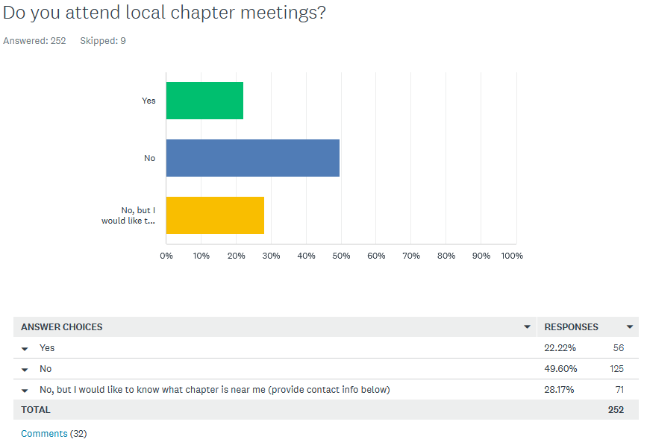
- Chapter is in rebuilding - ChrisMont Libertarian Central Committee
- psw003@yahoo.com
- I live in Genoa, by Dekalb
- Woodstock, IL 60098
- No local chapter near me.
- When I can however their chosen night of the week makes it nearly impossible for me.
- It’s been a little while though due to life circumstances and moving.
- Orland Park IL 60467
- My work schedule prevents me from attending.
- I use to attend before my work hours shifted.
- There isn't one
- Jan.williams73@yahoo.com
- I do not and will not support Mises Caucus as long as it is associated with misogynist and groomers.
- I am a Chapter Chair
- NateJay320@protonmail.com
- there is none in St Clair county. I've complained before. They have become something else.
- Knox county
- Last I checked Metro East had disbanded/disaffiliated from LPIL. Still true?
- I live overseas
- I did for years as a founding member but have not very often in last couple years
- J.winn.qc@gmail.com - Rock Island, IL.
- I attend local chapter meeting whenever they do not conflict with my other Wednesday commitments.
- I want to, I just have trouble with transportation since I don’t have a car
- Used to but moved
- Schaumburg, IL
- I have in the past but not recently.
- No local chapter near me.
- near Naperville, IL
- Casey Boatman Springfield IL
- Monroe County, IL stuart.straub@outlook.com
- misc@christopherstare.com
- When we have meetings.

Q2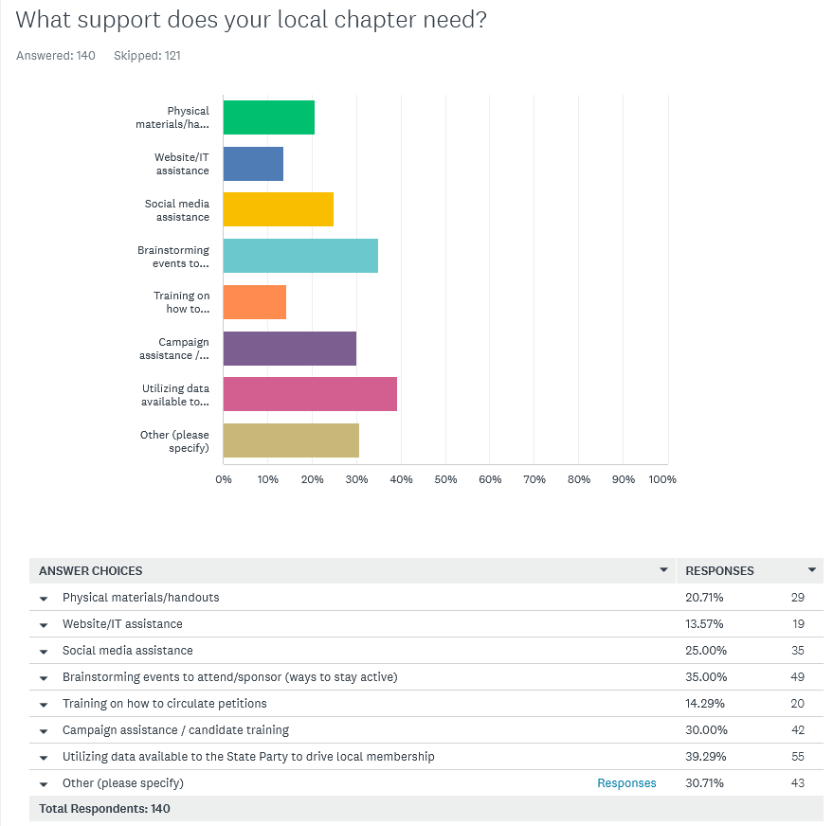

- Membership growth
- More members besides me
- Unsure
- I don’t attend
- They need help to not be self-interested **CENSORED**; I used to attend local meetings but the members were largely self-interested **CENSORED**.
- No idea
- Recruitment
- Recruitment help
- Recruitment help
- No idea
- No idea
- Establishing a county chapter
- N/A
- Not Sure
- I don't know.
- A State Party that isn't run by woke communists
- More people!
- Startup
- Wouldn’t know
- Not sure
- Don't know
- Don't even know if there is a local chapter
- No Idea
- Don't have a local chapter
- No idea
- I have no contact with a local chapter.
- More active members.
- Not sure it lacks relevancy
- Personnel to show up.
- More effort in getting candidates to run for local office.
- No idea
- N/a Very rural area -- no LP
- Money for speakers to teach what libertarian is. The Libertarian Party is first and foremost libertarian. Everything else comes second.
- Establishing a county chapter
- More members
- I don't know. However, wrt Item 3. below: I follow LP Illinois on Facebook, & yet never have seen ANY of their posts come up in my News Feed. I have to go to the LP Illinois page to see content. Shadow-banned, perhaps?!
- As of now the closest chapter meets in Freeport. Would love something closer to Rockford
- member recruitment strategies and help
- Members
- more members

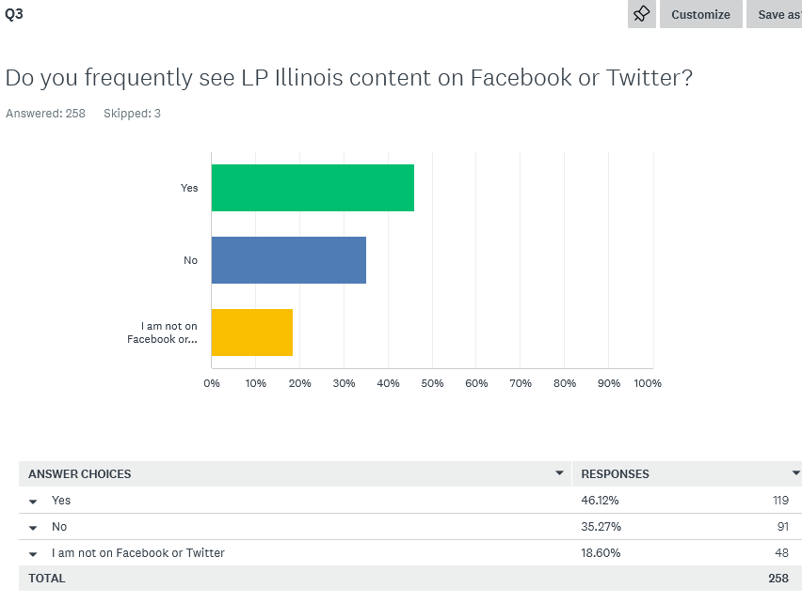

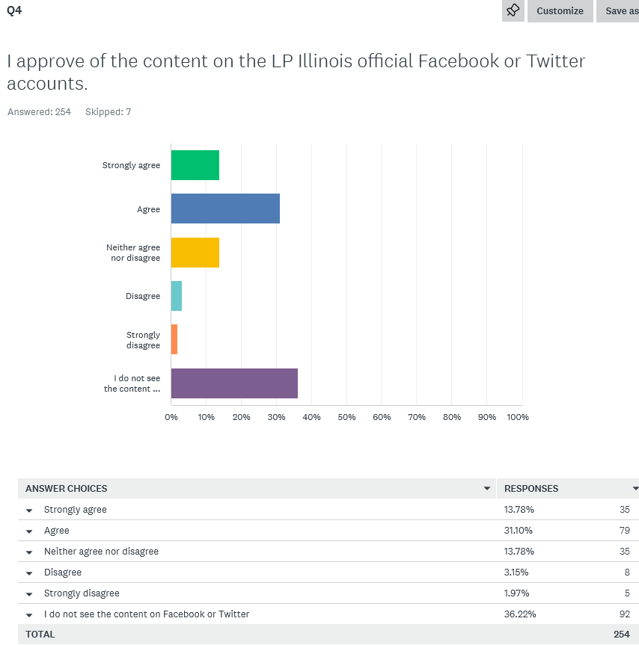

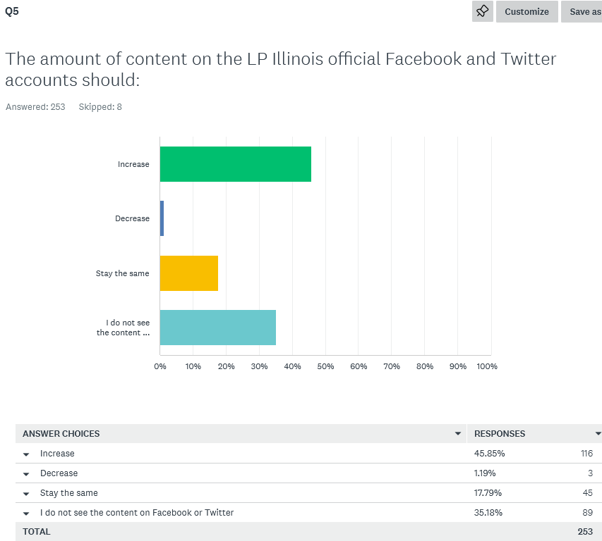

Q6
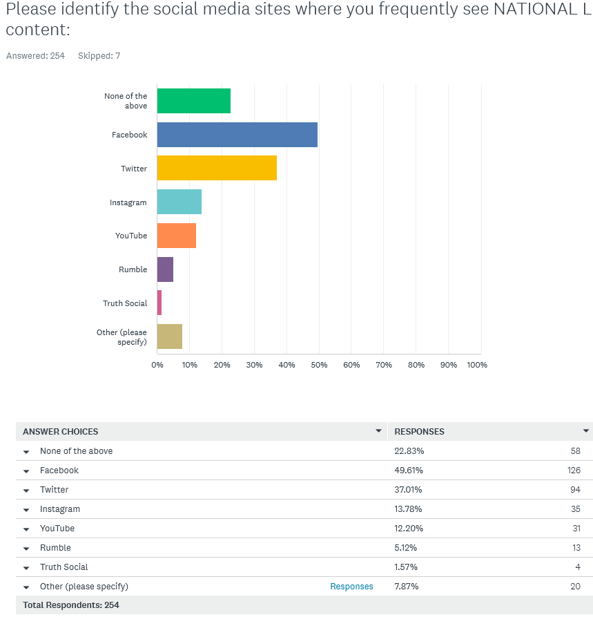
- Email
- Tic tok China spy app
- Bitchute and odysee
- I use YouTube daily, but rarely see LP content
- Locals
- The only LNC content I've seen in months is Angie's LNC post about her new cosmetic line for biological women.
- Reddit
- LP News
- I see some on Facebook but not much.
- BLEEP social media it is the cause of the current problems in America
- MeWe
- MeWe
- LinkedIn
- LewRockwell.com/ revolver news/rbn
- Reddit
- Email
- LP Website
- Online
- Emails
- Reddit reposting of twitter posts

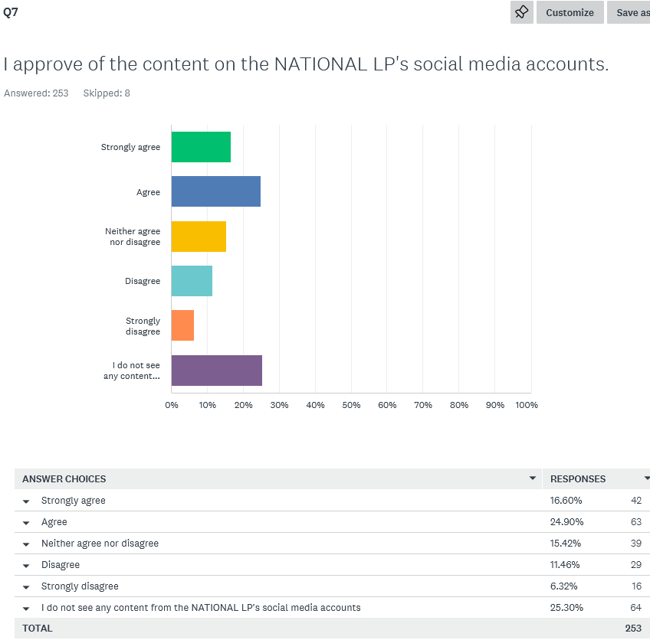

Q8
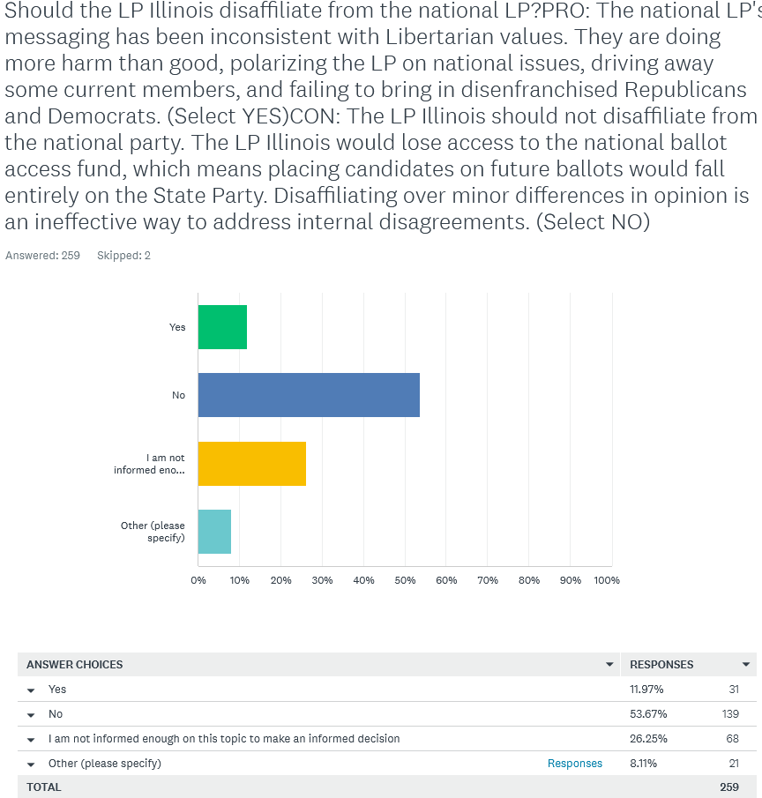

- Not all national pertain to local and vice-versa. Many of the LP come from both Rep and Dem backgrounds. Platform needs to be firm guidelines and honest.
- They use memes rather then actual information, making libertarians seem like a joke.
- Illinois needs Mises
- I fully agree with the Mises Caucus and believe LP Illinois should align with those values
- I follow many LP state accounts on twitter, I wish Illinois LP was more active but though division may happen with the party, we are still fighting for the same, our rights. Not every person will agree on things but that leaves space for discourse
- Work to change National policy statements
- I remain undecided on this issue
- No. How about putting together a question that isn't ridiculously biased? You people are complete jokes.
- I have been losing interest in the LP due to the sense that the National LP has been going in the wrong direction. However, I'm not sure how badly the loss of funding would hurt the IL LP. It would be nice to get the National LP back on track.
- Vote them out ASAP as it appears LNC has disaffiliated with libertarianism in general.
- Unless the Illinois LP can make up the ballot and fund access
- If you can’t change the people, change the people.
- Disaffiliation is not a solution to the discontent I feel about some of strident positions taken by National LP.
- Disaffiliating with the National LP may help struggling chapters increase membership; I do not want my chapter associated with the current leadership of the National LP, but I very clearly see the issue with ballot access. I chose not to take a side on this issue.
- The core goal should be to abolish the 2 party system. Maybe address this after this goal is met. We all have that much in common and cannot accomplish this if we are divided.
- No. If you disaffiliate from National then you are no longer a political party really. If you don’t like national priorities and messaging then work to drive engagement with the LNC and promote attendance to national conventions to change leadership.
- Yes, because the LP Illinois stances will drag down the national LP.
- No; but it should be noted that according to the LNC Chair, the LNC is “no longer concerned” with 50 state ballot access in 2024. We would not be receiving those funds regardless because we’re not a member of their ideological clique.
- No, the LP Illinois is the organization that has been putting out messaging and candidates inconsistent with Libertarian values. How about you guys follow New Hampshire's lead and try to be relevant?
- The National LP should field input from the state LPs for consideration and messaging
- Seems like very odd choices. Pro being a negative and Con just going along with them. What about a choice of being in agreement?? Biased at all?

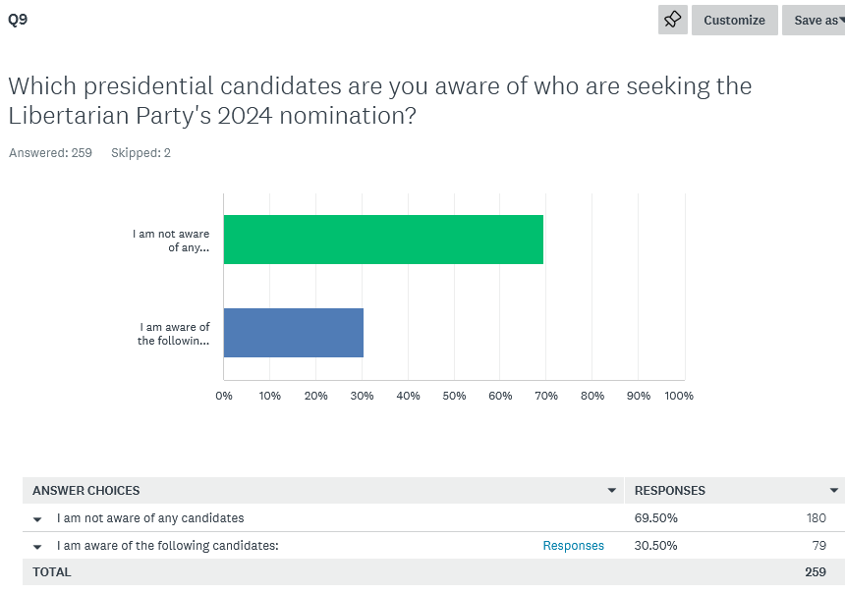

- Chase Oliver
- Jacob Hornberger, Mike ter Maat, Lars Mapstead, Chase Oliver, Josh Rodriguez
- Dave smith
- Just read that they were unknown on Il Facebook
- Joe Maldonado
- Lars Mapstead
- Chase Oliver, Lars,
- Mike Ter Maat, Mars Lapstead, and maybe Dave Smith, Justin Amash, Spike Cohen, Larry Sharpe, and Chase Oliver
- DAVE SMITH!!!
- Dave Smith
- Amash, chase, smith
- Dave Smith
- Chase Oliver
- Brett Ryan
- Chase, Lars, Ter Mat
- Lars, Oliver, Maat
- Joe Gograns
- Chase Oliver, Dave Smith (potential), and I think Hornberger is in again
- Chase Oliver , Mike Ter Maat , spike cohen
- Chase Oliver
- Chase Oliver, Lars Mapstead, Joshua Rodriguez, Mike ter Maat, Jacob Hornberger
- Hornberger, Oliver, ter Matt, Mapstead
- Mike ter Maat
- Chase Oliver and some comedian, Maybe we should go for the comedian; it's worked well for Ukraine.
- Spike Cohen?
- Chase Oliver
- Chase Oliver, Jacob Hornberger
- Joe Maldonado
- Chase Oliver, Spike Cohen?, Justin Amash?
- Spike Cohen
- Chase
- Justin Amash Dave Smith
- Lars Mapstead and Mike ter Maat
- Jacob Hornberger, Maj Toure, David DeSilva
- Chase and Lars
- I would assume Justin Amash but I haven’t seen him declare formally yet.
- Amash
- Chase Oliver
- Chase Oliver, Mike Terr Matt, Jacob Hornberger, Lars Mapstead, umm I think his name is Rodriguez?
- Dave Smith
- Mike T., Judge Napilatano
- Mike Ter Maat, Lars Mapstead
- I heard Bobby Kennedy Jr might run as a Libertarian
- Howard Stern
- Amash
- Amash
- possibly Spike Cohen and Dave Smith
- I think Amash is running, and hopefully not COMIC DAVE SMITH
- Amash and Smith
- “Comedian” Dave Smith (courtesy of the LPMC); Jacob Hornberger; and Chase Oliver. FEC filings also show two unknowns: Lars Mapstead, and Mike ter Maat.
- Trump, DeSantis, Biden, Kennedy, Haley
- Amash
- Amash
- Amash
- Amash and Smith
- Smith, Amash, Chase
- Chase Oliver, Mike ter Matt.
- Chase Oliver
- Chase oliver
- Chase Oliver, Mike ter Mat
- That "comedian" guy David something.
- Jacob Hornberger, Chase Oliver, Lars Mapstead, Mike ter Maat
- Mike ter Maat, Chase Oliver, Jacob Hornberger
- I've heard and read rumors, but I'm not aware of any official announcements.
- Chase Oliver
- Dave Smith
- Chase Oliver Lars Mapstead Joshua Rodriquez Michael ter Maat
- Chase Oliver, Mike ter Maat, Lars Mapstead, Joshua Rodriguez
- Spike Cohen, Dave Smith
- Mike ter Maat, Joshua Rodriguez, Lars Mapstead, Chase Oliver
- Justin Amash Dave Smith
- Chase Oliver
- Dave Smith
- Dave Smith; Mike ter Maat
- Chase Oliver, Lars Mapstead
- Chase Oliver, Mike Ter Maat, Joshua Rodriguez, Lars Mapsted
- Chase Oliver, Mike Ter Matt
- Mike Ter Maat, Lars, Oliver

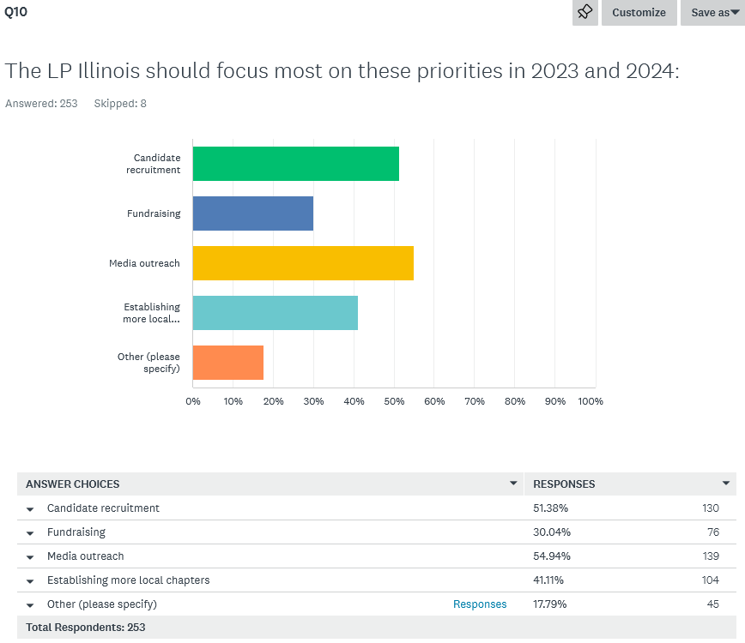

- Opposing the immanent nuclear war
- alligning more with the NP, removing whoever wrote this survey from leadership
- Growth of local chapters
- Informing people about policy and using real statistics and info rather then memes.
- More unified visibility
- Not associating with the radical right
- Winning local offices no matter how small. Inventory all vacancies and fill them.
- Speaking to people locally, canvassing, teaching people even if they don't agree with Libertarians, there are more parties than Dem/Rep and answer questions they may have because of the misconceptions about the LP
- Start rally and protest un democratic systems in illnois
- Member engagement
- Membership
- Getting in to debates
- Sane small government alternatives to current options WITHOUT the extreme conspiracy theory BS I currently see in libertarian emails
- Training existing chapter leaders
- Public messaging
- Not being woke communists.
- They need more material about what we support and less negatives about other parties. The public already knows the Dem/Repub. Beliefs/supports. Stop comparing them /us. Simply share what our beliefs and goals are.
- Petitioning & Lobbying for Ballot Access Reform in Illinois
- Recruitment statewide
- Increase membership
- Avoid the worse than provocative rhetoric LP National is engaged in
- All of the above
- Establishing statewide ballot access by finding reputable candidates for statewide office.
- Assisting current chapters with recruiting more members.
- increasing the number of people who vote Libertarian
- Establishing itself as a legitimate party against Dems and Reps!
- Increasing activism at local chapters; regularly publishing newsletters.
- Southern Illinois is not and never will be blue. No one wants smaller government more than farmers that are forced to pay Chicago taxes.
- Sorry these are all great. Hard to prioritize. I’d add supporting local non partisan election candidates specifically getting libertarians on school boards, city councils etc
- No Idea
- Local non-partisan races
- Stop obsessing on gender and trans-gender issues.
- Retention
- I'll volunteer for any lefty outreach, but it's unheard of. Plenty of us left libertarians can talk to left demsocs pretty easily, we just disagree on who fixes it. Left libertarians have been removed from existence to the mises caucus
- Distinguishing our messaging from LNC’s messaging; as the latter represents a radical right-leaning (and moving towards Statist) shift in our Party.
- Local issues activism (i.e. HB 5855)
- Teaching libertarianism, to its own members and the public.
- Making people aware that this is a viable option to combat the corruption and divisive lying from the two party system
- Media outreach with the PROPER MESSAGE. Stop speaking like the rest of the political establishment.
- Focusing on actual LP issues instead of whining and complaining..
- 2A Rights and Anti Trans youth Agenda issues
- Precinct Committeeperson recruitment
- Making friends. Helping others with similar interests
- more events in general
- Achieving ballot access through more volunteer signatures rather than paid petitioners

