BOARD OF DIRECTORS MEETING AGENDA

4/18/2023 7:30 PM

EXECUTIVE BOARD COMMUNICATIONS DIVISION
State Chair: William Redpath Director: Amanda Parsons
Vice Chair: Matt Piron Deputy Director: Nathan Florey
Secretary: Ken Mattes Broadcasting Director: Stacy Apel
Treasurer: Russ Clark Social media Director: Alex O’Dell
Executive Director: Justin Tucker Deputy social media Director: Vacant

IT DIVISON FIELD OPERATIONS DIVISION
Director: Bob Blair Smith Director: Blake Hanson
Deputy Director: Carter Mitchell Deputy: Lorraine DeNardis-Albert
Website: Vacant Chapter Development: Paul DiMasi
Operations: Kelly Liebmann Activism: Vacant
CRM Training: Derek Evans Events: Vacant
Membership: Kevin Mahoney
POLITICAL DIVISION Campus Outreach: Vacant
Director: Jake Leonard Volunteer: Vacant
1st Deputy Director: Jim Humay
Legislative: Vacant AD-HOC and NATIONAL
Campaigns: Jon King LP National Rep: Mark Tuniewicz
Candidate Recruitment: Vacant Convention Committee: Justin Tucker
Deputy Recruitment: Vacant
Ballot Access: William Redpath
Precincts: Vacant

STATE CENTRAL COMMITTEE
1st District: Jason Decker 10th District: Alexa Maffei
2nd District: vacant 11th District: Jon Harlson
3rd District: Danny Lewis 12th District: NOTA
4th District: vacant 13th District: vacant
5th District: Kevin Kauzlaric 14th District: vacant
6th District: Bob Blair-Smith 15th District: John Phillips Jr.
7th District: Jim Humay 16th District: Bennett Morris
8th District: Julie Fox 17th District: Donny Henry
9th District: Adam Balling

OTHER PARTICIPANTS:

AGENDA
MEETING CALL TO ORDER

PUBLIC COMMENT:

APPROVAL OF AGENDA

APPROVAL OF PREVIOUS MINUTES

OFFICER BRIEFS:

CHAIR:

VICE CHAIR:

SECRETARY:

TREASURER:

EXECUTIVE DIRECTOR:

DIRECTOR BRIEFS:

Communications Division Report:
IT Division Report:
Field Ops Report:
Political Division Report:
AD-HOC and National Reports:

OLD BUSINESS: N/A

NEW BUSINESS: MOTION #1 (DiMasi) to approve the attached survey to be sent out to membership via email (below).

MOTION #2 (Tucker) to adopt resolution (below).

Next Meeting Date:

Adjourn:

MOTION #1 SURVEY:
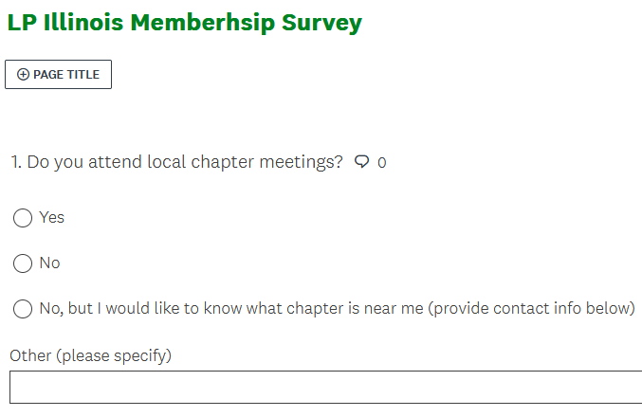
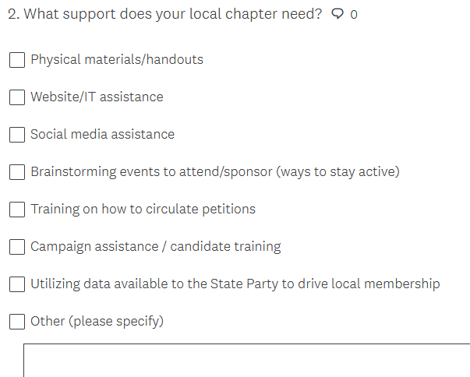
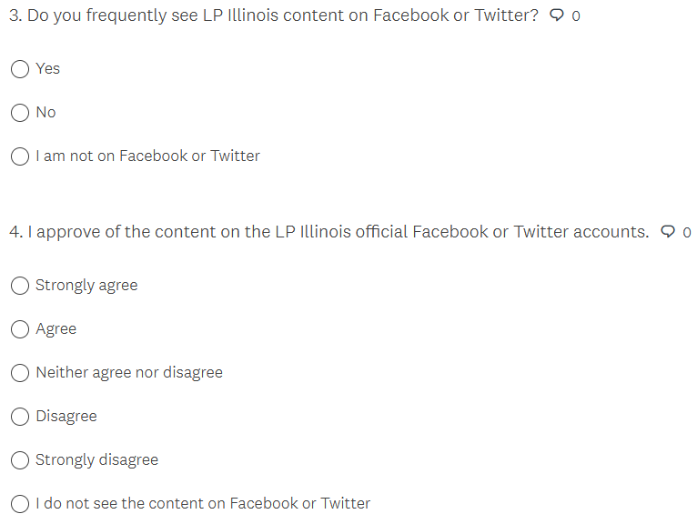
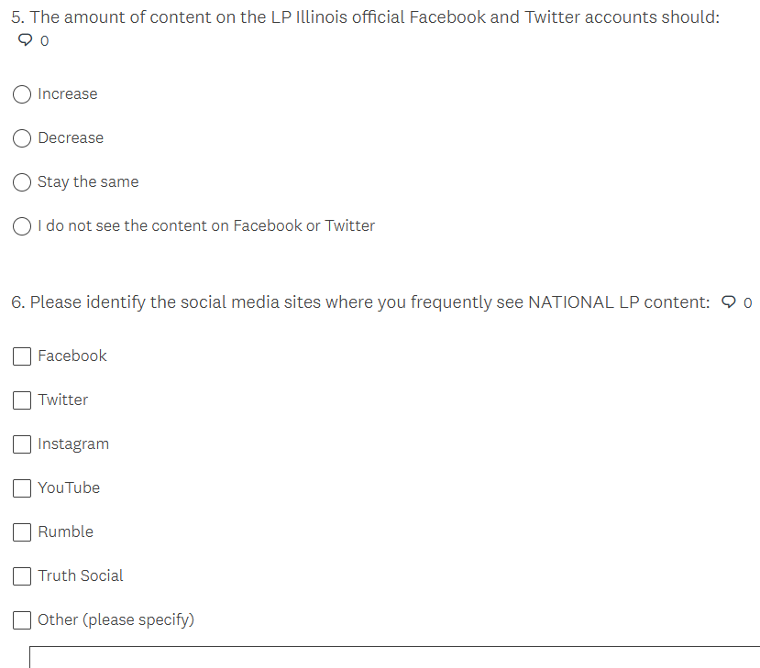
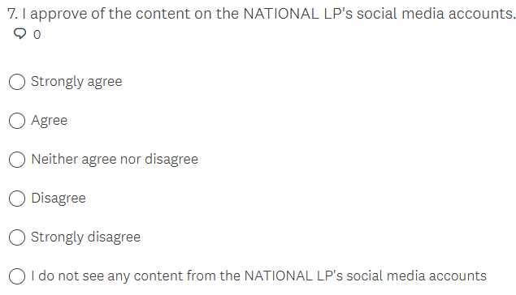
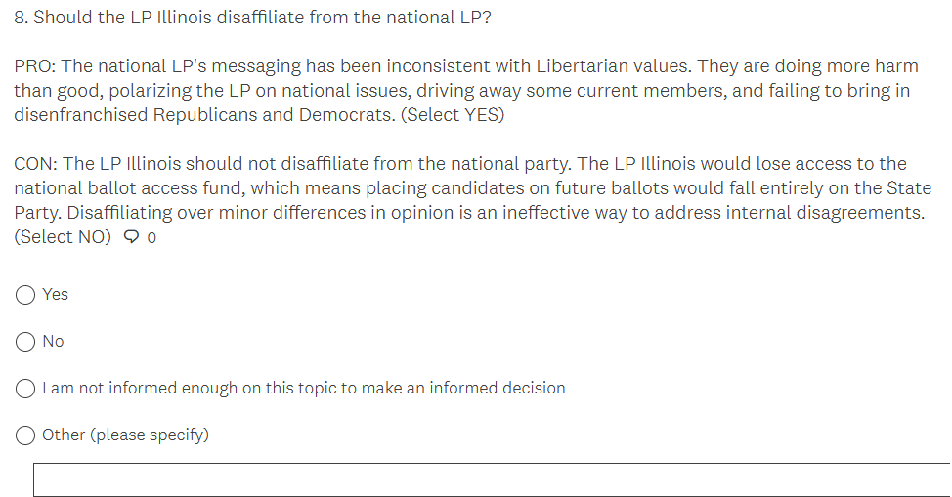
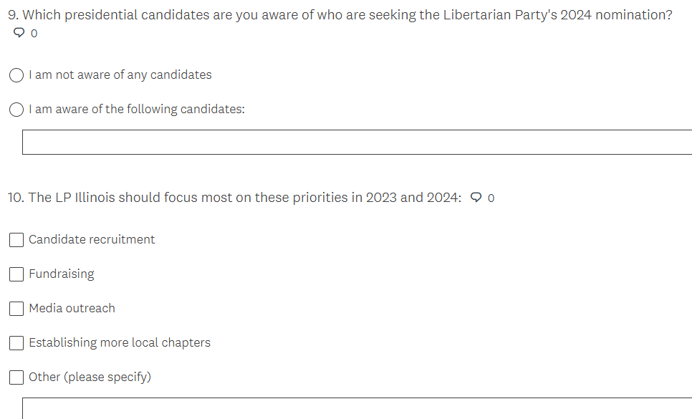

MOTION #2 RESOLUTION:

WHEREAS, Libertarians embrace the concept that all people are born with certain inherent rights
WHEREAS, Libertarians uphold and defend the rights of every person, regardless of their race, ethnicity, or any other aspect of their identity
WHEREAS, Libertarians hold governments, where they exist, should neither deny nor abridge any individual’s human right based upon sex, wealth, ethnicity, creed, age, national origin, personal habits, political preference, or sexual orientation
WHEREAS, Libertarians believe that the only legitimate use of force is in defense of individual rights — life, liberty, and justly acquired property — against aggression
WHEREAS, Libertarians affirm the individual right recognized by the Second Amendment to keep and bear arms
WHEREAS, Libertarians oppose the prosecution of individuals for exercising their rights of self-defense
WHEREAS, Libertarians oppose all laws at any level of government restricting, registering, or monitoring the ownership, manufacture, or transfer of firearms, ammunition, or firearm accessories
WHEREAS, Libertarians believe sexual orientation, preference, gender, or gender identity should have no impact on the government’s treatment of individuals
WHEREAS, Libertarians believe consenting adults should be free to choose their own sexual practices and personal relationships
WHEREAS, Libertarians believe parents, or other guardians, have the right to raise their children according to their own standards and beliefs, provided that the rights of children to be free from abuse and neglect are also protected
LET IT BE RESOLVED, the Libertarian Party of Illinois opposes any act of any legislative body to deny or abridge the right to self-defense of any individual.
LET IT BE RESOLVED, the Libertarian Party of Illinois opposes any act of any legislative body to deny or abridge the right of any individual to exercise sole dominion over their own lives.
LET IT BE RESOLVED, the Libertarian Party of Illinois opposes any act of any legislative body to deny or abridge on the right to live in whatever manner they choose, so long as they do not forcibly interfere with the equal right of others to live in whatever manner they choose.
LET IT BE FURTHER RESOLVED, the Libertarian Party of Illinois unites behind the inclusion of every individual who adheres to a lifestyle of non-aggression and stands in steadfast dedication to the defense of the rights of all.

