BOARD OF DIRECTORS MEETING AGENDA
Call in telephone number: 630-868-9596 (There is no code)
URL link: www.uberconference.com/chairlpil

July 19, 2022 – 7:30 PM

EXECUTIVE BOARD COMMUNICATIONS DIVISION
State Chair: Steve Suess Director: Amanda Parsons
Vice Chair: Donny Henry Deputy Director: Nathan Florey
Secretary: Brett Ryan Broadcasting Director: Stacy Apel
Treasurer: Russ Clark Social Media Director: Chase Renwick
Executive Director: Justin Tucker Deputy Social Media Director: Alex O’Dell

IT DIVISON
Director: Vacant POLITICAL DIVISION
Deputy Director: Carter Mitchell Director: Vacant
Platform: Vacant Deputy Director: Vacant
Operations: Kelly Liebmann Legislative: Vacant
Coding: Vacant Campaigns: Jon King
Candidate Recruitment: Vacant
FIELD OPERATIONS DIVISION Deputy Recruitment: Vacant
Director: Ballot Access: William Redpath
Deputy: Blake Hanson Precincts: Vacant
Chapter Development: Vacant
Activism: Vacant
Events: Vacant
Membership: Kevin Mahoney
Campus Outreach: Vacant
Volunteer: Lorraine DeNardis-Albert

AD-HOC and NATIONAL
LP National Rep: Joseph Ecklund
Convention Committee: Vacant

STATE CENTRAL COMMITTEE

1st District: vacant 10th District: vacant
2nd District: vacant 11th District: vacant
3rd District: vacant 12th District: Scott Schluter
4th District: Dan Lewis 13th District: Andy Apel
5th District: Vacant 14th District: vacant
6th District: Julie Fox 15th District: vacant
7th District: vacant 16th District: vacant
8th District: Todd Zimmerman 17th District: vacant
9th District: vacant 18th District: Damon Dillon

OTHER PARTICIPANTS:
See list at end of minutes.

____________________________________________________________________________
AGENDA
MEETING CALL TO ORDER -

PUBLIC COMMENT:
D. Evans: Desires to speak against tonight’s resolution. Lack of clarity, other problems, wish it to be tabled. Lack of clarification on decisions to end pregnancy. Lacks clarification on when a pregnancy can be terminated. This should be clarified or tabled, as infanticide.
M. Piron: Strongly disagree with resolution, termination of pregnancy, termination of fetus, motherhood, divisive issue. Wedge issue in other parties, especially LP. Echoing Amash, putting out statements that alienates large segments of LP is not the way to extend the party.
Does not serve us as a party; there are strong ethical opinions that Matt has, and others have. Fight for it on a personal level, but when it comes to statements as a political party; not for enforcing personal ethical beliefs. Our resolutions within the party need to represent this ethos.
K. Mattes: Requests help at McHenry County Fair. Chase will be there.

APPROVAL OF PREVIOUS MINUTES (June 17, 2022). Unanimously approved.

OFFICER BRIEFS

CHAIR:
Petition Turn-In and Press Conference
Eight days ago, we turned in roughly 37,000 signatures for our statewide candidates. I want to specifically thank Donny, Russ, Bill, Julie Fox, Chris Bennett and his family, Scott Schluter, Jesse White, and everyone else who helped us assemble and submit our petitions. I also want to thank everyone who either helped circulate petitions or donated toward ballot access this election cycle. We had an incredible volunteer signature total, and we would not have gotten on the ballot without that effort. After submitting petitions, we held a press conference at the state capitol. Coverage of our candidates was found that night statewide on television, radio, and print media.

Objections
Yesterday was the deadline for objectors to file an objection petition to our candidates' nomination papers. We did receive one objection, and it was only to Jesse White, not our entire slate. On advice of legal counsel, I will not discuss the details of the objection tonight. Our lawyer has advised us to keep everything close to the vest for the time being. In fact, he doesn't even want us to discuss it with the other candidates on the slate. I will say that right now we are hopeful that Jesse will survive this challenge and be on the ballot in November

Candidates Need Volunteers
Now that we know we're on the ballot, our candidates desperately need volunteers. Candidates need teams of people to canvass, place yard signs, and work behind the scenes. If you have any free time at all, please contact a candidate and volunteer to help with their campaign. The election is right around the corner, and we're working with limited time.

Party Leadership Elections, Transition and Thank You
Party leadership elections are next week on July 27th.On this day, established counties should be having county conventions to elect county central committees as well. Statewide leadership ballots will be distributed via email, and results will be made available on July 28. This is what the statewide ballot looks like at this moment.

Executive Committee
Chair Chase Renwick
Vice Chair Matt Piron
Treasurer Russ Clark
Secretary Brett Ryan

State Central Committee
D1 Jason Ross Decker
D2
D3 Danny Lewis
D4
D5 Adam Balling
D6
D7 Jim Humay
D8 Todd Zimmerman
D9 Paul DiMasi
D10
D11
D12
D13
D14
D15 John Phillips Jr.
D16 Michael Selover
D17 Donny Henry

If anyone would like to run for one of these offices, they must email me, expressing their intention to run, within the next week. Candidates must be current precinct committeepersons. No candidate will be added to the ballot after 7:30 p.m. next Tuesday, July 26th.

As you may have noticed, my name is not on the ballot for Chair, so this will be my last meeting as Chair of this party. I'd like to thank everyone for making it an enjoyable 2+ years, despite the many challenges we face, and I have no doubt our future leadership across this ballot will continue to build on what we've been able to do the past few years.
VICE CHAIR:
Thanks to everyone that helped with the petition drive. It’s the most volunteer signatures we’ve had. On the SCC vacancies; once we get done with county conventions; look to appoint precinct committeeman in those districts. We’ve kind of failed that. Need to fill as many leadership positions as possible. Hopeful to have some good people in there.
Thanks to Steve and his leadership; it’s been nothing short of impressive. He’s done an amazing job; gone through so many things. Lawsuit against the governor; so many are running because of that. Steve has well-organized the party. Donny showed his certificate of election for PC in his county for the group to see. We need to have PCs. R’s and D’s have the PCs. This is how they are successful. The PCs are the ground foundation of the party. If you aren’t one, get appointed as one.

As it’s his last meeting, he’s proud of what he accomplished. For a very long time it’s been very stagnant; there’s been a small group of people to carry out the work. What can you do for liberty? Show up to a chapter meeting; show up to a county meeting; show up for public comment. We’re weird people; it’s a Tuesday night and we’re talking LP. We’ve been awakened and energized for liberty. The more people, the lighter the work. We need to recruit. Excited for new faces. What can you do? If liberty matters; do something about it. It’s not good enough to just post on the internet; to just say you’re a libertarian.

He's been very proud to represent us as Vice Chair.

Ends with a quote from Thomas Paine:

Let it be told to the future world, that in the depth of winter, when nothing but hope and virtue could survive, that the city and the country, alarmed at one common danger, came forth to meet and to repulse it. Say not that thousands are gone, turn out your tens of thousands; throw not the burden of the day upon Providence, but "show your faith by your works," that God may bless you. It matters not where you live, or what rank of life you hold, the evil or the blessing will reach you all.

SECRETARY: Nothing new to report. Will discuss further in new business.

TREASURER:
We have had a successful ballot access drive this year however, we have one standing bill remaining. Arenza Thigpen was a paid petitioner and gathered 2,457 signatures for us in roughly 10 days. He is an outstanding member of our petitioning team and is due $5 per signature. The Redpath Campaign and the LP IL agreed to split the costs of these signatures. We only have $5,303.65 remaining in the ballot access budget for this year and I would ask that we authorize an additional $838.85 in the budget to pay Mr. Thigpen in full. The Redpath Campaign has paid Mr. Thigpen his half of what he is due. We currently have $36,661.52 on hand and are capable of paying this bill in full.
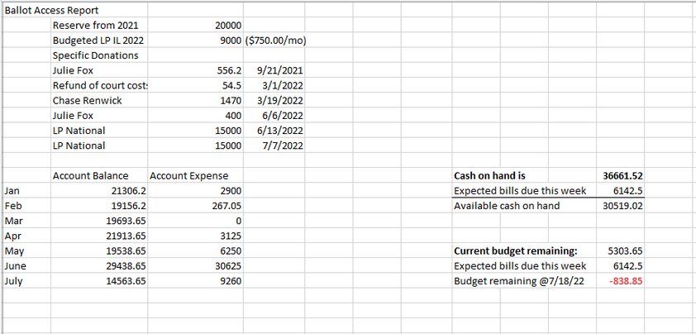
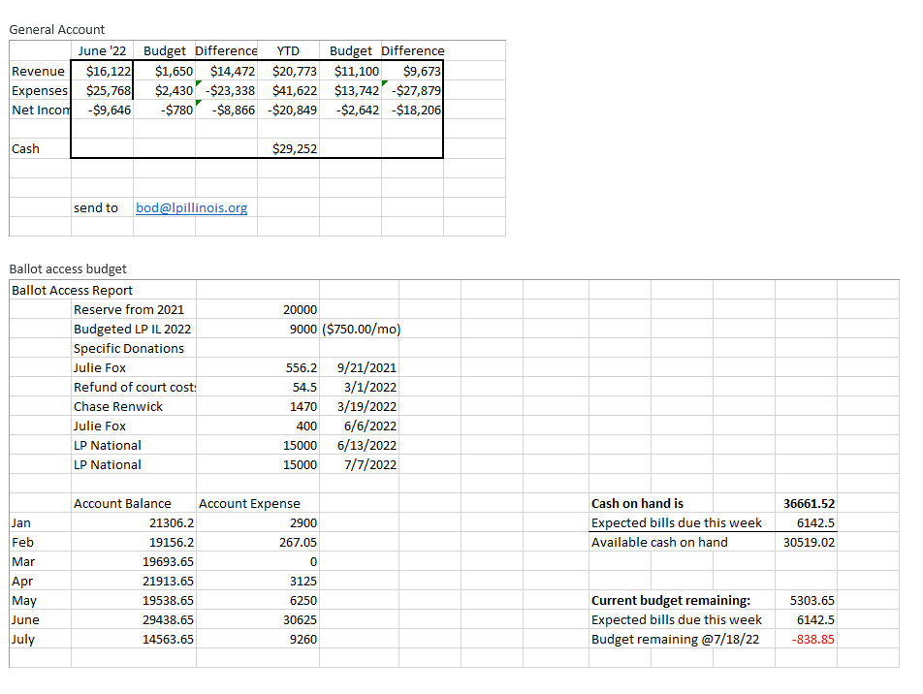

B. Ryan: Asks a question regarding any litigation costs and what pot of money that will come from.
R. Clark: Litigation will be drawn from Ballot Access. We will need to address the Ballot Access budget next month.
EXECUTIVE DIRECTOR REPORT:

Fellow Libertarians - Happy birthday, Adam!
I strongly the numerous inflammatory and unprofessional actions of New Hampshire
Libertarian Senate nominee Jeremy Kauffman, which reflect poorly on Libertarians everywhere and jeopardize the electoral success of all Libertarian candidates.
If you are not a recurring monthly donor to the LP Illinois, please visit www.lpillinois.org/donate to set. If you cannot donate monthly, please consider a one-time donation. Also please consider Lifetime Memberships. Thanks to all our donors, both new and recurring. We just paid for a petition drive and we need to rebuild the treasury. Become a donor today!
If you are not a Precinct Committeeperson, please consider becoming one. If you are in an established county, start planning the next PC elections. Meanwhile, the information on https://lpillinois.org/precinct-committeemen/ should be updated.
Thanks to everyone who participated in the collection drive. Whether you signed, circulated, validated, donated, or are a candidate for office, your contributions are greatly appreciated. I am looking forward to November. Thanks for making this possible!
I turned in a total of 1345 signatures. I was over 10 pages short of my pledge, which I am disappointed I did not make.
The GOP is actively filling vacancies in Cook County. We are likely to see three-way races.
Keep an eye out for an email appeal.
In the month of May, we brought in a total of $1774.10. In June, we brought in $1211.01. Now that I have more free time, I am going to audit my all time donations.
9 of the top 20 months for contribution aggregate have been since April 2021.
I am seeking another term as Chair of the Cook County Libertarian Central Committee. I seek to institute a plan for 2024 Ward Committeeperson races, update our bylaws to better comply with IL law, and to fill vacancies in Cook County townships. Please vote for me if you plan to attend the CCLCC convention next Wednesday in Oak Park. Visit here for more details regarding the CCLCC convention: https://lpchicago.org/event/2022-cook-county-libertarian-central-committee-convention/
I followed up with JB Pritzker's staffer, who I met at an LGBT rights rally. Still no reply.
I shopped my op-ed around to several outlets. No reply or reply to follow up. I may modify the op-ed again now that we have turned in petitions and continue sending it to other publications.
I attended a meeting of the Chicago chapter of the Neoliberal Project. Some members are LPIL members or sympathetic to the LP. Many of the attendees were fans of the land value tax, a policy prescription supported by LP Cook County Commissioner candidate James Humay, who was also at the same microbrew for a MC meeting.
I encourage folks secure their Libertarian memorabilia in our archive at UIC to protect them from damage. Reach out to me about donations, as I just received instructions from our former archivist. I received a copy Professor McCloskey's book "Leave Me Alone and I'll Make You Rich" with her autograph made out to the LP and plan to put into the archive. Thanks to Ken Mattes for his donation of music performed by the choir at the convention gala in Reno to the archive.
Thank you for letting me serve you as Executive Director.
Best,
Justin Tucker
Executive Director, Libertarian Party of Illinois

DIRECTOR BRIEFS

Communications Division Report: Amanda not present. Nathan Florey is. Amanda sent out 3 press releases, received good coverage in Springfield area.
C. Renwick: Social Media, he’s been having Nathan working on social media. Chase has been trying to put out more with national and put up a professional profile and leaving more contentious items for personal to debate.

B. Ryan: Asked a question where the press releases were.
Answer: They were just sent to local press. Typically those press releases just get sent to them, not to the group at large.

Field Operations Division Report:
No field Ops Director. Blake not on call.
Lorraine—did get one volunteer signup Donald Lapuma, interested in keeping everything. Harassing candidates should have records kept.
Will be attending YAL in August.

IT Division Report: Lex working on system for voting. Bob reached out to help with IT.

Convention Report: None.

Political Division Report:
B. Redpath: 36,600 signatures requires a 68.31 percent validity rate. 7181 signatures gathered; almost 1/5th. He took it as a full-time job. LP Volunteers did around 11,000. Good performance, but we do need more volunteer signatures. All LP volunteers had validity rates of 73% and higher. Believes we have enough valid signatures to survive challenge. Thanks to paid petitioners. Bob Lynch. Sanford Pankin came for 1 month. Arenza Thigpen. Possibly the best petitioner encountered. In 10 days did slightly over 2400 signatures. Bill thanked everyone he could think of; Justin Tucker; Matt Piron and others that Bill is missing.

LP National Report: Joe Ecklund not on the call tonight. Will invite for next month.

OLD BUSINESS: None.

NEW BUSINESS:

Motion:
R. Clark: Authorize an additional $1043.85 in the ballot access budget to pay Mr. Thigpen in full.
Seconded: D. Henry.
Result: Motion passes unanimously.

Motion: D. Lewis: (see below for text of resolution, seconded by J. Tucker.)
Resolution to Protect Individual Rights Regarding Reproduction

WHEREAS no level of government should regulate, prohibit, subsidize, or encourage any reproductive choice; now, therefore, be it
RESOLVED the Libertarian Party of Illinois defends the right of all persons to privacy in and control over this aspect of their biological nature, including decisions about contraception, termination of pregnancy, designer babies, surrogate motherhood, artificial insemination, and cloning.

D. Lewis: Roe V. Wade recently overturned; national party removed the reproductive rights platform. Took the platform plank from the Radical Caucus to turn into resolution. Doesn’t believe that it says anything; just that the government isn’t involved in it. The State should not tell people what to do with their own bodies. It’s a personal decision between doctor and patient. It doesn’t mean you’re in favor of abortion; just that the government shouldn’t be involved. It also shouldn’t be subsidized; taxation is theft.

D. Henry: Against removal of abortion plank. There has to be a purpose and a net positive. When we put something out there it has to have a purpose and a net positive. We as a party don’t need to take a stand.

J. Tucker: Motion to amend as below. Seconded B. Redpath.

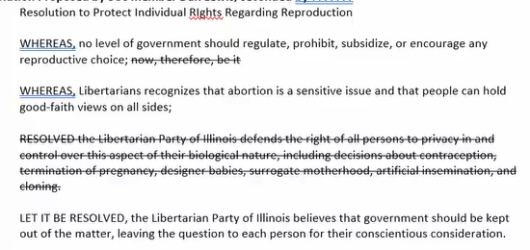
J. Tucker: Heard public comment. Don’t agree with removal of the plank from the platform. He does think it’s timely; does think it’s appropriate. Disagreed with Dan’s wording. Took what he liked and added the new portion. Thus he amended the original resolution.

B. Redpath: Is this the text of the abortion plank from Reno? Some of it. Bill prefers this in terms of the original motion. He believes it reads better. Believes it is superior

Motion to amend passes.

WHEREAS, no level of government should regulate, prohibit, subsidize, or encourage any reproductive choice;

WHEREAS, Libertarians recognizes that abortion is a sensitive issue and that people can hold good-faith views on all sides;

LET IT BE RESOLVED, the Libertarian Party of Illinois believes that government should be kept out of the matter, leaving the question to each person for their conscientious consideration.

Resolution fails.
Roll Call Vote Results:
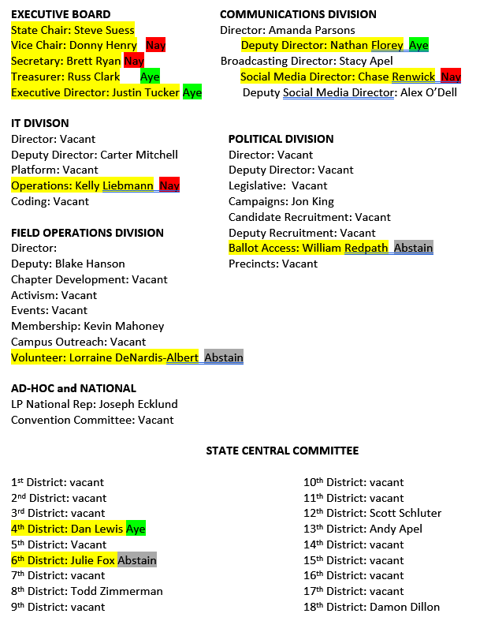

B. Malouf researching no-knock raids. Looking to reach out to Buckner to reach out for bipartisan support. The democrat social justice side. More difficult for Republican side. Framed as more dangerous for police when they go into the situation themselves. There was not a lot of organization around. He’s got a rubric on how to write a bill. Link to the bill in Illinois; draft to what he would like for no-knock’s in Illinois.

Next Meeting Date: August 16th, 2022, 7:30 PM

Adjourn: B. Redpath, Seconded: L. DeNardis-Albert 8:51

Attendees:
Jim Humay
Jason Decker
Donny Henry
Steve Suess
Stuart Straub
Ken Mattes
217-935-8685
314-609-7097
312-504-3995
Jon Harlson
Derek Evans
Matt Piron
Julie Fox.
