BOARD OF DIRECTORS MEETING AGENDA
Call in telephone number: 630-868-9596 (There is no code)
URL link: www.uberconference.com/chairlpil

June 21, 2022 – 7:30 PM

EXECUTIVE BOARD COMMUNICATIONS DIVISION
State Chair: Steve Suess Director: Amanda Parsons
Vice Chair: Donny Henry Deputy Director: Nathan Florey
Secretary: Brett Ryan Broadcasting Director: Stacy Apel
Treasurer: Russ Clark Social Media Director: Chase Renwick
Executive Director: Justin Tucker Deputy Social Media Director: Alex O’Dell

IT DIVISON
Director: Vacant POLITICAL DIVISION
Deputy Director: Carter Mitchell Director: Vacant
Platform: Vacant Deputy Director: Vacant
Operations: Kelly Liebmann Legislative: Vacant
Coding: Vacant Campaigns: Jon King
Candidate Recruitment: Vacant
FIELD OPERATIONS DIVISION Deputy Recruitment: Vacant
Director: Les Deffner Ballot Access: William Redpath
Deputy: Blake Hanson Precincts: Vacant
Chapter Development: Vacant
Activism: Vacant
Events: Vacant
Membership: Kevin Mahoney
Campus Outreach: Vacant
Volunteer: Lorraine DeNardis-Albert

AD-HOC and NATIONAL
LP National Rep: Joseph Ecklund
Convention Committee: Vacant

STATE CENTRAL COMMITTEE

1st District: vacant 10th District: Les Deffner
2nd District: vacant 11th District: vacant
3rd District: vacant 12th District: Scott Schluter
4th District: Dan Lewis 13th District: Andy Apel
5th District: Vacant 14th District: vacant
6th District: Julie Fox 15th District: vacant
7th District: vacant 16th District: vacant
8th District: Todd Zimmerman 17th District: vacant
9th District: vacant 18th District: Damon Dillon

OTHER PARTICIPANTS:
See list at end of minutes.

____________________________________________________________________________
AGENDA
MEETING CALL TO ORDER - 0732

PUBLIC COMMENT: Adam Bolling: Hiccup at national party, put out there he still looks forward to working with everyone on every side; ex// Danny Malouf, Jim Humay. New national chairwoman had rumblings of those against the mises caucus. There should be open discussion, blocking of anyone on social media should be avoided.

APPROVAL OF PREVIOUS MINUTES (May 17, 2022)

OFFICER BRIEFS

CHAIR:

Questions regarding PC’s in cook county? Paul DiMasi. Steve Clarified
Petition Drive
Bill will have specifics about this in his ballot access report, but this is the most important thing you can do as a Libertarian in the next three weeks. If you have absolutely any time to spend toward libertarianism between now and July 10th, Please go out and gather signatures. This ballot access drive will succeed or fail based on the number of volunteer signatures we can gather. Bring a clipboard to your 4th of July family get together, or even better, your town's Independence Day parade. Stand outside a precinct on Primary Election Day and collect signatures. Go to an event - even a small one - and gather at least a page. We desperately need your help, and there is nothing else more valuable you can do for our cause right now.

National Convention
The LNC Convention was in Reno three weeks ago, and Illinois delegates had a good showing. Even through contentious leadership elections and platform changes, our delegates were mostly respectful with each other and heard each other out, and I appreciate everyone who helped make that happen. We have a new Region 6 representative. His name is Joseph Ecklund, and he's from Wisconsin. Joe has already shown willingness to listen to our members about concerns we have. Please feel free to reach out to Joe if you need anything or have questions regarding National.

Ballot Access Funding
At the national convention, I had the opportunity to discuss ballot access funding with our new Chair Angela McCardle and other members of the new LNC. I floated the idea that we receive a similar funding pattern that New York received for ballot access, where we receive funding from national when hitting certain benchmarks with petition signatures. The LNC voted two weeks ago to immediately fund $15,000 to LP Illinois and another $15,000 when we reach 27,500 signatures, which is 115% of our state mandated minimum. We are gracious for this funding, but while this funding will help, we will not succeed without exceeding our volunteer signature pace between now and July 10th. This is not a problem we can just throw money at. We NEED volunteer signatures.

Vacancies on the Board
Several members have stepped down from their leadership roles in LP Illinois. IT Director Deb Renwick resigned as IT Director with health concerns. Political Director Jake Leonard and Legislative Director Bennett Morris resigned after the convention. These resignations are in addition to our already vacant positions on both the Board of Directors and the SCC. Given how many vacancies there are, some of you might ask why this wasn't near the top of my report. It's because petitioning is much more important right now. We can fill these positions after the ballot access drive, and honestly, it will make sense to fill them after party elections in July.

Party Elections
Elections for the Executive Committee and State Central Committee will take place via email vote on July 27th. Only Precinct Committeepersons will vote. If you're in an established county, you must be running for Precinct Committeeperson in the Primary Election to vote. Local Chairs may not appoint new PCs in establish counties until after county elections. On July 28th, the new committees will begin their terms. Here is a list of people who are running...

Executive Committee
Chair Chase Renwick
Vice Chair
Treasurer Russ Clark
Secretary Brett Ryan

State Central Committee
D1
D2
D3 Danny Lewis
D4
D5
D6
D7 Jim Humay
D8 Todd Zimmerman
D9 Paul DiMasi
D10
D11
D12
D13
D14
D15
D16
D17 Donny Henry

If you'd like to be added to the ballot, please reach out to me as soon as possible in writing via email so I can add you to the ballot. You must be a Precinct Committeeperson to run for State Central Committee.
County Conventions
Established counties should also hold a county convention on July 27th and elect new executive committees. Local Chairs need to be prepared to execute this function that's required by state law. This does not affect Chairs in unestablished counties. If any chapter Chairs from established counties have questions, please reach out to both me and Donny.

VICE CHAIR:
Petitioning! Volunteer signatures, even 1 page will make all the difference. Don’t worry about anything else other than getting them notarized. DON’T put page numbers. Contact D. Henry if you need help with pickup. Like Steve said, county conventions are on July 27th. 29 days after the primary for established counties. Elect county officers, etc. Formal thing. For non-established counties, get in practice for this. Must be PC to be a position. Lex Green put a lot of thought into this; lined-up our elections up with the state election code. Brings us into compliance with state election laws. It made it so that you must have skin in the game to be a part of the leadership of the state party. You must do the work and be involved. Lot of disappointment/frustrations at LNC convention. Good people at the convention; regardless of MC or not. Need to welcome everyone that wants to roll up their sleeves to do the work. Everyone is welcome with open arms. Larry Sharpe quote, “The Party is literally a dumpster fire on wheels. But without it, we're walking. So I'm on it still. I don't know where you think you're going or what you think you're doing. This is still the only party that is actually doing anything. There's no one else who is. There's no one else who is.”

Dan Lewis: We do have notaries within the party; not that many though.

SECRETARY: Nothing to report.

TREASURER:
This is the results of the May budget.
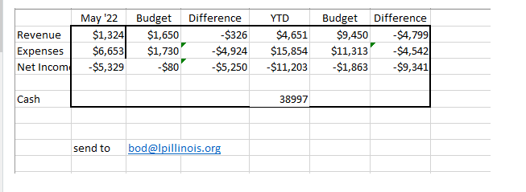

Discussed PC’s in Cook County as differs from other areas. Ward committeeman & Township committeeman. Can be appointed after election by county chair.

We continue to be the Low Stack Ninjas as we are progressing forward with petitioning. If you can, PLEASE donate your money or time to our effort. There are three great opportunities we have ahead of us to push forward and ensure we get ballot access for November.
Petition at precincts!!!! I can provide county chairs with a list for precincts to stand at and gather signatures as people go in and out of the polls. You must remain 100 feet from the door but other than that, you can be there all day or move from precinct to precinct. Busy times for the polls will be 6 AM (polls open), lunch and after 4 PM when people get off work. The majority of the activity will be in the (R) primary due to the governor’s race and they may be more inclined to sign as we align politically on finances. Weather is expected to be great and dry.
Petition during 4th of July events! Parades, foot races and other public gatherings in parks are areas where people gather are good locations to gather signatures.
VALIDATION!!! If you can’t make it out to gather signatures, you can validate and “cure” them from the comfort of your home. Please contact Bill Redpath or someone on the validation team for more details.

EXECUTIVE DIRECTOR REPORT:
Petitioning is #1 right now; past 800 mark. Got 90 outside of Dave Smith show with Jim Humay, met Robbie the Fire. Reach out to Justin for questions on petitioning. Shared a lot of same sentiments expressed about the members at the convention; thanks to everyone for stepping up and circulating. Convention really jazzed up a lot of people.

If you are not a PC, can find information on website about becoming a PC in non-established counties. Reach out if you’re in Cook County after Justin found out about this write-in strategy.

Been texting with Michael Heise back and forth; MC has a preference for local elections; excited to tell him about Cook County and other locales in Illinois.

Apologize about needling Brian Dennehy—no ill-will meant.

DIRECTOR BRIEFS

Communications Division Report:
Amanda Parsons: Nothing to report. Had to find a new job for next year; found one much closer to home and will be pushing out more.
Chase Renwick: Social media: If you’re on a candidates team, please send and reach out to Chase so state social media can share.

Field Operations Division Report:
Les Defner: Thank everyone that has worked hard; ballot access; national convention; local affiliate, etc. Asked for Elizabeth Arnold has decided to resign as campus director.

Announced that Les is resigning as field ops director as of the end of this month. In plan before national; regardless of national outcome, was still planning to resign. Resigning as chairman of Lake County LP. Maintaining as PC. Leaving the door open to involvement with the state party in a smaller capacity.
Lorraine Denardis: Have one volunteer; referred to Chicago LP party. Make people aware she’s the volunteer director. Regarding HR crisis, she went through this in TX in 2008; ended up hiring a membership director that did a lot. Feels like we can pull through this.
Chair responded with a message of gratitude to Les for all of his hard work.

Les is still available for calls/help.

IT Division Report: Looking for IT director; Lex Green has offered to help, but 1000 miles away in Texas. Blake Hanson tentatively offered to help.

Convention Report:

Political Division Report: Jake Leonard has resigned; let Steve know if interested in PD.
Bill Redpath: Overall volunteers 12,285; paid petitioners have gathered 9506. Total 21,791.
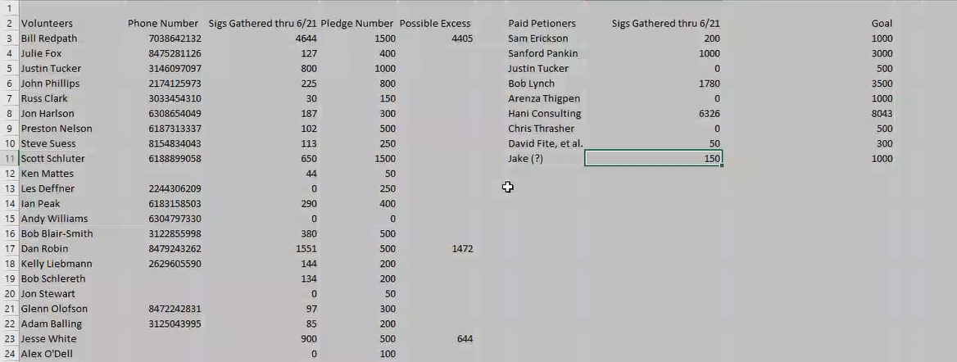
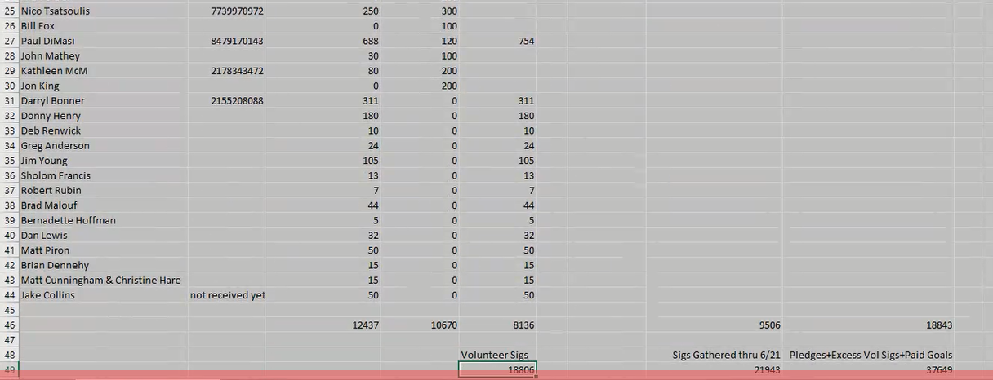

R. Clark provided ballot access budget info from Long and short is that we need to hit our 27,500 to receive the additional 15k from national. Our budget is OK, but we need to push ASAP to get as many as possible. LPIL will continue to spend money and has adequate cash on hand to do so.
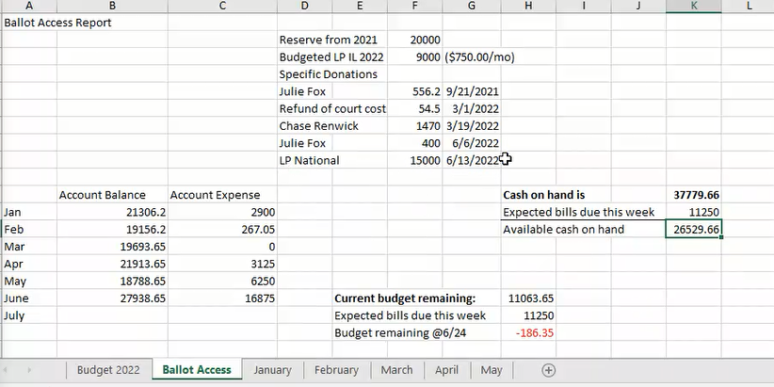

LP National Report: Will invite LNC rep for next meeting.

OLD BUSINESS: None.

NEW BUSINESS:

Resolution Proposed by Executive Director Justin Tucker, seconded by S. Suess.
J. Tucker:
LET IT BE RESOLVED, "Democracy is that form of political constitution which makes possible
the adaptation of the government to the wishes of the governed without violent
struggles."

J. Tucker spoke for the motion; relating meeting with socialist in Logan Square that accused LP of not being democratic and important to show that we are.
B. Dennehey spoke against the motion; related democracy to wolves voting on what to eat. Democracy is mob rule; tyranny of the majority.
L. Deffner: Point of Information: Clarification on need to make this resolution. Underlying need beyond a one-off scenario.
J. Tucker: Based on several interactions. Several libertarian philosophers that are prominent and oppose democracy. As a political party that is asking for votes to make change to the democratic process, we need to emphasize where we stand on democracy.
D. Henry called the question.
L. Defner seconded.

Resolution passes by acclimation.
Resolution Proposed by Vice Chairman Donny Henry, seconded D. Lewis.
WHEREAS, The Libertarian Party of Illinois (“LPIL”) has a long tradition of advocacy for justice, inclusion, and recognition of the dignity of all individuals;
WHEREAS, LPIL is committed to defending the rights of individuals regardless of color, culture, creed, ability, sexual orientation, gender, or any immutable characteristic;
WHEREAS, LPIL unequivocally supports an individual’s freedom of expression and recognizes that some individuals will use that freedom to espouse views that are objectionable to others;
WHEREAS, LPIL rejects any interpretation of its Statement of Principles that disparages the rights of any person because of their immutable characteristics;
WHEREAS, LPIL accepts a commonly understood definition of "bigotry" to be the intolerance and dislike of lifestyles or identities different than one's own;
BE IT RESOLVED, LPIL condemns bigotry as irrational and repugnant; and
BE IT RESOLVED, LPIL does not welcome any individual as a Member or Candidate who expresses hate in their hearts for anyone based on immutable characteristics; and
BE IT FURTHER RESOLVED, LPIL unites behind the inclusion of all individuals who adhere to a lifestyle of non-aggression and stands in steadfast dedication to the defense of their natural right to Life, Liberty, and Property.

D. Henry: In response to platform to LNC Wrote this resolution specifically because libertarian only requires NAP to join the party. Libertarians come from a wide background. You can believe in things that D. Henry doesn’t like. You cannot be a member of the party if you despise those based on immutable characteristics. Make it clear that people that are racist and bigots, aren’t welcome in the party. Reason this is so important, Richard Mayers, Berwyn, attempted to run as sheriff as libertarian. Is an avowed white supremacist. Need to be able to point to something that they’re not welcome.
B. Ryan spoke against. Believes it’s a waste of time and doesn’t accomplish anything.
L. Defner spoke for because it gives more ammunition to those to tear down the LP. Having a resolution to point to for defense against those. Any member can point to that; another individual does this; is not in line with the state party. A rock-solid defense.
D. Lewis spoke in favor. Google news of LP about removing bigotry from platform. Can point to LP of Illinois can point to that. Used for interacting with getting sigs and voters.
L. DeNardis-Albert spoke in favor. Important that the state forms its own identity; helps her to be more impartial; focuses on economics and LGBTQ, African-American liberties. Protects all of those.
B. Hanson spoke in favor. It’s very important to emphasize and fundamentally necessary in our march towards liberty.
B. Dennehey spoke against. People using this language to label people as racists, white supremacists when they don’t get what they want in the party, run off to the SPLC to declare the party as racist. Believes this is a mistake, but that we’ll (Illinois LP) will do it anyway and he’ll deal with it.
Vote: All Aye with singular exception of Secretary B. Ryan.
Next Meeting Date: 19 July 2022

Adjourn: W. Redpath motioned to adjourn.
L. Defner seconded.
Adjourned at 8:59.
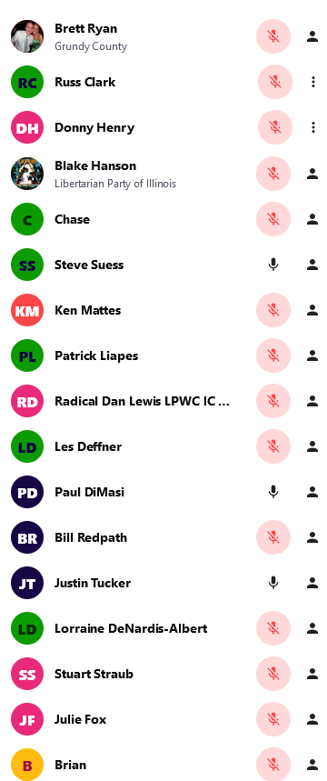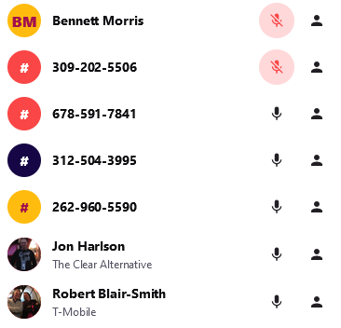
B. Dennehey (SP)
Matt Cunningham

