BOARD OF DIRECTORS MEETING AGENDA
Call in telephone number: 630-868-9596 (There is no code)
URL link: www.uberconference.com/chairlpil

July 19, 2022 – 7:30 PM

EXECUTIVE BOARD COMMUNICATIONS DIVISION
State Chair: Steve Suess Director: Amanda Parsons
Vice Chair: Donny Henry Deputy Director: Nathan Florey
Secretary: Brett Ryan Broadcasting Director: Stacy Apel
Treasurer: Russ Clark Social Media Director: Chase Renwick
Executive Director: Justin Tucker Deputy Social Media Director: Alex O’Dell

IT DIVISON
Director: Vacant POLITICAL DIVISION
Deputy Director: Carter Mitchell Director: Vacant
Platform: Vacant Deputy Director: Vacant
Operations: Kelly Liebmann Legislative: Vacant
Coding: Vacant Campaigns: Jon King
Candidate Recruitment: Vacant
FIELD OPERATIONS DIVISION Deputy Recruitment: Vacant
Director: Ballot Access: William Redpath
Deputy: Blake Hanson Precincts: Vacant
Chapter Development: Vacant
Activism: Vacant
Events: Vacant
Membership: Kevin Mahoney
Campus Outreach: Vacant
Volunteer: Lorraine DeNardis-Albert

AD-HOC and NATIONAL
LP National Rep: Joseph Ecklund
Convention Committee: Vacant

STATE CENTRAL COMMITTEE

1st District: vacant 10th District: vacant
2nd District: vacant 11th District: vacant
3rd District: vacant 12th District: Scott Schluter
4th District: Dan Lewis 13th District: Andy Apel
5th District: Vacant 14th District: vacant
6th District: Julie Fox 15th District: vacant
7th District: vacant 16th District: vacant
8th District: Todd Zimmerman 17th District: vacant
9th District: vacant 18th District: Damon Dillon

OTHER PARTICIPANTS:
See list at end of minutes.

____________________________________________________________________________
AGENDA
MEETING CALL TO ORDER -

PUBLIC COMMENT:

APPROVAL OF PREVIOUS MINUTES (June 17, 2022)

OFFICER BRIEFS

CHAIR:

VICE CHAIR:

SECRETARY:

TREASURER:
We have had a successful ballot access drive this year however, we have one standing bill remaining. Arenza Thigpen was a paid petitioner and gathered 2,457 signatures for us in roughly 10 days. He is an outstanding member of our petitioning team and is due $5 per signature. The Redpath Campaign and the LP IL agreed to split the costs of these signatures. We only have $5,303.65 remaining in the ballot access budget for this year and I would ask that we authorize an additional $838.85 in the budget to pay Mr. Thigpen in full. The Redpath Campaign has paid Mr. Thigpen his half of what he is due. We currently have $36,661.52 on hand and are capable of paying this bill in full.
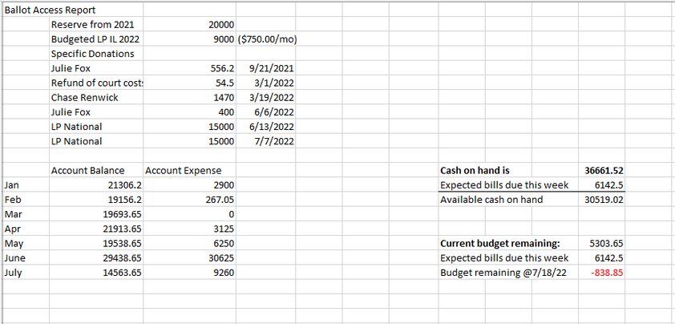
Motion: Authorize an additional $838.85 in the ballot access pudget to pay Mr. Thigpen in full.
Seconded:

EXECUTIVE DIRECTOR REPORT:

DIRECTOR BRIEFS

Communications Division Report:

Field Operations Division Report:

IT Division Report:

Convention Report:

Political Division Report:

LP National Report:

OLD BUSINESS:

NEW BUSINESS:

Resolution Proposed by SCC member Dan Lewis, seconded by ???????
Resolution to Protect Individual RIghts Regarding Reproduction

WHEREAS no level of government should regulate, prohibit, subsidize, or encourage any reproductive choice; now, therefore, be it
RESOLVED the Libertarian Party of Illinois defends the right of all persons to privacy in and control over this aspect of their biological nature, including decisions about contraception, termination of pregnancy, designer babies, surrogate motherhood, artificial insemination, and cloning.
Next Meeting Date: Elections??? August 16th, 2022

Adjourn:

