BOARD OF DIRECTORS MEETING AGENDA
Call in telephone number: 630-868-9596 (There is no code)
URL link: www.uberconference.com/chairlpil

February 15th, 2022 – 7:30 PM

EXECUTIVE BOARD COMMUNICATIONS DIVISION
State Chair: Steve Suess Director: Amanda Parsons -EXCUSED
Vice Chair: Donny Henry Deputy Director: Nathan Florey
Secretary: Vacant Broadcasting Director: Stacy Apel
Treasurer: Russ Clark -EXCUSED Social Media Director: Chase Renwick
Executive Director: Justin Tucker Deputy Social Media Director: Alex O’Dell

IT DIVISON
Director: Deborah Renwick-EXCUSED POLITICAL DIVISION
Deputy Director: Carter Mitchell Director: Jake Leonard
Platform: Vacant Deputy Director: Vacant
Operations: Kelly Liebmann Legislative: Bennett Morris
Coding: Vacant Campaigns: Jon King
Candidate Recruitment: Vacant
FIELD OPERATIONS DIVISION Deputy Recruitment: Vacant
Director: Les Deffner Ballot Access: William Redpath
Deputy: Blake Hanson Precincts: Vacant
Chapter Development:
Activism:
Events: Vacant
Membership: Kevin Mahoney
Campus Outreach: Elizabeth Arnold
Volunteer: Lorraine DeNardis-Albert

AD-HOC and NATIONAL
LP National Rep: John Phillips Jr.
Convention Committee: Vacant

STATE CENTRAL COMMITTEE

1st District: vacant 10th District: Les Deffner
2nd District: vacant 11th District: vacant
3rd District: vacant 12th District: Scott Schluter
4th District: Justin Tucker 13th District: Andy Apel
5th District: Bennett Morris 14th District: vacant
6th District: Julie Fox 15th District: vacant
7th District: vacant 16th District: vacant
8th District: Steve Dutner 17th District: vacant
9th District: vacant 18th District: Damon Dillon

OTHER PARTICIPANTS

____________________________________________________________________________
AGENDA
MEETING CALL TO ORDER -

PUBLIC COMMENT:

APPROVAL OF PREVIOUS MINUTES:

OFFICER REPORTS

CHAIR: COOK COUNTY LAWSUIT. RULE ON MOTION FEB 23RD. INDICATIONS should be a ruling in LPIL favor. Convention committee is open and in need of people. Contact Chair. SCC MTG to be called soon. Tentatively 3/8 7:30pm.

VICE CHAIR: in unestablished counties, petitioning is 29 days after primary, LPIL will have elections for Executive committee. Please consider running, or being an SCC rep. Also consider being a donor to LPIL. Quote of the month: “But let me offer you my definition of social justice: I keep what I earn and you keep what you earn. Do you disagree? Well then tell me how much of what I earn belongs to you - and why?” ― Walter E. Williams

SECRETARY: - none

TREASURER: Here is our monthly income statement for January
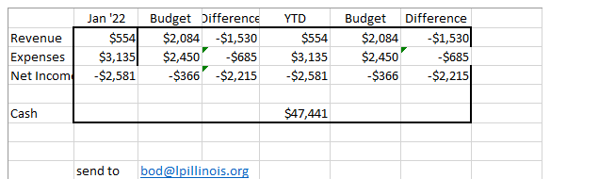

For those who have not been on the email lists, the state party is now involved in a lawsuit in Cook County to ensure that our full rights as an Established Party are not being abridged. We received 6.7% of the vote in the States Attorney race against Kim Foxx in 2020. Per Illinois election law and LP IL v. Schulz (7th Circuit finding, 2017), we are an Established Party in Cook County for 4 years and are able to elect precinct committeemen and have ballot access for all subordinate political subdivisions within the county. Cook County Clerk Karin Yarbrough has decided that as this year is a redistricting year, we do not qualify for township offices, precinct committeemen nor Cook County Board district seats. We have 3 candidates for County Board as well as a full slate for Cook County countywide officials. We gave our arguments in Federal Court last week and the judge will hear from the States Attorneys representing Clerk Yarbrough. The judge in this matter will rule on our motion on February 23. Should he not find in our favor, I would expect the executive committee to move forward with an appeal to the 7th Circuit shortly thereafter. As Schulz was a 7th Circuit decision, it is expected that the court would rule in our favor. I will notify the board of the Clerk’s response to our motion on the 16th when I am notified.

EXECUTIVE DIRECTOR REPORT:
Fellow Libertarians - If you are not a recurring monthly donor to the LP Illinois, please visit www.lpillinois.org/donate to set. If you cannot donate monthly, please consider a one-time donation. Also, please become a Precinct Committeeperson if you are not already one.
Since the last meeting, I was responsible for $202. My recurring donors for the month of January brought in $182, including one new recurring donor from February's appeal. Since the beginning of my second term, I have collected $1538 in donations. My all-time grand total is $4923.
In early December, I sent out a Holiday appeal email which brought in $261.50.
Yesterday, I send out a Valentine's Day email appeal, thus far bringing in $25.
Shake-up with LNC staff puts the status of a potential large donor into question. Will follow up when I know more of the situation.
I have been active in recruiting and petitioning for the Cook County primary. We are at our minimum signature require and are continuing to chug along.
I have also been to recent meetings of LPC, the Chicago Mises Caucus, and the College of Complexes, where Brian Dennehy and I made a connection with Anna Schiefelbein of the Green Party. The LPC hopes we can collaborate with the Greens on a statement against drug prohibition.
All BOD officers and 14th CD are invited to the Underwood meeting.
14th District Libertarians and BOD members are invited to join this meeting with Rep. Lauren Underwood on Feb. 17th at 5:30 PM. Details here: https://www.eventbrite.com/e/14th-district-libertarians-meeting-w-rep-lauren-underwood-il-14-tickets-267778381347

Please RSVP if you can make it and provide me with some questions you may have.
I encourage those who won auction items to secure those items in our archive at UIC to protect them from damage. I repeat: If you are not a recurring monthly donor to the LP Illinois, please visit www.lpillinois.org/donate to set. If you cannot donate monthly, please consider a one-time donation. Also, please become a Precinct Committeeperson if you are not already one.

DIRECTOR REPORTS

Communications Division Report:
- If anyone has any stories, memories, or things that they would like to share about Fran Holt, please send those to me at communications@lpillinois.org
- I will be reaching out to our candidates with surveys to fill out. Jake, do we have a list of our candidates that I can use? Do we have their contact information?
- Thank you for everyone who has stepped up to help out with the commercials/videos. I would like to extend the invitation to anyone not on the Comms team to join us, if you want to.
Chase – Social Media – platforms posts. Sharing platform points, articles about Covid- rules, and inflation. Trying to stay away from unprofessional images.

Field Operations Division Report:

A. Field Ops Director Les Deffner - as weather improves, our team will find more ways to become more active.
B. Field Ops Deputy Director Blake Hanson - No report
C. Membership Director Kevin Mahoney - No report
D. Volunteer Director Lorraine DeNardis-Albert – No report
D. Chapter Development Director – I have spent some time to call both the newest chapter, Winnebago County and they report they have seen a downturn in members meeting attendance. The same scenario has occurred with Chapters in Lake County, as well as Stateline Libertarians. Holidays and weather have been the primary drivers of this. Cook County and McHenry County have been very active in getting their candidates out for signatures. A political club of Stevenson High School in Libertyville asked Lake County LP to participate. Newly relocated Alexa Maffei and veteran party member Bob Schlereth represented the party. They report that a lot of teens were interested. It was only an 1.5hr event. Chicago Chapter held a rally for Ballot Access Reform. Les will continue to perform Chapter Development duties until the role is filled.
E. Activism Director – Keith Zelinske has tendered his resignation. See addenda.

F. Campus Outreach Director Elizabeth Arnold – No report.
G. Division Meeting - none scheduled.

I. Asking all chapter chairs to inform their members of the (3) slots needed filled:
- Chapter Development Director
- Deputy Chapter Development Director
- Activism Director
IT Division Report:
CiviCRM:

Working on pending user. Still finding problems adding users. Added Bernie Behrens and had to fix problems not documented. David has been addressing any problems we are having.

Still trying to document how to add new users. Will then request the current Policy and Operations Manual of the State Organizing Committee.

Need to find a CRM Director. Any help is appreciative.

Amazon Web Services (AWS):

AWS has been tested by Andy and the treasurer was sent email about current charges.

Voter’s Roll Purchase 2022:

Still waiting on when to purchase.

Webmail:

Created document for users to use Webmail through browser or CiviCRM. Includes document on instruction from National.
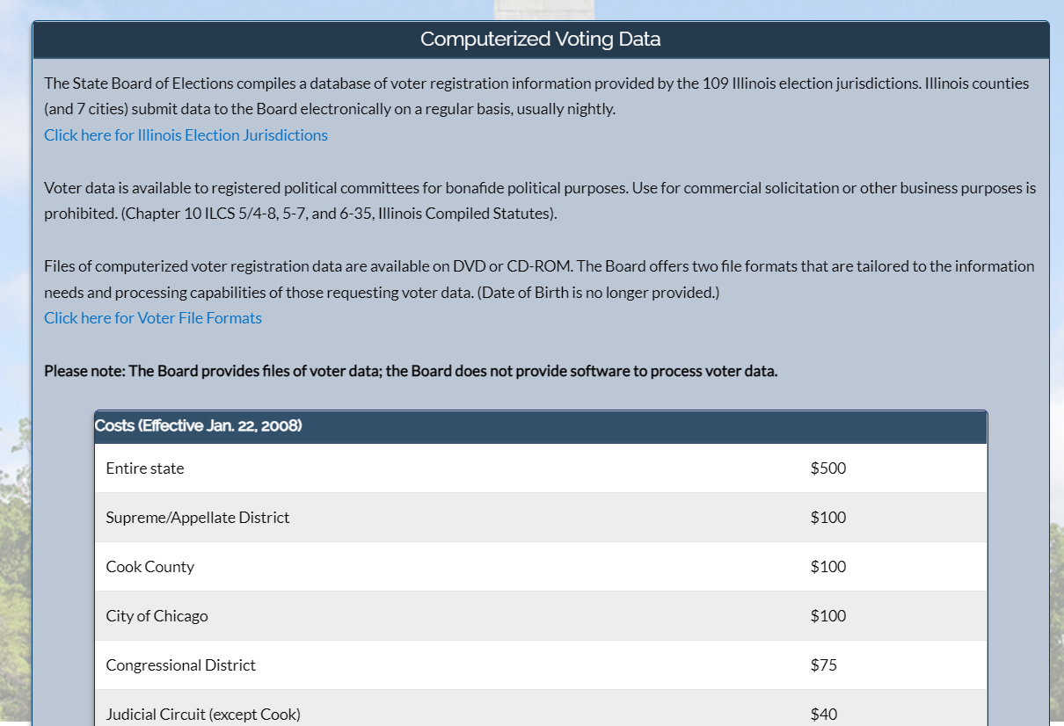

Convention Report:

Political Division Report:
Things have been considerably limited in the Division this past month. Of course, one of the biggest issues would be that of our current lawsuit against the Cook County government (since the Chicago Board of Election Commissioners are allegedly going to abide to whatever the decision is).

The initial lawsuit is the precursor of a potential ballot access lawsuit for this cycle regarding ballot access for all Congressional and General Assembly races in districts exclusively within the county.

The only political subdivision that LP Chicago/Cook County Libertarian Central Committee will be unable to run candidates for is the Metropolitan Water Reclamation District, which has a small amount of territory protruding into DuPage County. Earning recognized party status in DuPage will resolve that issue if a countywide candidate was to run this year to secure countywide ballot access.

Petitioning in our seven established counties are still ongoing, and they must have their petitions turned in by the end of the day of March 14, the final day of filing for the June 28 primary. In the case of Cook County, I would hope for a quick decision in the courts so that the candidates for county commission can be on the ballot for the primary.

I could not express enough the importance of using your powers as established counties to utilize the post-primary nominations in vacancy (NiV) system. Those candidates will still have to collect the signatures required for an established party as a part of the NiV to represent the party in the November general election.

Only one candidate inquiry came from National in the past month: David Pruitt, who is seeking a run for mayor of Chicago in 2023. Currently, I do not know if we receive candidate inquiries via our website like we did under our pre-CiviCRM website format.

I’m still trying to recover all the campaign training materials to pass on to the statewide campaigns, but I have not had the time or opportunity to access them. I hope to have that information out by the next BOD meeting.

Ballot Access Director Bill Redpath – Scott Schulter site down. Bill Redpath site has gone up and down. Their campaign teams need help for web design, development, and maintenance. Need volunteers with technical knowledge. Need candidates for Treasurer & Comptroller.
APRIL 12 …START DATE FOR STATEWIDE PETITIONING. ( 90 DAYS PRIOR TO DEADLINE)
JULY 11 ..LAST DATE FOR STATEWIDE PETITIONING. (DEADLINE)
Asking people to pledge signatures. Bill pledges 1300 sigs. Schluter 1000, Tucker 1000, Fox 400, Suess 250, Brian Lambrecht 100. Bill asks for party members to pledge 250 sigs. We need 40,000+ to withstand challenges.
Legislative Director Bennet Morris – Asking for volunteers to make calls to legislators. Please contact him to author resolution and work with Comms Dept for issues. contact him via Twitter @BennettMorris or bwmorri@gmail.com

LP National Report:
Ken Mattes - LNC convention platform committee has been meeting. Will be discussing new proposals. Start with less controversial topics, then they will work towards the more challenging ones. Platform Committee meets here https://groups.google.com/u/1/a/lp.org/g/platform-committee-2022 Contact him at kmattes2000@gmail.com

CHAPTER REPORTS: Please submit any chapter reports to Secretary@LPIllinois.org

OLD BUSINESS: none

NEW BUSINESS:

Motion #1 – Resolution supporting “Defend the Guard” Legislation in Illinois (Henry)

“Whereas Article I Section 8 of the United States Constitution grants the United States Congress the exclusive power to declare war;
Whereas despite the clear language of the United States Constitution granting Congress the exclusive power to declare war, the Executive Branch has unconstitutionally assumed that power while the Congress has abdicated its Constitutional duty;
Whereas although the United States Congress has not declared war in over 70 years, the nation has gone to war repeatedly at the whim of the Executive branch;
Whereas when unconstitutional acts are taken by the Federal government, it is the proper role of the States themselves to take action to remedy such situations as evident in the Kentucky and Virginia Resolutions of 1798;
Be it resolved that the Libertarian Party of Illinois supports the passage of “Defend the Guard” legislation by the Illinois General Assembly which would require an official declaration of war or a legislative action to call forth the state militia by the United States Congress before members of the Illinois Army and/or Air National Guard may be released from state control to participate in active duty combat operations.”

Next Meeting Date: 15 March 2022

Adjourn:

