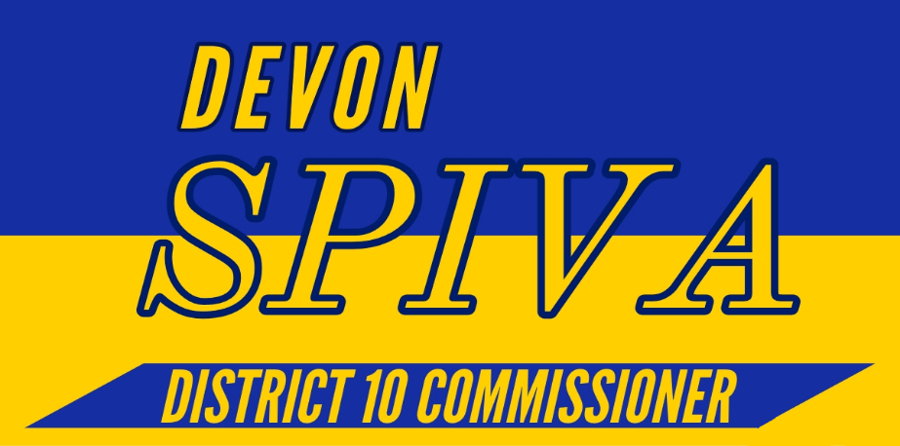

Platform

1. Promote Accountability, Transparency and Honesty on the commission through advocacy for a Citizen’s oversight committee on SPLOST funding and by keeping citizens informed of meetings and refusing to allow the commission to move assigned meeting dates unless listed a week in advance.
2. Work towards affordable housing by revising and repealing zoning regulations that prevent affordable housing from being built. IE the regulation that prevents houses from being built that are less than 1000 square feet unless it is on a multi-family lot. Additionally, looking into using other sources of funding rather than raising property taxes.
3. Bring new businesses and keep current businesses in Athens by determining what is causing them to move to neighboring Oconee County and revising regulations accordingly.
   1. Explore the options to incentivize businesses through tax breaks or tax relief from the city commission.
4. End the School to Prison Pipeline through work with community leaders and reforms such as repealing the current curfew of 11pm.
   1. Work with businesses and community leaders to identify apprenticeships and alternative ways of serving community service for students who have been charged with “crimes” such as affray or breaking curfew.